


ANNUAL

REPORT
2025

Carve your path




TABLE OF CONTENTS

Carve your path

- Land Acknowledgement
Introductions
- Mayor's Address
- Village Council
- CAO's Address

Strategic Priorities
- Municipal Priorities
9 Economic Development
22 Infrastructure
29 Social Responsibility
39 Environment


Financial Reporting
9�
DISTRICT
46 2025 Budget Guide
49 Village Services
50 Property Taxes
53 Community Services
54 Permissive Tax Exemption 57 Statement of Financial
Information

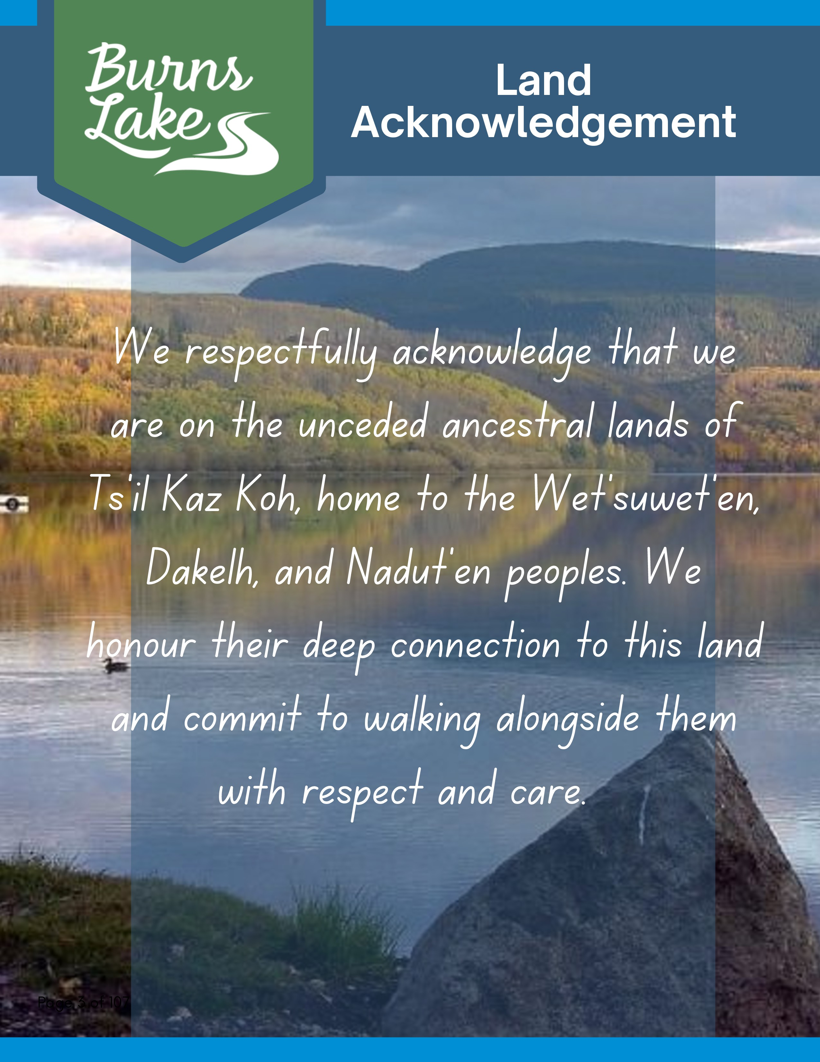


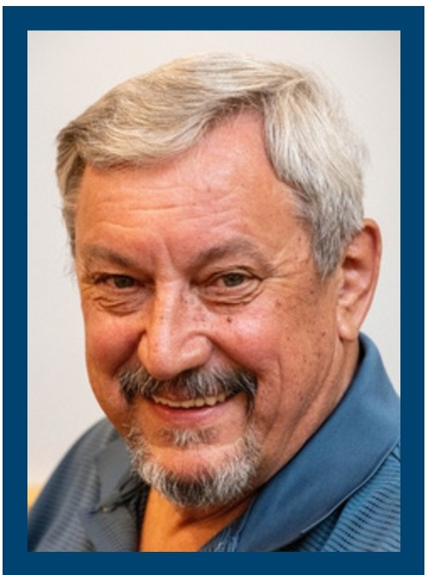
MAYOR'S ADDRESS
Mayor Henry Wiebe
As we reflect on the past year, I am proud of what we have accomplished together. Throughout this report, you will

read about investments in housing, infrastructure, economic development, climate action, emergency preparedness, intergovernmental cooperation, and community-to-community partnerships that have strengthened Burns Lake over the past year. While each initiative is significant on its own, Council has never viewed progress simply as completing projects. Together, they tell a much larger story, one guided by a broader vision to build the capacity our community will need to shape our future and seize the opportunities ahead.

Northern British Columbia is entering a period of unprecedented investment in natural resource development, infrastructure, and economic growth. Stretching west from just beyond Burns Lake is a corridor of significant natural resource development that will help shape the future of our region. This community has always been a place where people choose to live, raise their families, build careers, and invest in the future. We now have an opportunity to build on those strengths and expand the role Burns Lake plays throughout northern British Columbia.

I believe Burns Lake has the potential to play a defining role in the future of northern British Columbia. I envision our community becoming a centre for workforce training and education, supporting the skilled trades, professional services, and industries that will help shape the North for generations.

Achieving that vision starts with the work we are doing today. It means ensuring we have the housing to welcome new residents, the infrastructure to support growth, and the municipal services that businesses and families depend upon. It means strengthening relationships with our neighbouring First Nations, collaborating with regional partners, and continuing to advocate for the investments that will allow our community to thrive. It means making deliberate investments that build our capacity and position Burns Lake to seize the opportunities ahead. Above all, it means that what we have accomplished is not a series of isolated achievements, but the building blocks of a stronger, more resilient Burns Lake.

The future will bring both challenges and opportunities, but I am confident Burns Lake is well positioned to meet them. By continuing to invest in our people, our partnerships, and our capacity, we are creating a community that is ready to lead, ready to grow, and ready to serve as a hub for the opportunities that lie ahead.


It has been an honour to serve this community. I extend my sincere appreciation to my fellow members of Council, Village staff, our volunteers, local businesses, neighbouring First Nations, community organizations, and regional partners. Your commitment, collaboration, and belief in our community continue to move Burns Lake forward.
With gratitude, Henry Wiebe
MAYOR


VILLAGE COUNCIL

The Village of Burns Lake is led by an elected Council composed of a Mayor and four Councillors, each serving a four-year term.
Councillor Kristy Bjarnason


The Council serves as the primary decision-maker for the municipality, holding the authority to govern and manage its legislative and administrative responsibilities.
Through their role as policymakers, Council members provide leadership, set policies, shape the strategic course for the municipality, and determine the budget necessary to address the needs of the Village. Each member represents the Village as a whole, rather than specific geographic areas, and is therefore elected at large by all residents.
The Councillors bring a diverse range of skills and local knowledge, reflecting their strong commitment to serving the interests of all residents. They actively participate in various committees and community initiatives, working collaboratively to address local priorities and foster a vibrant, inclusive environment.

Councillor Charlie Rensby



Councillor Darrel Hill

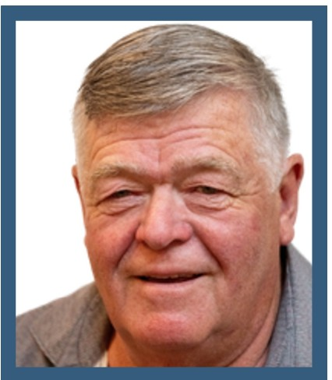
Councillor Kevin White


CAO'S ADDRESS

Ryan Nitchie

As Chief Administrative Officer for the Village of Burns Lake, we are pleased to present the 2025 Annual Report on behalf of our dedicated municipal team.
First, we acknowledge the dedication and professionalism of the staff team, who continued to advance Council's priorities throughout the year. Their commitment to serving our community-from maintaining critical services and protecting public safety to providing recreation opportunities, welcoming visitors, and supporting essential administrative functions-is commendable.
In 2025, staff and Council worked together to advance several priorities identified in the Strategic Plan. Key initiatives included continued development of the Village Heights subdivision, creation of a Recreational Area Development Plan for the Gowan Road property, completion of the Richmond Loop commercial area, advancement of Burns Lake Venture Corp., exploration of housing opportunities, and continued relationship-building with Ts'il Kaz Koh and Lake Babine Nation. Staff also made significant progress on several important projects, including sewer treatment plant upgrades, Government Street improvements and revitalization, Rod Reid Trail enhancements, and other community focused initiatives.

Council and staff remain focused on the Village's strategic goals, with infrastructure renewal, social and environmental responsibility, and sustainable economic development continuing to serve as guiding priorities. Through strategic grant acquisition, careful use of capital reserves, and ongoing collaboration with regional partners, several major projects will continue to move forward. These include liquid waste management upgrades, renovations to the former fire hall building, the integration of supplemental solar power at the wastewater treatment facility, service extensions into Village Heights, and other priority initiatives.

As we look ahead, we are inspired by the strong sense of civic purpose evident throughout our community. This annual report is more than a summary of operational activity; it reflects the Village's strategic direction, the challenges we have navigated, and the collective efforts of Council, staff, community partners, and residents to strengthen and serve Burns Lake. On behalf of staff, we are privileged to serve the organization at such an important time, and we look forward to continuing our work in partnership with Council, neighbouring First Nation governments, and the broader community as we continue to Carve our Paths together.

Ryan Nitchie
CAO

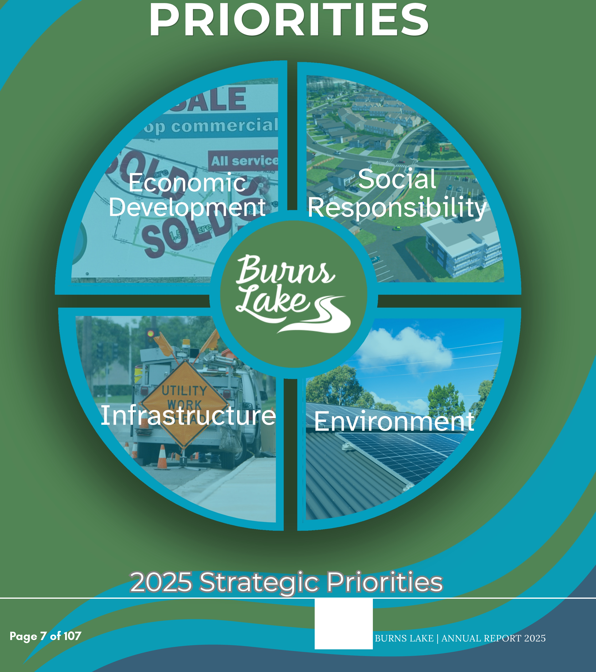


YILLAGE OF.


Strategic Planning

Three-Year Strategic Plan

Council has developed a Three-Year Strategic Plan to provide a coordinated, long-term direction for the Village of Burns Lake.

The plan establishes a framework for setting priorities, allocating resources, and aligning municipal projects, services, and investments with Council's vision for the community.

It is implemented through annual work plans, departmental activities, and the Village's budget process.

Council reviews the Strategic Plan annually to monitor progress and ensure it remains responsive to changing community needs, emerging challenges, and new opportunities. Progress reviews support transparency and allow Council and the community to assess how municipal initiatives are advancing the Village's objectives.

Implementation is guided by the principles of:

- communication and transparency;
- responsiveness to community needs;
- good governance;
- fiscal responsibility;
- continuous improvement and evidence-based practices; and
- advocacy and partnerships.

Strategic initiatives are coordinated with the Village's Five-Year Financial Plan and proceed
when appropriate funding has been approved and is available. The plan organizes Council's work around four strategic priorities:
- Economic Development, Invest in Infrastructure
- Social Responsibility
- Environmental Stewardship & Climate Resilience

Together, these priorities provide a clear basis for measuring progress and communicating how individual projects contribute to the Village's broader goals.


2025 Strategic

Priorities

ECONOMIC DEVELOPMENT

The Village will undertake initiatives that support the development of a strong and diverse economy, including industry, commerce, tourism, and a vibrant downtown.

2025 INITIATIVES AND PROJECTS

2025 Focus

During 2025, Council continued laying the foundation for long-term economic growth by advancing housing-ready land, recreation-based tourism, healthcare recruitment, digital connectivity, downtown vitality, and strategic partnerships. These initiatives strengthen Burns Lake's ability to attract residents, businesses, visitors, and investment while preparing the community to benefit from economic growth occurring throughout Northern British Columbia.

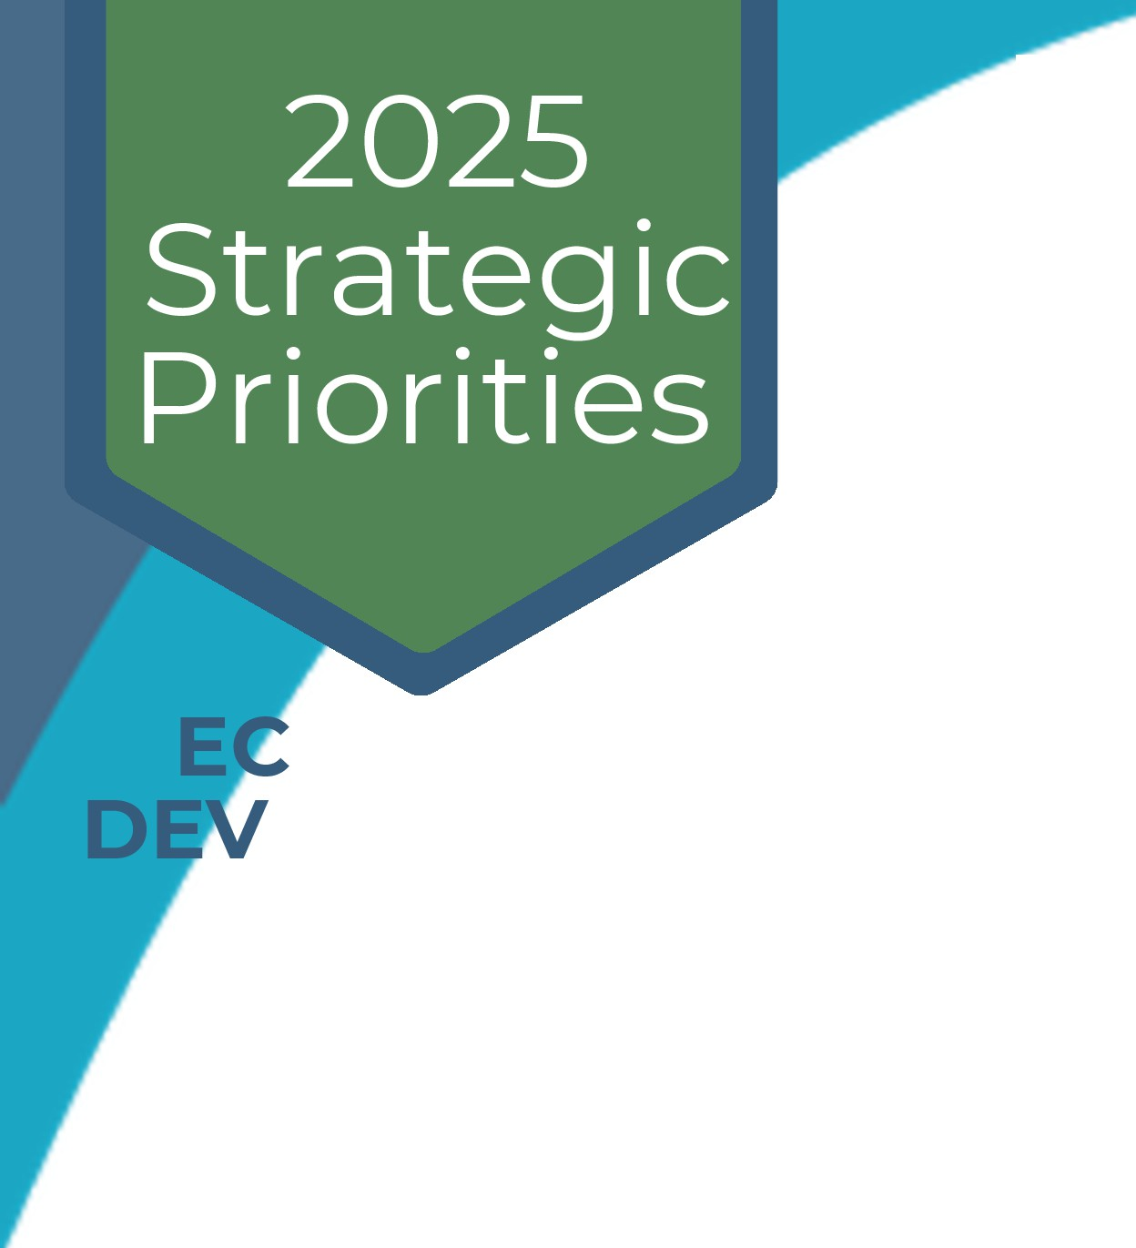
2025 Completion Highlights

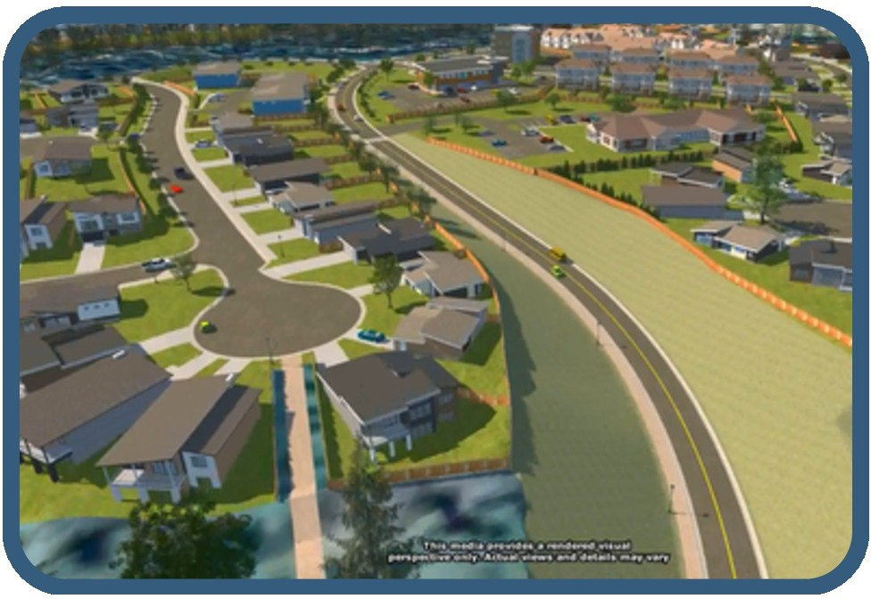
ONOMIC ELOPMENT
Village Heights Residential Development

- Subdivision of the first Village Heights housing parcel, awarded the off-site servicing contract, completed deep utility and road-base construction to the development entrance. This work included off-site servicing along Aspen Drive and Third Avenue and created the infrastructure foundation needed to bring new residential land to market.

- Completed the rezoning required for the first phase and continued design and planning for roads, sidewalks, curb and gutter, shallow utilities, and future servicing. Increasing the supply of serviced residential land supports housing construction, workforce attraction, healthcare recruitment, and private investment.

Burns Lake Venture Corporation

- Received approval from the Inspector of Municipalities to establish the Burns Lake Venture Corporation and continued the legal, financial, and organizational work required to make the corporation operational. This provides the Village with an additional tool to support economic diversification, pursue revenue-generating opportunities for community benefit, and strengthen long-term financial sustainability while managing financial and operational risk responsibly.

Gowan Road Community Recreation Project

- Formalized a partnership with Ts'il Kaz Koh and established a Community-to-Community Recreation Committee, with a joint mandate and Terms of Reference to guide the collaborative planning of recreation infrastructure and provide recommendations to both Councils.

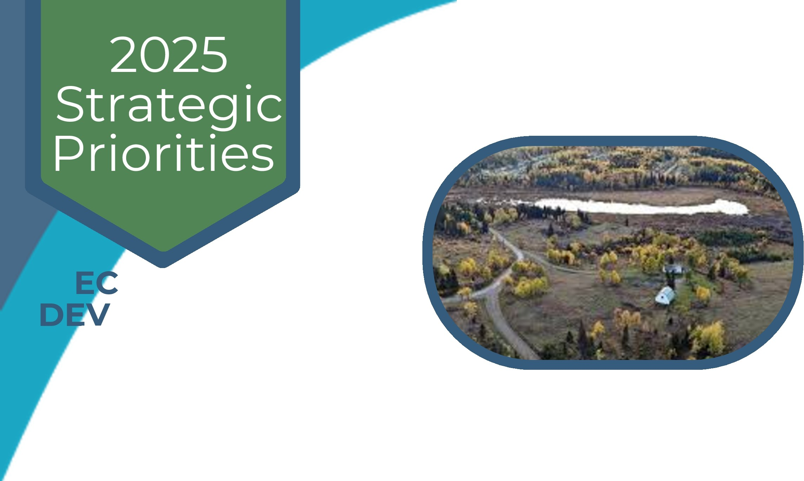
2025 Completion Highlights

ONOMIC ELOPMENT

- Secured support from the Burns Lake Community Forest Legacy Fund and engaged TRUE Consulting to prepare a comprehensive Recreation Area Development Plan for the approximately 160-acre Gowan Road property. The plan will assess the feasibility of potential recreation amenities by examining site conditions, servicing requirements, costs, regulatory approvals, operating considerations, and possible development phases before the partners determine how to proceed.

- Work initiated in 2025 included community and stakeholder engagement, site analysis, recreation concepts, golf-course and irrigation design, a water-feasibility assessment and consideration of archaeological, environmental, geotechnical, and hydrological requirements.

Visitor Information Centre and Visitor Services

- Operated the Visitor Information Centre for 1,283 hours and assisted 1,855 visitors with local knowledge, directions, trip planning, recreation information, community services, and recommendations for businesses and attractions throughout the Lakes District.

  - ...t OI r
11 ritag Gall ry

on 11w
- Continued providing a welcoming and reliable first point of contact for travellers while gathering visitor-origin and information-request data to better understand visitor interests and inform future tourism marketing.

- Supported the Lakes District Museum by providing consistent access to the Heritage Room and promoting its rotating exhibits, workshops, collections, and cultural programming to residents and visitors.

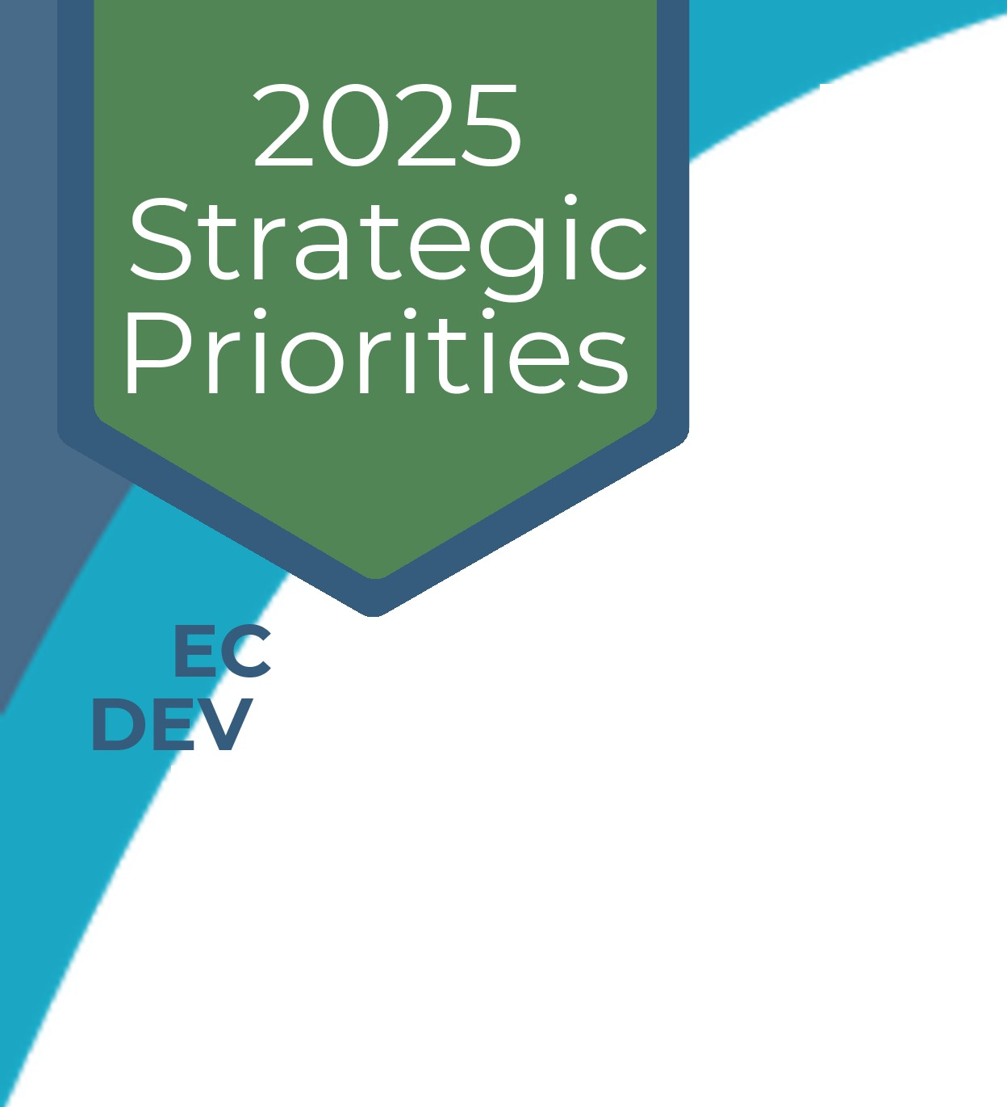
2025 Completion Highlights

ONOMIC ELOPMENT
  - Updated the Community Resource Guide to provide current information about local organizations, healthcare and social services, recreation, education, emergency contacts, and other community resources.


    - Expanded opportunities for local artists through the Visitor Centre gift shop, featuring work from 14 artists and connecting visitors with locally created products and cultural experiences.

Tourism Marketing and Digital Communications

    - Consolidated the Village's municipal and tourism websites into a single platform and launched the foundational version of the new
website. The amalgamation created one central source for municipal information, visitor resources, community events, and local attractions while allowing staff to manage updates directly. Staff continue to develop the site's content, organization, functionality, and visitor resources to create a more comprehensive and user-friendly online presence.

    - Created and managed more than 3,000 pieces of content across the Village, Visit Burns Lake, and Burns Lake Camping social-media accounts, contributing to a doubling of the online audience during 2025. The content promoted local businesses, community events, recreation opportunities, visitor services, municipal programs, and emergency information, extending Burns Lake's reach while providing a cost-effective platform for tourism marketing and community communication.

    - Continued regional and destination marketing through RideBurns advertising, mountain-bike tourism partnerships, print and digital campaigns, visitor maps and brochures, community storytelling, and collaboration with neighbouring highway communities.

Page 12 of 107
Bu�
VILLAGE OF BURNS LAKE I ANNUAL REPORT 2025 Carve your path
�s�


2025 Completion Highlights
ONOMIC ELOPMENT
Worked with Destination BC on the location and agreement for new lconics signage to strengthen Burns Lake's visibility and connection to broader provincial destination-marketing initiatives.
- Advertising Initiatives: Supported key regionally focused activities and societies such as the
Lakes District Fall Fair, Lakes District Performing and Visual Arts, Chamber of Commerce, Burns Lake Music Society, Babes in Balance, Show 'n' Shine.

Magee House on Boer Mountain

  - Completed the second full year of operating Magee House as visitor accommodation, generating net revenue surplus of approximately $22,000 while maintaining Superhost status, a five-star rating, a 100% response rate, and a zero-cancellation rate. The property accommodated tourists, recreation groups, family gatherings, workers, weddings, and special events, demonstrating how a Village-owned asset can generate revenue while supporting visitor services, recreation tourism, and the local economy.

Faces and Places of the Lakes District

  - Completed the Faces and Places of the Lakes District campaign, featuring nine local businesses and eight community locations and adding 353 professional photographs to the Village's digital marketing library.
  - The campaign created authentic, reusable content that showcases the people, places, businesses, and experiences that distinguish Burns Lake. These assets strengthen future tourism promotion, local

business marketing, community storytelling, and investment-attraction efforts.
Bu�

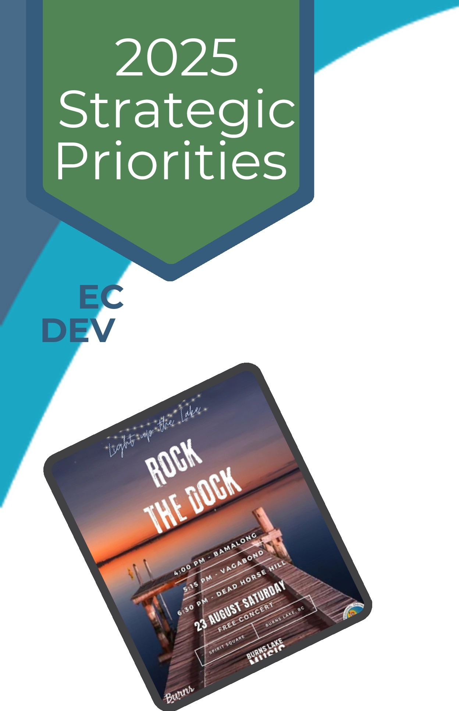
2025 Completion Highlights

Community Events and Destination Development

ONOMIC ELOPMENT
  - Supported and promoted National Indigenous Peoples Day, Canada Day in partnership with the Lakes District Arts Council, the Lakes District Fall Fair, Light Up the Lake, the Pioneer Park Light-Up, and downtown Christmas shopping initiatives. These events created opportunities for residents to gather, attracted visitors, supported local vendors and businesses, and contributed to an active and welcoming community.

  - Expanded Light Up the Lake through a partnership with the Burns Lake Music Society to introduce the first Rock the Dock music festival. The event featured local bands, children's activities, food vendors, and an expanded boat parade, creating a new visitor experience and additional opportunities for local participation.

    - Supported Burnt Bikes through the Small Neighbourhood Grant to operate a visitor shuttle to the Boer Mountain trail network. The shuttle reduced a transportation barrierforvisitors, supported a local recreation business, and strengthened Burns Lake's position as a mountain-biking and outdoor-recreation destination.

    - Assisted local organizations and businesses with events and promotional initiatives.

Downtown Vitality and Business Support

    - Continued the Business Fa9ade Improvement Program to assist commercial property and business owners with exterior improvements that contribute to a more attractive and welcoming downtown and highway commercial area.

Page 14 of 107
Bu�
VILLAGE OF BURNS LAKE I ANNUAL REPORT 2025�_.

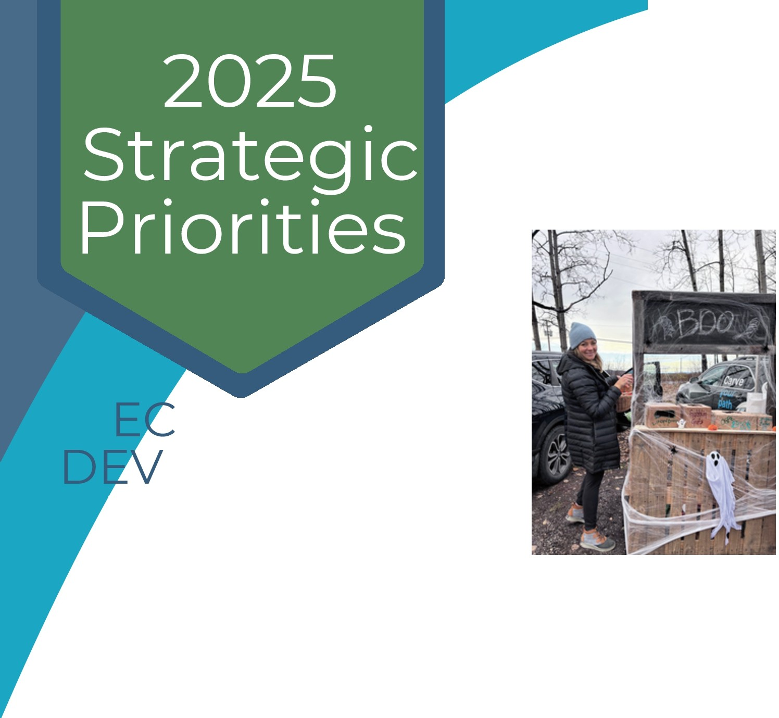
2025 Completion Highlights

ONOMIC ELOPMENT

Healthcare Recruitment and Retention
- Supported new community and tourism initiatives through local partnerships and the Small Neighbourhood Grant program, including the first Trunk or Treat event and the Wild Roots Christmas Market and Festival. These initiatives expanded family-oriented seasonal programming and increased activity in the downtown core.

  - Council supported a retention-focused healthcare recruitment program in partnership with Northern Health, the Northern Interior Rural Division of Family Practice, and the Regional District of Bulkley-Nechako.

  - The Recruitment and Retention Coordinator worked directly with prospective and incoming healthcare professionals on housing, temporary accommodations, transportation, childcare and schools, spousal employment, community orientation, and access to local services.

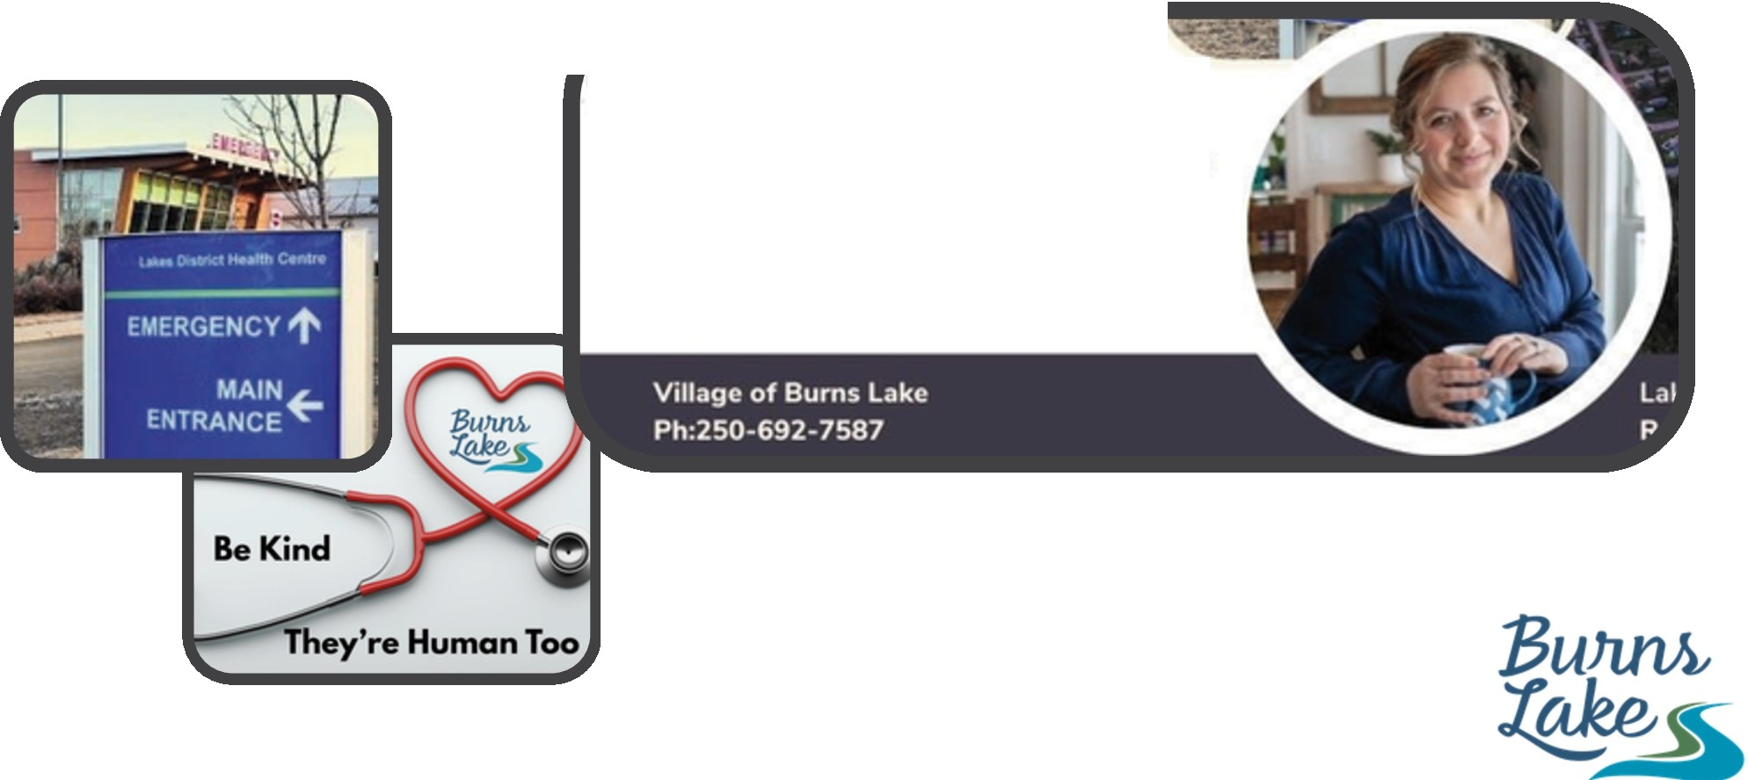
  - By the end of 2025, Northern Health had confirmed that five new physicians were expected to join the community, with some anticipated to begin practising in 2026. This represented an important improvement in the recruitment pipeline and demonstrated the value of coordinated settlement support.
SERVICES PROVIDED
Teri will be promoting Burns Lake to potential recruits, supporting medical staff to build community connections, helping them settle into life in rural BC and guiding them through the transition of making Burns Lake their home.

Page 15 of 107 VILLAGE OF BURNS LAKE I ANNUAL REPORT 2025

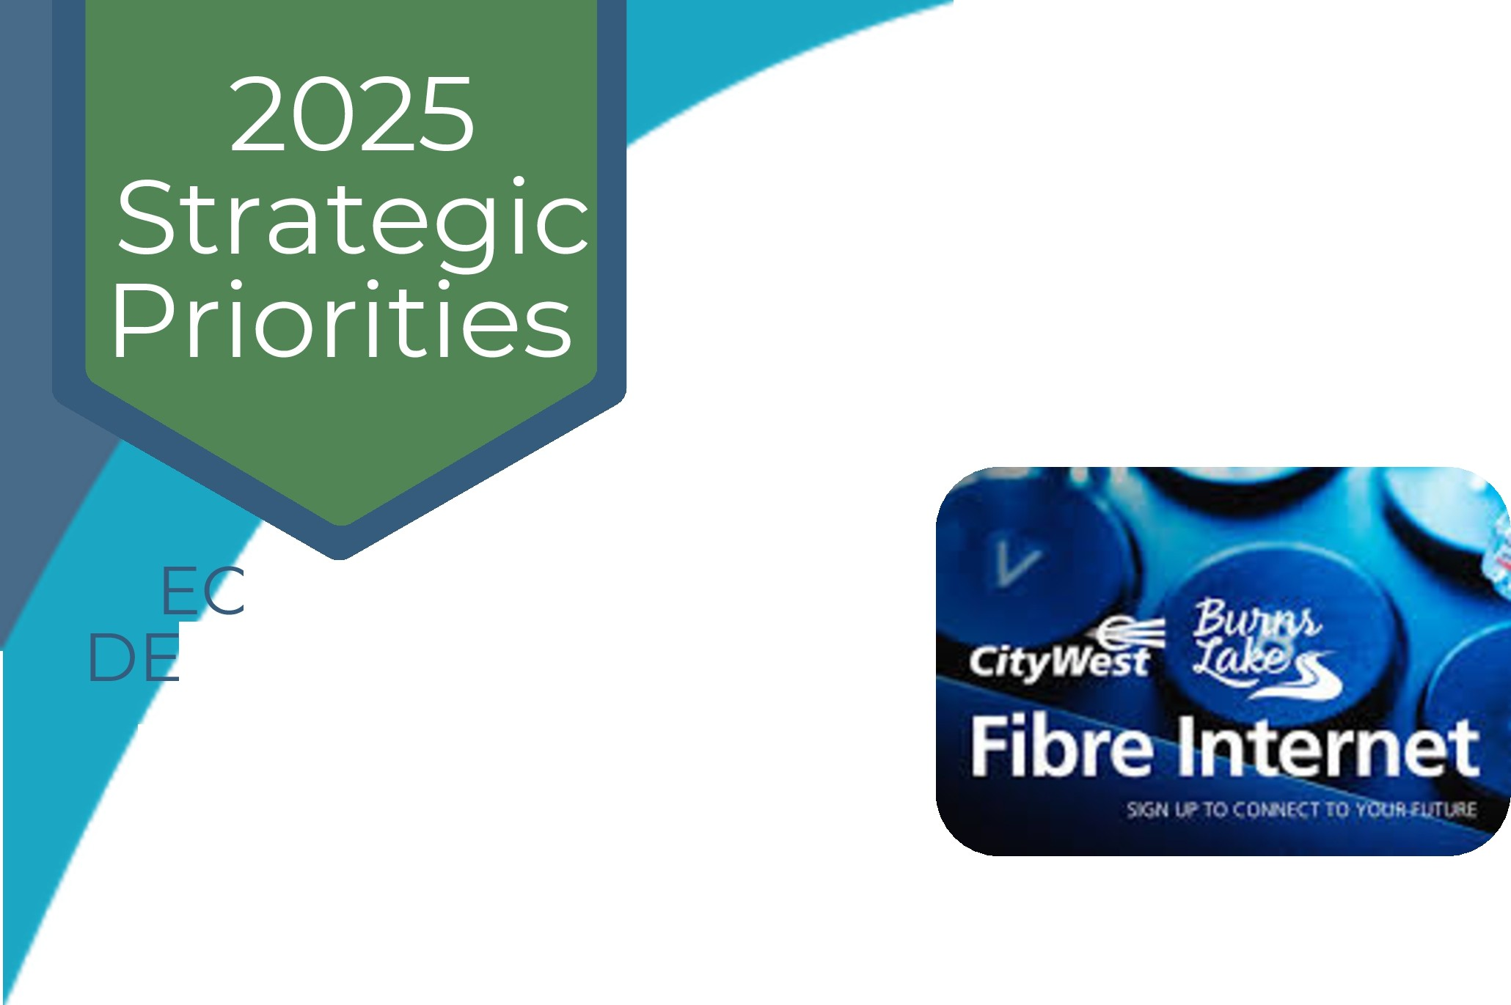
2025 Completion Highlights

ONOMIC VELOPMENT

Digital Connectivity

- Completed the Village's Phase 1 work supporting CityWest's fibre-optic network expansion, while CityWest continued connecting neighbourhoods in phases. Expanded access to reliable high-speed internet supports local businesses, remote work, education, digital services, and household connectivity, strengthening the infrastructure needed to attract residents and investment.

Economic Diversification

- Continued implementation of the 'Chart the Course' economic diversification plan.

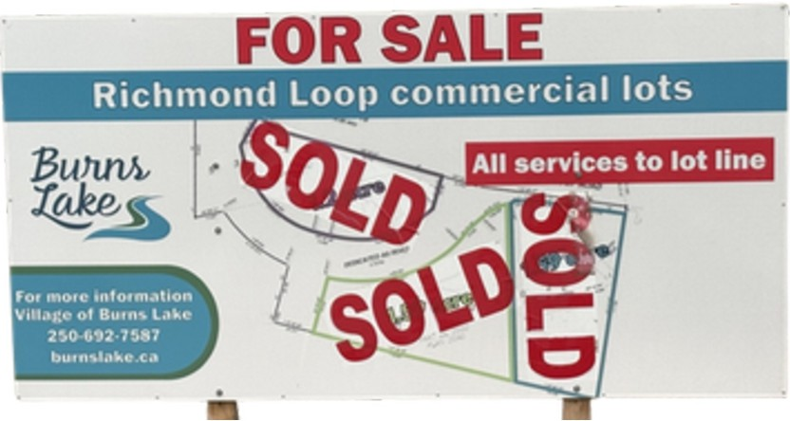
Richmond Loop Commercial Development

- Worked collaboratively with the proponent through the Village's planning and development-approval process to develop a comprehensive site design and complete
a Development Permit application for the Richmond Loop commercial property.

Page 16 of 107 VILLAGE OF BURNS LAKE I ANNUAL REPORT 2025 


2025 Strategic Priorities
ECONOMIC DEVELOPMENT

Highlights of the Upcoming 2026 Projects and Initiatives

2026 Focus

In 2026, Council will build on the groundwork completed during 2025 by advancing serviced residential land, completing strategic development plans, strengthening tourism and downtown initiatives, supporting incoming healthcare professionals, and establishing new tools for community economic development.


2025 Strategic

Priorities

ONOMIC ELOPMENT
Highlights of the Upcoming 2026 Projects and Initiatives

Village Heights Construction and Lot Development

  - Complete the remaining design, tendering, and construction work for the first phase of Village Heights, including shallow utilities, roads, asphalt, sidewalks, curb, and gutter.

  - Prepare the first six serviced residential lots for sale through an open and competitive process, creating opportunities for new home construction and generating proceeds that can be reinvested in future land development.

  - Continue construction-ready design and funding efforts for future phases of the Village Heights development, using a phased approach that responds to northern construction conditions and available financial resources.

  - Undertake a transportation study to evaluate future road connections, access points, and traffic impacts associated with the continued development of Village Heights.

Burns Lake Venture Corporation

  - Advance the formal launch and initial operations of the Burns Lake Venture Corporation, including its governance, business planning, capitalization, and project-development framework, with the longer-term goal of becoming independently funded by 2028.

ONOMIC ELOPMENT

2025 Strategic


Priorities
Highlights of the Upcoming 2026 Projects and Initiatives

Gowan Road Community Recreation Project

  - Complete the comprehensive Recreation Area Development Plan and associated technical studies, providing the partners with a coordinated framework for phased development of the property.

  - Refine the golf-course design and evaluate complementary recreation, tourism, cultural, and event amenities based on site conditions, servicing requirements, environmental considerations, community input, and long-term operational sustainability.

Magee House Improvements

  - Install electrical service in the Magee House barn to expand its potential use for outdoor activities, gatherings, and visitor experiences. The improvement is included in the 2026 budget and can be completed using the property's 2025 operating surplus, allowing the Village to enhance the site without requiring external funding.

Village Boundary Extension

  - Advance the municipal boundary-extension process with the Province of British Columbia to incorporate the Gowan Road property within the Village of Burns Lake. Bringing the municipally owned property inside the Village boundary to establish local jurisdiction for land-use planning, permitting, servicing, bylaw administration, and future development.

ONOMIC ELOPMENT

2025 Strategic

Priorities
Highlights of the Upcoming 2026 Projects and Initiatives

Tourism Development and Destination Marketing

  - Review and update the Village's Tourism Plan to reflect current visitor trends, available assets, community priorities, and opportunities for sustainable destination development.

  - Expand the Faces and Places campaign into additional areas of the Lakes District and continue building the Village's library of professional photography, video, and community stories.

  - Strengthen the Visit Burns Lake website page through improved visuals, storytelling, visitor itineraries, and targeted digital promotion.

  - Continue developing the Visitor Centre artisan gift shop and pursue opportunities for familiarization tours, partnerships with content creators, and regional tourism collaboration.

Community Events and Visitor Experiences

  - Build on the success of Light Up the Lake and Rock the Dock by expanding music, family activities, visitor experiences, and promotional content.

  - Complete planned improvements to the public boat launch to support community events, recreation access, and visitor use.

ONOMIC ELOPMENT

2025 Strategic


Priorities
Highlights of the Upcoming 2026 Projects and Initiatives

Downtown Revitalization and Business Fac;ades

  - Continue the redesign and implementation of Downtown Revitalization Phase 3 and maintain the Business Fa9ade Improvement Program. The work will focus on accessible public spaces, pedestrian safety, streetscape improvements, and commercial-buildinginvestment to support a vibrant and welcoming downtown.

Healthcare Recruitment and Retention

  - Support the arrival, onboarding, and community integration of physicians and associate physicians expected to begin practising in Burns Lake during 2026.

  - Continuing to coordinated assistance with housing, transportation, family settlement, schools, childcare, spousal employment, and community connections for all medical professionals
new to the community.

  - The program will continue to develop relationships with prospective candidates, medical learners, locums, and training programs to sustain recruitment momentum and improve the long-term retention of healthcare professionals.

Regional Workforce Development and Economic Diversification

  - Advocate with the Province, the College of New Caledonia, other post-secondary institutions,
industry, and regional partners to expand access to skills training and education in 13W"ns Lake.
DU�


2025 Strategic

Priorities
INFRASTRUCTURE

The Village will engage in good government that is financially sustainable and invests in infrastructure to service the community.

2025 INITIATIVES AND PROJECTS

2025 Focus

During 2025, Council continued renewing the core systems that residents and businesses rely on each day. Work focused on wastewater treatment, water-system reliability, transportation safety, long-term asset planning, and the replacement of aging equipment.
By coordinating construction, using external funding and reserves responsibly, and completing technical work before major capital decisions, the Village advanced essential infrastructure while protecting the community's limited tax base.


2025 Completion Highlights

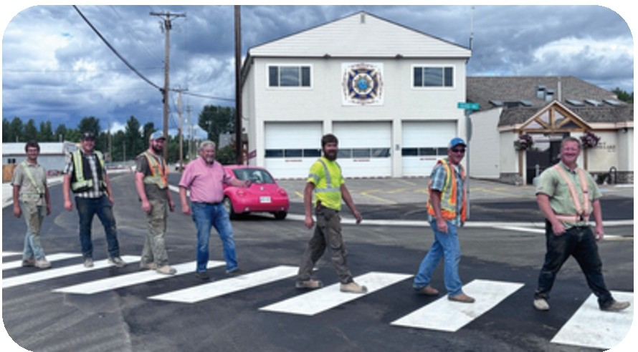
ASTRUCTURE
Government Street Active Transportation - Phase 2

    - Completed the second phase of the Government Street Active Transportation project on time and within budget. The coordinated project upgraded underground water connections and delivered wider sidewalks, new curb ramps, improved crosswalks, traffic-calming measures, and multi-use connections to homes, parks, and the downtown.
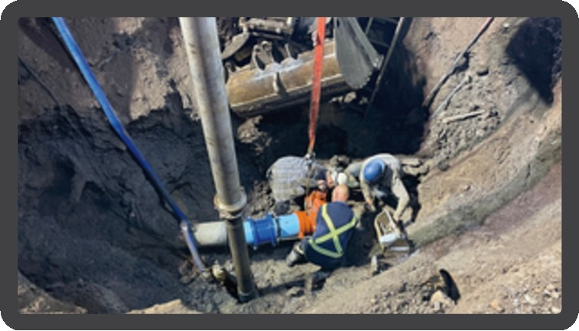
      - Combining utility work with surface improvements reduced the need for future excavation and disruption. The completed corridor improves pedestrian safety, accessibility, and mobility while extending the useful life of municipal infrastructure.

Wastewater Treatment and Lagoon Upgrades

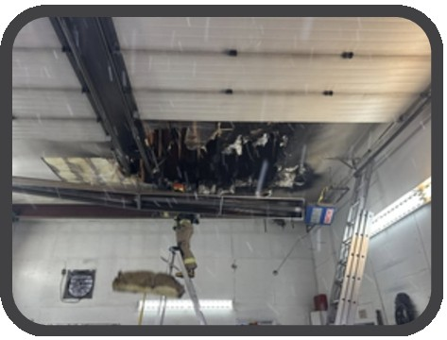
  - Advanced the final phase of the multi-year wastewater treatment upgrade by commissioning the new Lagoon Blower House and its mechanical, electrical, control, and aeration systems. The Village also installed a new water line beneath the creek to serve the future ultraviolet-treatment building and awarded the building contract. These improvements modernize a critical regional system, improve treatment reliability, and support responsible service delivery for the Village and neighbouring communities.

Public Works yard Building Repair

    - Completed repairs to the Public Works building following damage caused by a fire. Restoring the facility protected an important municipal asset and ensured Public Works could continue
operating from a safe and functional building.


2025 Completion Highlights

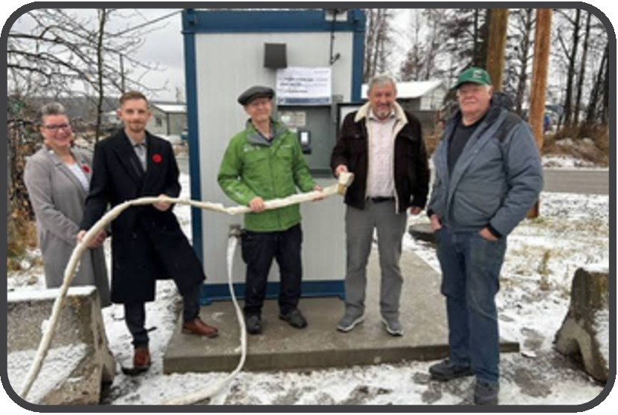
ASTRUCTURE
Public Water Fill Station

    - Installed an automated, metered public
water fill station in partnership with the Regional District of Bulkley-Nechako. The facility gives rural residents dependable access to treated drinking water without relying on municipal staff availability, improving regional water security while creating a more efficient and accountable service.

Water-System Reliability and Planning

    - Completed a system-wide assessment and testing of municipal water valves, including work at the Government Street and Gilgan Street intersection, to identify maintenance and replacement priorities. Reliable isolation valves reduce service interruptions during repairs and support water-system operation and fire-flow performance.

    - Secured funding and initiated the engineering work required to develop a comprehensive Water Master Plan. The plan will assess system capacity, condition, and future servicing requirements, providing the technical basis for prioritizing upgrades and supporting future housing and community growth.

Pioneer Main Lift Station Replacement Planning

    - Completed the feasibility and preliminary engineering work needed to prepare for replacement of the aging Pioneer Main Lift Station, including geotechnical investigation, site and land-acquisition work, repairs to the existing station, and development of an engineered project
design.


2025 Completion Highlights


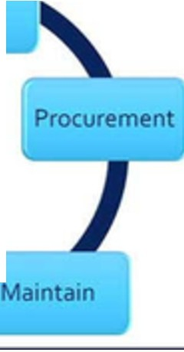
ASTRUCTURE
Planning

Asset Management - Phase 2

Began the second phase of the Village's Asset Management Program in September 2025, focusing on a risk framework and levels-of-service framework. This work will help reliably determine infrastructure condition, service expectations, lifecycle risks, and long-term costs so that capital decisions can be prioritized transparently and incorporated into future budgets.

Garbage Truck Procurement


Completed the procurement process and placed an order for a new garbage collection truck to replace aging equipment. Planning the replacement through the dedicated equipment reserve and user-fee-supported service protects reliable curbside collection while reducing the risk of escalating maintenance costs and unplanned service interruptions.

Road, Parking, and Drainage Improvements

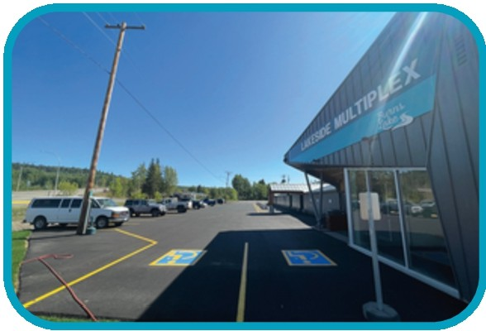
Improved drainage, regraded, and repaved the Lakeside Multiplex and arena parking area, and completed sidewalk and paving work near the Government Street and Gilgan Street intersection. These projects corrected deteriorated surfaces and drainage concerns, improved access to community facilities, and extended the service life of public assets.


2025 Strategic

Priorities

INFRASTRUCTURE

Highlights of the Upcoming 2026 Projects and Initiatives

2026 Focus

In 2026, Council will build on the engineering, procurement, and construction work completed in 2025 by finishing major wastewater improvements, advancing replacement of the Pioneer Main Lift Station, completing infrastructure-planning tools, and continuing targeted renewal of roads, utilities, and equipment. Projects will proceed through the approved financial plan and available external funding, with an emphasis on reliability, lifecycle value, and coordinated construction.


2025 Strategic

Priorities

ASTRUCTURE
Highlights of the Upcoming 2026 Projects and Initiatives

Complete the Wastewater Treatment Upgrade

- Complete the remaining wastewater-treatment work, including construction of the ultraviolet-treatment facility, lagoon-cell improvements, removal of remaining sludge from the site, fencing, and final cleanup. Completing the multi-year project will strengthen treatment performance, protect public health and the environment, and improve the long-term reliability of a critical regional service.

Pioneer Main Lift Station Replacement

- Advance final design, land acquisition, approvals, and construction of the replacement Pioneer Main Lift Station, subject to the confirmed project scope and available funding. Replacing the aging station will reduce the risk of failure, improve operational reliability, and protect the wastewater service relied upon by the Village and neighbouring First Nations communities.

Water Master Plan and Priority Water Upgrades

- Complete the Water Master Plan and use its findings to identify capacity constraints, condition risks, and priority improvements within the water system. Integrating the plan with asset management and capital budgeting will help Council direct limited resources to the projects that provide the greatest service, public-health, fire-protection, and growth benefits.

- Continue replacing or repairing priority water valves and other water infrastructure identified through the 2025 testing program. This work will improve the Village's ability to isolate sections of the system during repairs and reduce the number of properties affected by future service interruptions.

2025 Strategic

Priorities

ASTRUCTURE
Highlights of the Upcoming 2026 Projects and Initiatives

Asset Management Implementation

- Complete Phase 2 of the Asset Management Program and begin incorporating the risk and levels-of-service frameworks into budget and capital-planning decisions. Staff training and integration with the Five-Year Financial Plan will support consistent, evidence-based decisions about maintaining, renewing, and replacing municipal assets.

Roads and Active Transportation

- Continue road rehabilitation and active-transportation improvements on a priority basis, coordinating surface work with underground utility needs wherever practical. This approach improves safety and accessibility, extends asset life, and avoids the cost and disruption of repeatedly excavating the same corridor.

- Implement crosswalk safety enhancements at priority locations throughout the community.

Garbage Truck Delivery

- Receive and place the new garbage collection truck into service following the procurement completed in 2025. The replacement will improve the reliability of curbside collection and reduce dependence on increasingly costly repairs to aging equipment.


2025 Strategic

Priorities

SOCIAL RESPONSIBILITY

The Village will exercise social responsibility by supporting housing inventory for the community's diverse population, and recreational opportunities that improve quality of life.

2025 INITIATIVES AND PROJECTS

2025 Focus

During 2025, Council invested in the conditions that help people live well in Burns Lake: diverse housing opportunities, accessible recreation, community safety, and stronger relationships among local governments and First Nations. The Village combined direct service delivery with partnership-based planning so that programs and facilities could respond to residents of different ages, abilities, household circumstances, and cultural backgrounds.

Page 29 of 107
Bu�
VILLAGE OF BURNS LAKE I ANNUAL REPORT 2025 Carve your path
�s�


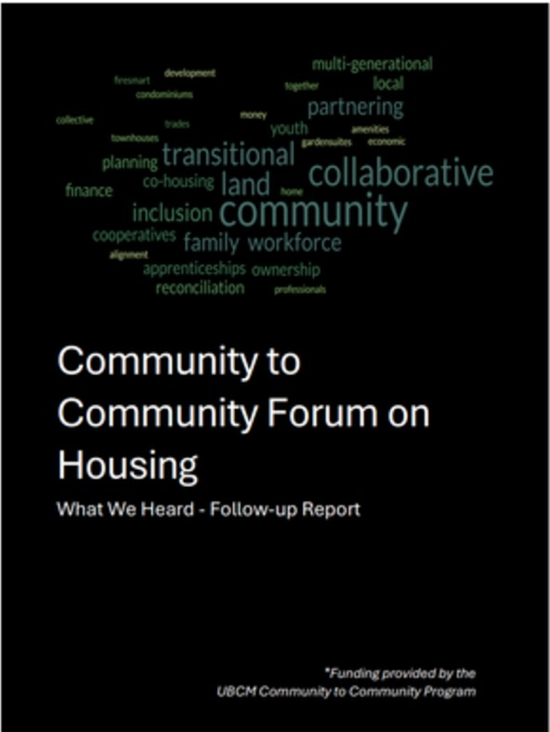
2025 Completion Highlights

SOCIAL SPONSIBlLITY
Community-to-Community Housing Forum

- Hosted a Community-to-Community Housing Forum with Ts'il Kaz Koh and Lake Babine Nation to identify shared housing needs, development barriers, and opportunities for regional collaboration. The resulting What We Heard Report identified workforce, seniors', accessible, affordable, culturally appropriate, and climate-resilient housing as common priorities.

- The forum recommended coordinated planning, joint funding applications, identification of serviceable land, and continued intergovernmental collaboration. Establishing this shared evidence base strengthened relationships and created a practical foundation for pursuing housing solutions that serve the region's diverse population.

Burns Lake Housing Enhancement Society

  - Advanced the preliminary work required for a proposed grant funded multi-unit housing development through the Burns Lake Housing Enhancement Society, including site and servicing analysis, concept development, accessibility considerations, cost and operating work, and preparation of a provincial funding application. Although the provincial funding stream was discontinued before the application was decided, the completed pre-development work remains valuable and can be adapted to future housing opportunities.



2025 Completion Highlights


SOCIAL SPONSIBlLITY


Recreation Programs and Participation

  - Delivered recreation programs for children, youth, adults, and families through municipal staff, contracted instructors, and community-sport partnerships.
THANK YOU!!!
toallof ou,partnerswhohelpedmakeour
2025 Summer Camps a hug, sucttss!
We covldnl haw: done it without yoor supi,ort!
Program Partners
,1-trt
CH
LAKtS OtSTAICT
ENGER Suck Creek Hatchery & Nature Centre

  - The summer day camp filled 709 participant-days, a new program record.

  - Learn-to-skate, Pro-D camps, fitness, dance, yoga, martial arts, and other contractor-led recreation programs recorded 438 registrations and 1,121 drop-in participations across 107 classes and program sets, for a combined total of 1,559 program participations.

  - Recorded 4,527 hours of facility use, an increase of 27% over the previous year, including substantial growth in arena, squash-court, curling-rink, and climbing-wall bookings. Increased use demonstrates the importance of accessible municipal facilities and programming to community health, social connection, and quality of life.


2025 Completion Highlights
SOCIAL SPONSIBlLITY
Recreation Facility and Equipment Improvements
- Completed targeted improvements at recreation facilities, including arena parking-lot
paving and drainage, a curling-rink heat pump, replacement curling exits, refreshed
fitness equipment, dance mirrors, and basketball nets. These projects addressed safety, condition, energy use, and program needs while extending the usefulness of existing community assets.

  - Added a 15-passenger recreation van to improve the department's ability to transport participants, equipment, and program supplies. The vehicle expands options for off-site and outdoor programming and helps reduce transportation barriers to participation.

Rod Reid Trail Improvements

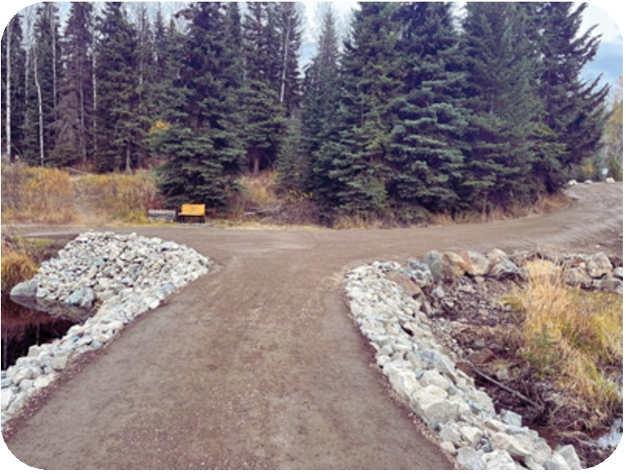
    - Completed improvements to the Rod Reid Trail using external funding, including trail-surface and drainage work, updated signage, and trail markers. The upgrades made the trail easier to navigate and more
comfortable to use, preserving a well-used outdoor space that supports walking, recreation, and connection with the natural environment.

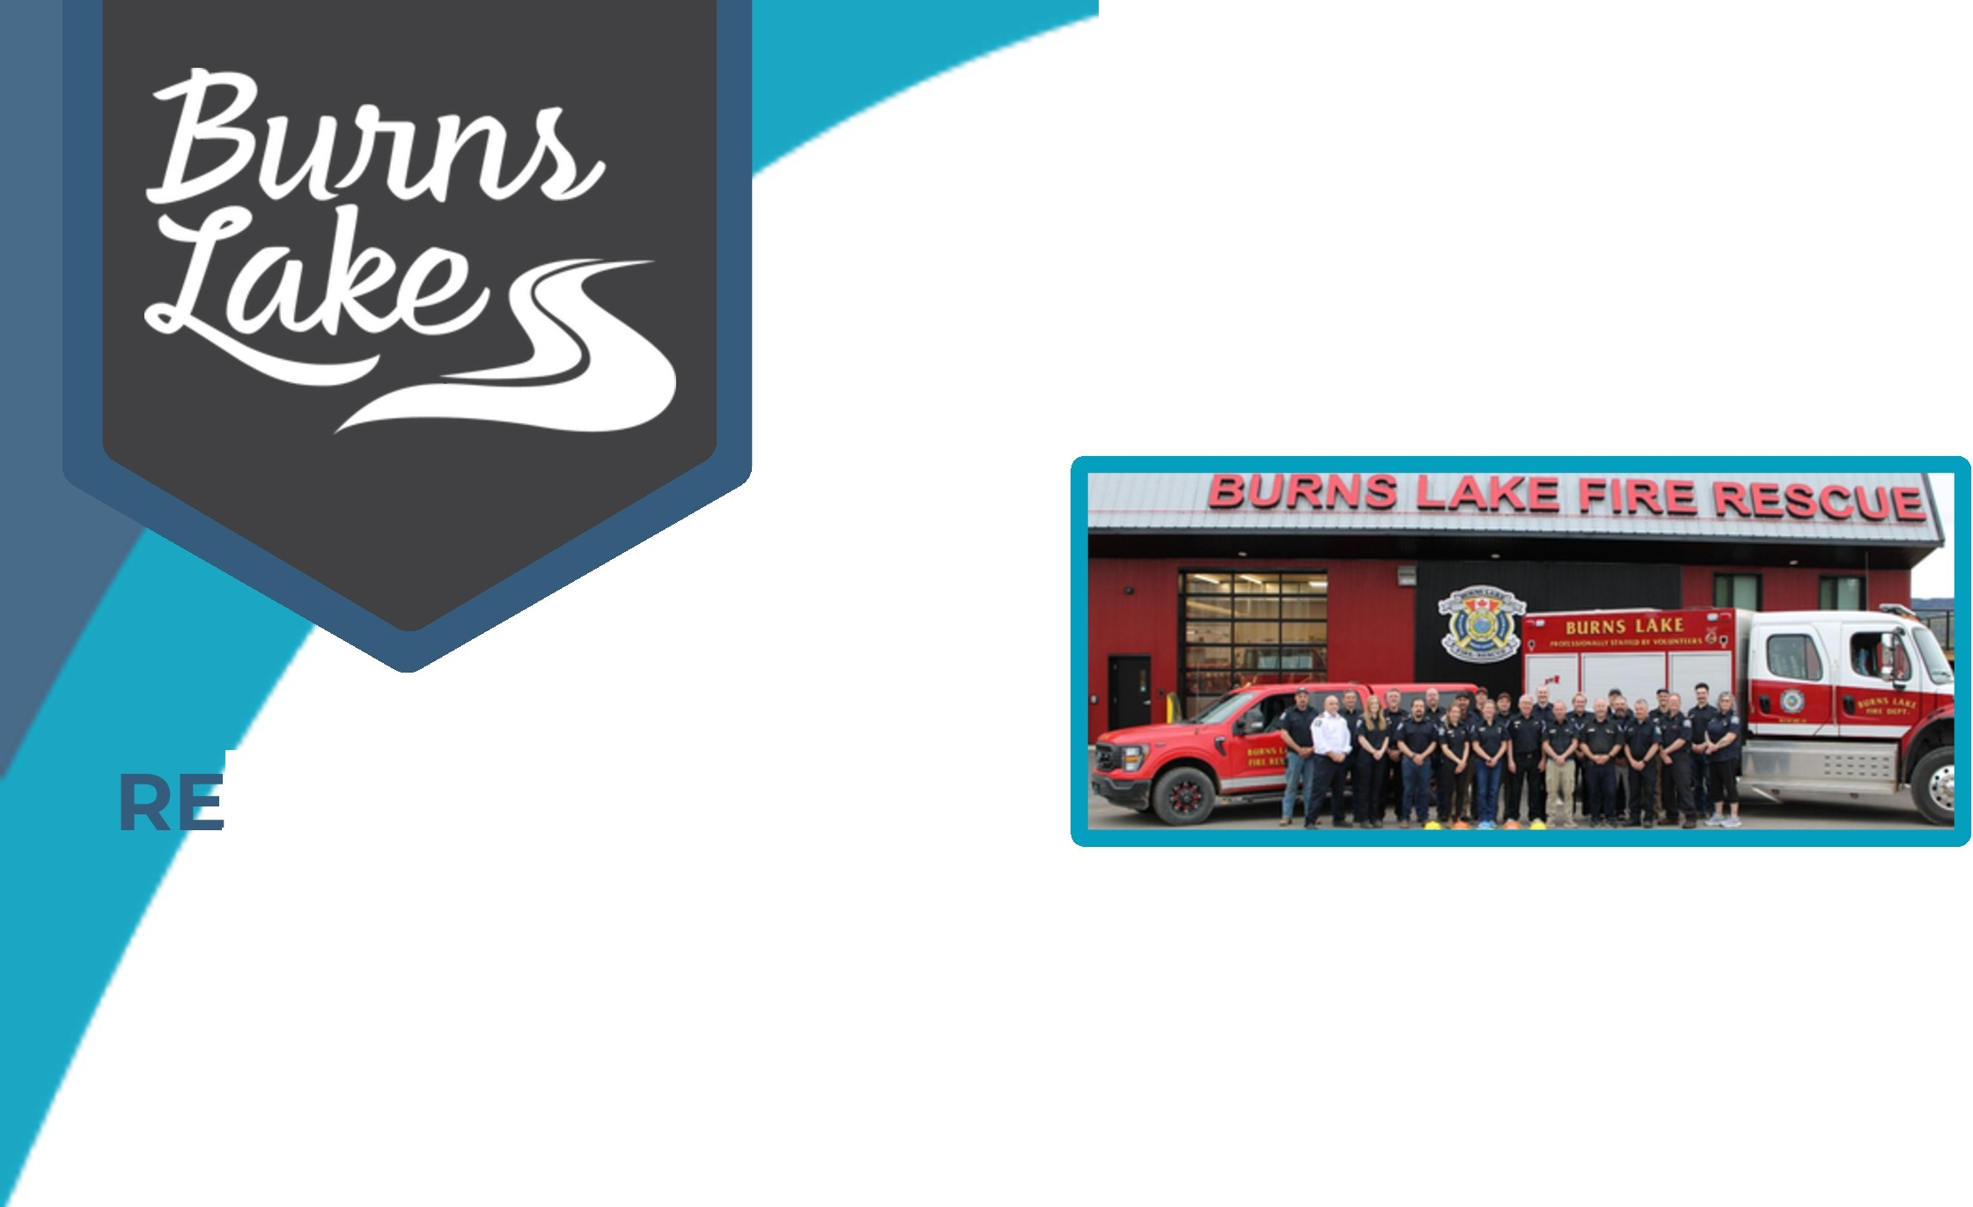
2025 Completion Highlights
SOCIAL SPONSIBlLITY
Community Safety and Protective Services
- Maintained a strong volunteer fire department with 25 active members at year-end and six
new recruits beginning orientation and basic training. Members contributed approximately
8,500 hours to emergency response, training, prevention, and public education, sustaining an essential service for the Village and surrounding area.

- Delivered more than 100 regular training sessions and specialized instruction in rapid intervention, vehicle extrication, wildland fire response, forcible entry, and LNG/LPG incidents. Ongoing training improves responder safety and ensures the department is prepared for the varied emergencies that occur in a rural regional-service area.

Bylaw Services and Community Standards

  - Updated or developed five bylaws, responded to 81 bylaw complaints, and continued working with the Regional District of Bulkley-Nechako to prepare for ticket adjudication. Strengthening the enforcement framework supports fair and consistent responses to
animal, parking, property-maintenance, zoning, and other concerns that affect public safety and neighbourhood quality of life. Bu�

Page 33 of 107
VILLAGE OF BURNS LAKE I ANNUAL REPORT 2025 � s�


2025 Completion Highlights

Council Advocacy and Community Support in 2025
SOCIAL SPONSIBlLITY

Council provided letters of support for funding applications submitted by the:
- Lakes District Senior Citizen Housing Association
- Fall Fair Association,
- Omineca Ski Club.
- Lakes District Airport Society's applications for an Airport Master Plan and runway-maintenance equipment
These actions helped local organizations demonstrate municipal support and pursue external funding for housing, community events, outdoor recreation, transportation infrastructure, and regional services that contribute to quality of life and economic activity.

Council advocated for affordability, food security, and equitable access to healthcare by:
- Requesting continued and expanded investment in the BC Farmers' Market Nutrition Coupon Program
- Raising concerns about the effect of proposed Pacific Northern Gas rate increases on residents
- Address emergency-department closures and healthcare access in the Lakes District
- Supported the establishment of a Northern British Columbia blood and plasma donor centre in Prince George.
These actions ensured that the needs of rural and northern residents were communicated to the provincial government, Northern Health, and regional local-government partners.

- Council advocated against Bill M216, the proposed Professional Reliance Act, because of concerns about reduced municipal oversight of technical submissions, increased municipal liability, and potential impacts on community-specific planning, public safety, and responsible development decisions.


2025 Completion Highlights

SOCIAL SPONSIBlLITY
Provincial Advocacy at UBCM
Council Advocacy and Community Support

- Council met with provincial ministers at the 2025 UBCM Convention to advocate for infrastructure funding that enables housing development, resolution of the Highway 16 access constraints, and forestry policies that prioritize local processing, community participation in forest stewardship, and long-term economic stability in resource-dependent communities. These meetings provided Council with an opportunity to present Burns Lake's priorities directly to provincial decision-makers and seek action on issues that cannot be resolved by the municipality alone.


2025 Strategic

Priorities

SOCIAL RESPONSIBILITY

Highlights of the Upcoming 2026 Projects and Initiatives

2026 Focus

In 2026, Council will use the information gathered through housing, recreation, and facility-planning work to identify practical next steps. Priorities include regional housing collaboration, responsible planning for aging recreation infrastructure, targeted improvements to parks and facilities, accessibility, and continued delivery of programs and protective services that support an inclusive and connected community.

SOCIAL SPONSIBlLITY

2025 Strategic


Priorities
Highlights of the Upcoming 2026 Projects and Initiatives

Recreation Facilities Feasibility Study

  - Undertake a comprehensive feasibility study of Village recreation facilities using Resource Benefits Alliance funding. The study will assess facility condition, accessibility, lifecycle needs, program capacity, community priorities, and options for refurbishment or replacement, giving Council the evidence needed to establish a responsible long-term investment plan.

Follow-up Community-to-Community Housing Forum

  - Host a follow-up Community-to-Community Housing Forum with Ts'il Kaz Koh and Lake Babine Nation using grant funding secured in 2025. The gathering will build on the priorities identified through the 2025 forum, support cultural learning, and advance collaborative approaches to housing planning, project development, and future funding opportunities.

Regional Housing Funding Opportunities

  - Work with neighbouring communities and housing organizations to explore a coordinated regional application to suitable federal housing programs. Bringing together the pre-development work completed for several smaller projects may create a stronger regional case, improve project scale, and preserve work that could not proceed when provincial funding was discontinued.

SOCIAL SPONSIBlLITY

2025 Strategic

Priorities
Highlights of the Upcoming 2026 Projects and Initiatives

Parks, Trails, and Recreation Improvements

  - Continue practical improvements identified through the Recreation and Parks Master Plan and facility assessments, including the next phase of Rod Reid Trail upgrades, skate-park repairs, volleyball-court sand, Spirit Square lighting, curling-rink storage-roof work, overflow parking, and boat-launch improvements, subject to final budgets and any required external funding. These projects will improve safety, accessibility, program capacity, and the quality of community recreation spaces.

Accessible and Inclusive Services

  - Continue participating in regional accessibility planning and incorporate accessibility improvements into municipal projects wherever practical. Applying an accessibility lens to existing facilities, new construction, communications, and service delivery helps remove barriers and supports fuller participation in community life.


2025 Strategic

Priorities
ENVIRONMENT

The Village will provide responsible environmental stewardship and mitigate wildfire risk

2025 INITIATIVES AND PROJECTS

2025 Focus

During 2025, Council strengthened the Village's ability to prepare for emergencies, reduce wildfire risk, conserve resources, and improve the environmental performance of municipal operations. The year's work combined long-range risk planning with practical investments in emergency response, water conservation, energy efficiency, and resilient infrastructure.

2025 Completion Highlights


NMENT
Community Wildfire Resiliency Plan

  - Engaged Forsite Consulting and completed an updated Community Wildfire Resiliency Plan with input from local subject-matter experts. The plan evaluates local wildfire risk and identifies prioritized actions related to FireSmart practices, vegetation management, emergency planning, interagency cooperation, critical infrastructure, and public education.

  - The completed plan identified 39 high- or very-high-priority actions, with 11 already underway or being addressed by staff. Establishing a current, evidence-based implementation framework positions the Village to direct resources to the highest risks and pursue available funding for future mitigation work.

Structure Protection Unit

  - Added a dedicated Structure Protection Unit trailer and equipment to strengthen local response capacity during interface-wildfire events. The mobile unit allows equipment to be deployed where it is needed to help protect buildings and critical assets, improving preparedness as wildfire conditions become more frequent and complex.


2025 Completion Highlights

IRONMENT
Emergency Support Services Agreement

  - Approved a new Emergency Support Services Agreement to formalize the arrangements for assisting residents displaced by emergencies. The agreement clarifies responsibilities and strengthens coordination so trained personnel and essential supports can be mobilized effectively when needed, improving the community's capacity to respond to fires, floods, and other emergencies.

Emergency Training and Regional Preparedness

  - Participated in specialized emergency training and a large-scale regional airport exercise involving more than 300 participants. The exercise provided practical experience in multi-agency coordination and complex incident response, strengthening relationships and preparedness that can be applied during emergencies affecting Burns Lake and the wider region.
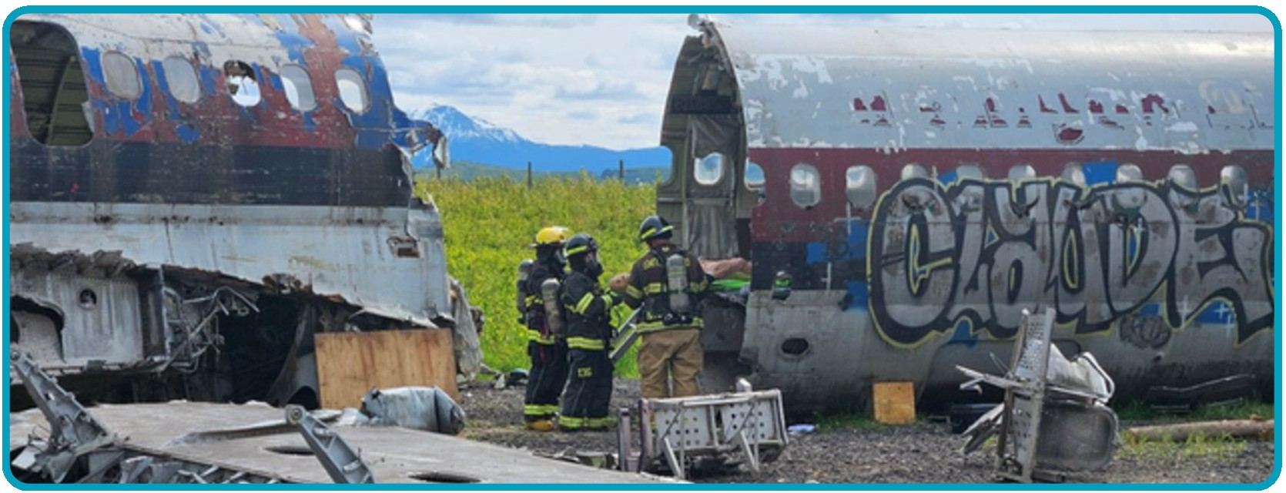


2025 Completion Highlights
IRONMENT
Water Conservation
- Adopted a new Water Conservation Bylaw to establish a clearer framework for managing
water use during seasonal demand, drought, or system constraints. The bylaw supports responsible use of treated water and gives the Village a practical tool to protect system capacity and long-term water security.

Energy-Efficient Recreation Improvements

    - Installed a heat pump at the curling rink and continued planning for larger greenhouse-gas-reduction improvements at the arena and multiplex. Investing in energy-efficient systems reduces operating emissions and utility costs while supporting the long-term sustainability of heavily used community facilities.

Regional Air-Quality Planning

    - Provided financial support to the Bulkley Valley-Lakes District Airshed Management Society for regional air-quality planning. Supporting coordinated monitoring and planning helps the Village participate in evidence-based approaches to protecting public health and environmental quality across the airshed.


2025 Strategic Priorities
ENVIRONMENT

Highlights of the Upcoming 2026 Projects and Initiatives

2026 Focus
In 2026, Council will move from planning toward prioritized implementation of wildfire-resilience, emergency-preparedness, and emissions-reduction initiatives. The Village will also continue investigating climate-related risks to infrastructure and public spaces while using partnerships and external funding to make resilience work achievable for a small community.


Highlights of the Upcoming 2026 Projects and Initiatives

IRONMENT

Community Wildfire Resiliency Plan Implementation

    - Prioritize the Community Wildfire Resiliency Plan's recommendations and develop short-, medium, and long-term implementation options, including costs, staffing needs, partnerships, and grant opportunities. A phased approach will allow Council to address the highest risks first while integrating mitigation work into future budgets and operational plans.

    - Continue participating in regional FireSmart initiatives and evaluate resources for public education, property-level participation, and coordination of fuel-management and vegetation-treatment projects. Community participation is essential because wildfire resilience depends on coordinated action across public and private lands.

Emergency Operations and Regional Coordination

    - Invest in Emergency Operations Centre training and exercises for staff and pursue closer collaboration with the Regional District of Bulkley-Nechako. Building shared procedures, trained personnel, and interoperable communications will improve coordination and decision-making during emergencies that cross jurisdictional boundaries.

    - Implement the new Emergency Support Services Agreement and maintain trained volunteer capacity to assist residents displaced by emergencies. Operationalizing the agreement ensures the governance work completed in 2025 translates into timely, coordinated support when an incident occurs.

Highlights of the Upcoming 2026 Projects and Initiatives

IRONMENT

Arena Greenhouse-Gas Reduction Project

    - Advance the grant-dependent arena greenhouse-gas-reduction project, including heat recovery from the ice plant and replacement of aging heating, ventilation, dehumidification, and air-handling equipment. If funded, the project is expected to substantially reduce facility emissions and operating costs while replacing systems nearing the end of their service life.

Sauls Creek and Eveneshen Trail Resilience

    - Investigate options to address concerns along Sauls Creek and the Eveneshen Trail related to flooding, erosion, wildfire risk, public safety, and active transportation. Coordinating these considerations will help the Village identify solutions that protect infrastructure and natural features while maintaining safe community access.

Waste Reduction and Water Conservation

    - Promote recycling and water conservation and examine the feasibility of improved recycling services, including potential curbside options. Reducing waste and treated-water demand supports environmental stewardship while helping manage the long-term operating demands placed on municipal systems.



The Village has two types of budget expenses: Operating and Capital

OPERATING

The municipal operating budget outlines the annual costs required to deliver day-to-day services to the community, including funding for services such as water, sewer, roads, fire protection, waste management, supplies, general government, tourism, recreation, and employee wages and benefits.

CAPITAL
The Capital Budget funds long-term infrastructure investments and major projects, including one-time investments in equipment to maintain, upgrade, or expand municipal assets.

VILLAGE OF BURNS LAKE I ANNUAL REPORT 2025

Supports Strategic Priorities
- Aligns with Council's goals and priorities to maintain quality of
Funded Primarily by Property Taxes
- The majority of operating revenue comes from property taxes, user fees, and government grants.








life and community infrastructure.

WHERE YOUR TAX DOLLARS GO
Water
12'!6
,...General Government
15'!6
r Protective Service
/ 12'!6
Economic Development
lO"Ai
�
�
Public Works-Transportation 20'!6
Environmental Health
3'!6

Includes Wages and Supplies
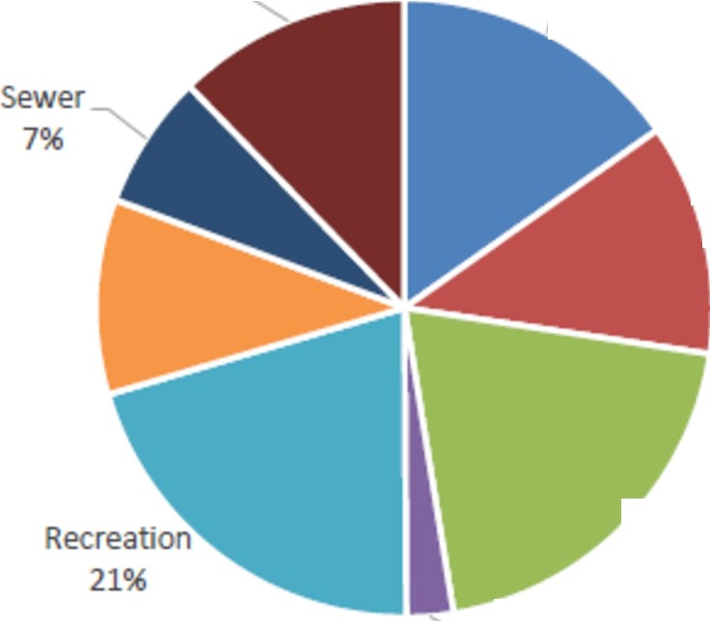
  - Covers staff salaries' supplies, utilities,
insurance, and contractual services
needed to run municipal operations.

Service Delivery Focused
- Ensures consistent delivery of public services that meet community expectations and regulatory requirements.

Page 47 of 107 VILLAGE OF BURNS LAKE I ANNUAL REPORT 2025

Under the Community Charter Council Must
Prepare a five-year financial plan and adopt a Five-Year Financial Plan Bylaw

AND
Review the revenue needs and adopt a Tax Rate Bylaw


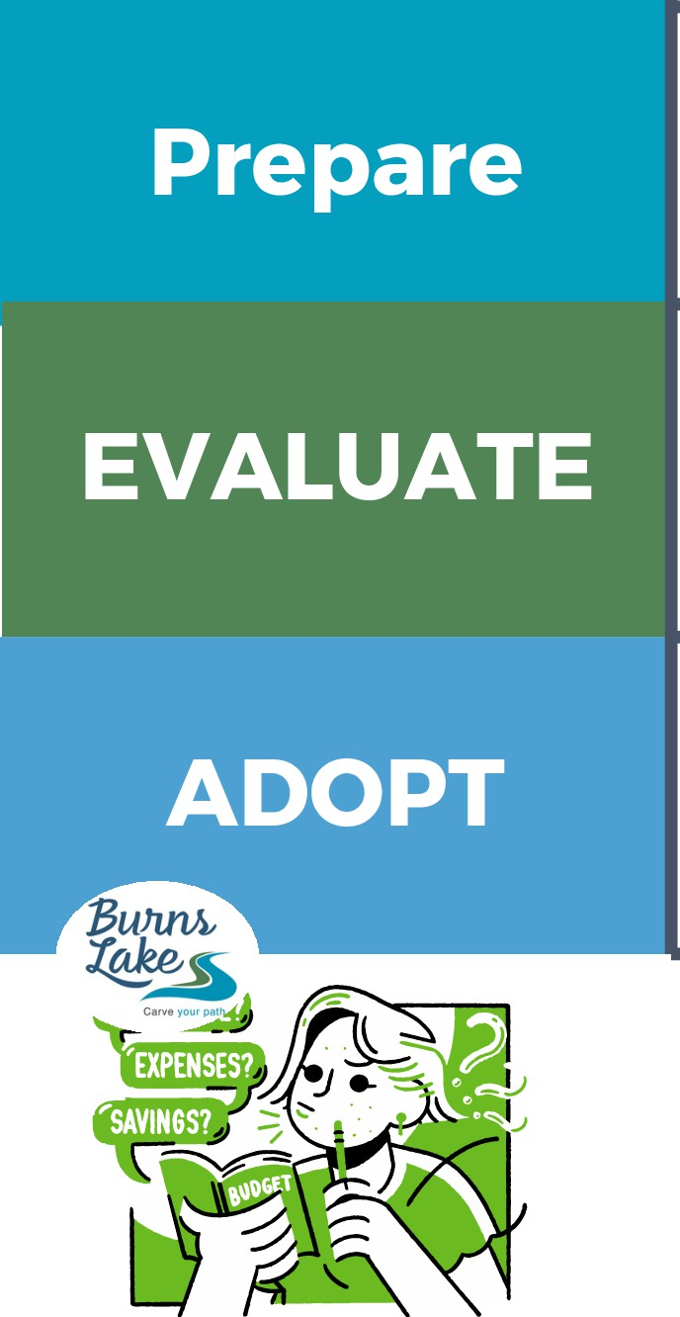

ANNUAL FINANCIAL PLANNING STAGES AND REQUIREMENTS
The five-year requirement prompts municipal Councils to assess the long-term effects of today1s decisions.

  - Departments prepare Operating and Capital budgets
  - Financial Planning staff review budgets with each department once submitted
  - Over several days Council reviews and considers all aspects of the proposed budgets
  - The Village conducts public engagement
  - Council considers public feedback

  - Provisional approval for the Operating & Capital Budget
  - Council adopts the Five-Year Financial Plan and Tax Rates Bylaw prior to May 15

Village staff are involved in the budget year-round
- drafting, presenting, amending, and monitoring it.

Revenue by Funding Source

11%
2025 Capital Projects were funded by grants, reserve funds and partnership contributions

Borrowing Procee
3%

Carve your path

7%
Frontage Tax
1%

Grants and Contribution 66%


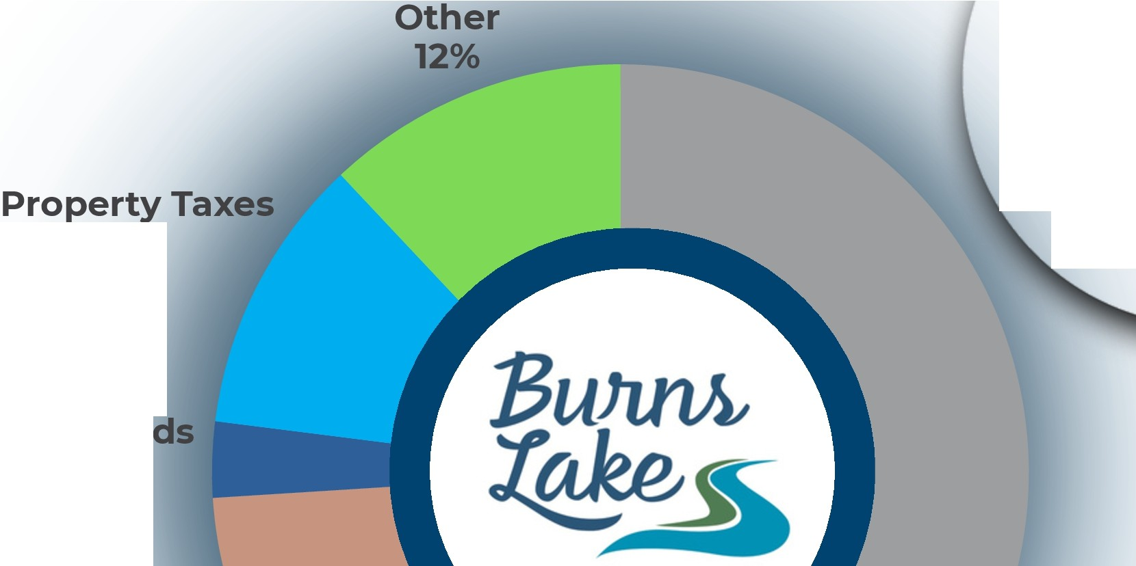



The Village of Burns Lake's
property tax revenue accounts for 11% of all revenue used to support Village services, including wages and daily operations.
The frontage tax is based on a property's measured boundary along utility lines and helps fund services like water, sewer, drainage, and roads.

Taxes are calculated by dividing the assessed value of your property (determined by BC Assessment) by 7,000 and then multiplying that by the current tax rate (set by the Village) for your property class.

2024 PROPERTY TAX NOTICE
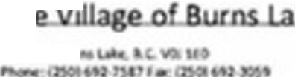
:Bww.,
�Th�

 8C

DUE DATE
July 2 2025
Property Taxes
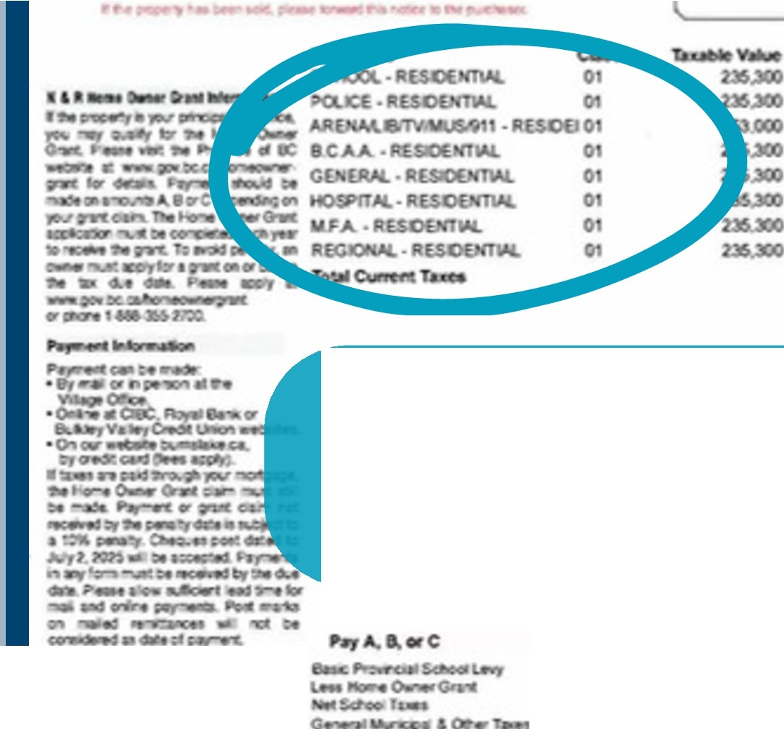
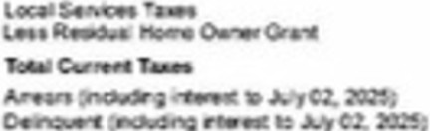
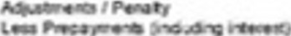
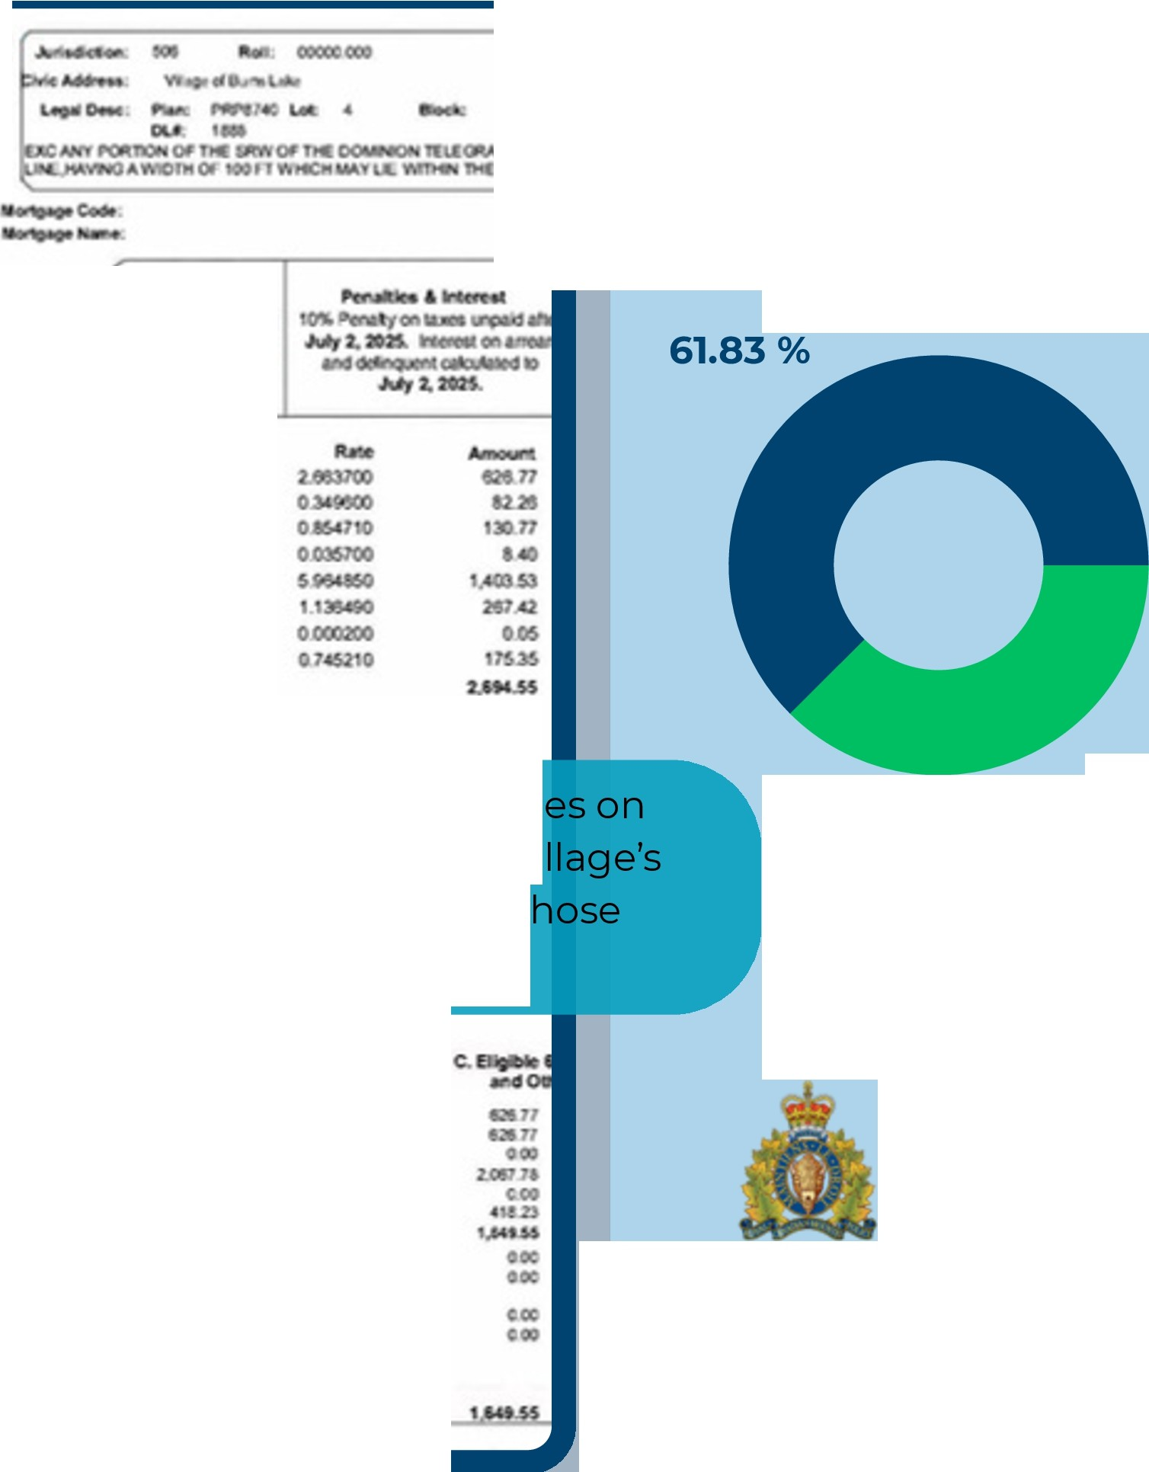
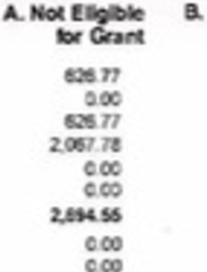



Collected

Municipal Services

Please keep in mind that not all the charg your property tax notices are within the Vi control. The Village is required to collect t taxes on behaIf of the other agencies.
38.17 %
Other Government Bodies

Tl a&Tl too

0
SCHOOL
DISTRICT
9�

ECHAKO
LAKES


CIOO
too
OCIC
�00

BC ASSESSMENT

Stuart-Ntchako

e Residential e Commercial
Other
Industrial


2022

2023

2024
In 2025,

57.96% of

our tax revenue came from residential properties.


2025

0% 10% 20% 30% 40% 50% 60% 70%

In British Columbia, the BC Assessment Authority is responsible for determining the property tax class (also called the assessment class) for each property.

GENERATE NON-TAX REVENUES
Revenue opportunities are limited by the Community Charter, and may require capital
investments.

EXAMPLES

USER FEES
- Unlike taxes, which fund services broadly, user fees are direct payments for services used such as recreation programs, facility rentals, permits
LEVERAGE ASSETS
- Negotiate Revenue-sharing agreements, such as Burns Lake Community Forest
- Use resources and current assets to apply for grants and no-interest loans

The Village uses value as a
CONTROL EXPENDITURES
ECONOMIES OF SCALE ALTERNATIVE PROVIDERS

consideration for expenses as cost alone may result in higher long term costs
  - Controlling expenditures through shared services and efficiencies
  - Partnerships transfer or reduce the financial risk.
  - While certain services can be effectively contracted out, others must remain in-house to ensure service standards are upheld.

ADJUSTED SERVICE LEVELS
What is a reasonable or sustainable level
of service?
What level do you actually need versus the level that you want?


SHARED SERVICES

Key Strategies the Village can use to offset tax increases:
    - Some trail maintenance is a partnership, such as Rod Reid Trail
    - Facility maintenance can
be shared with other local governments
REDUCE SERVICES
- Which services does the Village adjust? Can everyone agree?
- Our residents generally expect the same services as service levels available in neighbouring communities.



Under the Community Charter, the Village Council is responsible for providing services and laws that benefit the community.
This mandate is advanced through the delivery of essential, priority, and support services.


ESSENTIAL SERVICES
Protective Services• Water• Sewer• Garbage• Roads• Cemetery

Services that support the health and safety of the residents and are foundational to daily community life


PRIORITY SERVICES
Parks• Recreation • Library• Bylaw Enforcement• Licensing & Permitting• Arts• Culture• Heritage• Planning• Environment, tourism • Economic Development
Defined by local priorities and values and guided by Council's strategic direction


SUPPORT SERVICES
Administration• Finance• Human Resources• Payroll• Legislative Services• Information Technology• Tax Collection
The internal functions and departments that enable a municipality to deliver all services effectively

A Permissive Tax Exemption is a provision under Section 224 of the Community Charter (BC) that allows municipal councils to exempt certain properties from property taxation. Unlike statutory exemptions (which are automatic under law), permissive exemptions are discretionary and require a municipal bylaw.

Council has granted exemptions from municipal property taxes, as per the Community Charter, for the following purposes:
Organizations that own property for which a permissive exemption has been provided must still:


T
Understanding Permissive
Tax Exemptions
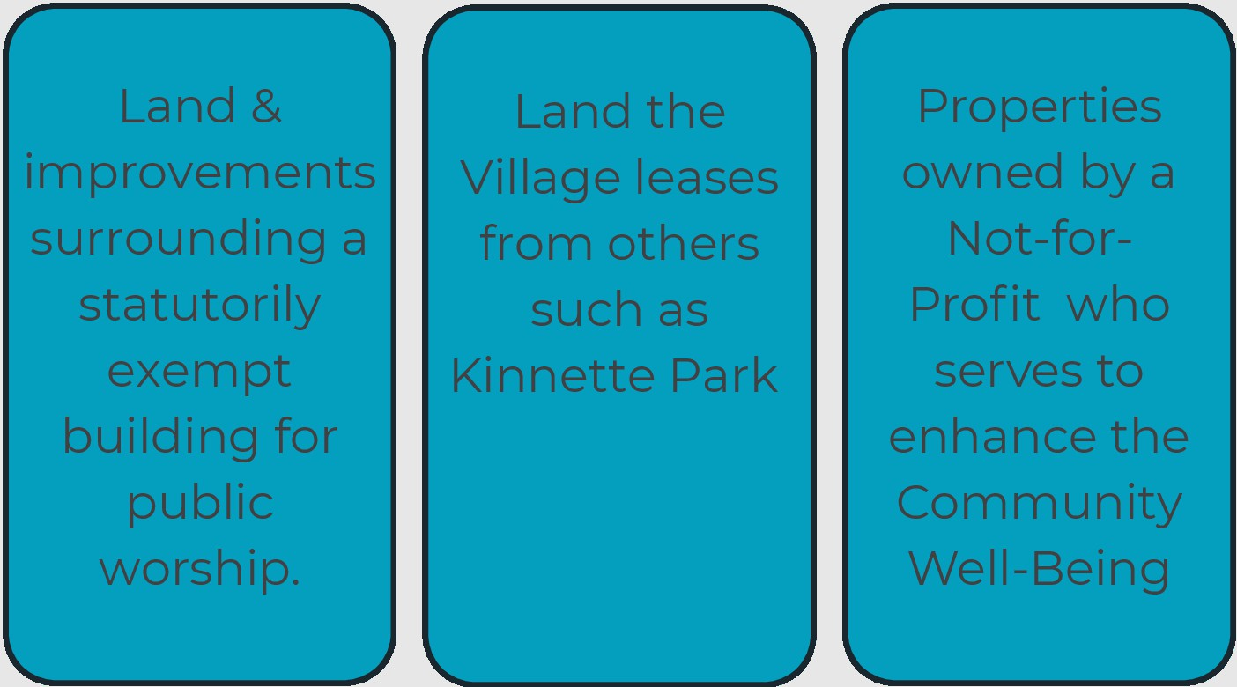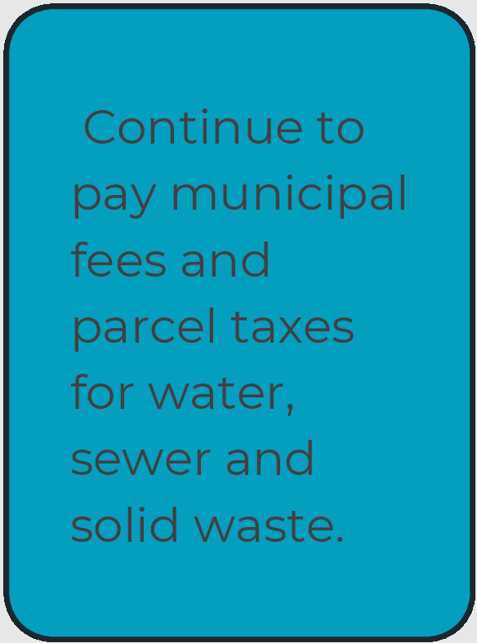



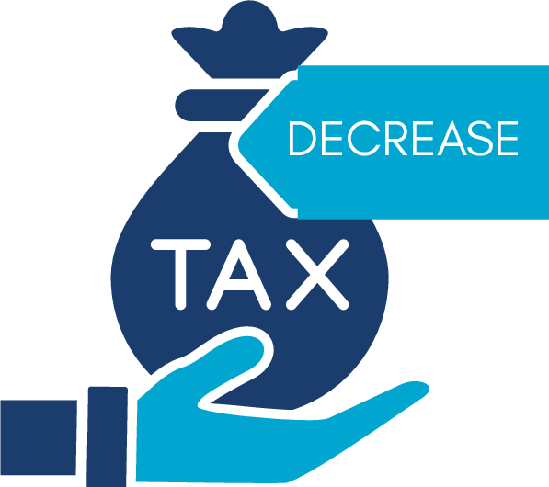
These properties are granted a Permissive Tax Exemption under the Village of Burns Lake's Permissive Tax Exemption Bylaw No. 1026, 2020 or the Permissive Tax Exemption Amendment Bylaw No.1099, 2025


$7,978.87






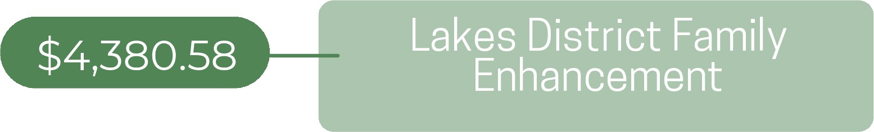
TAX


Carve your path.









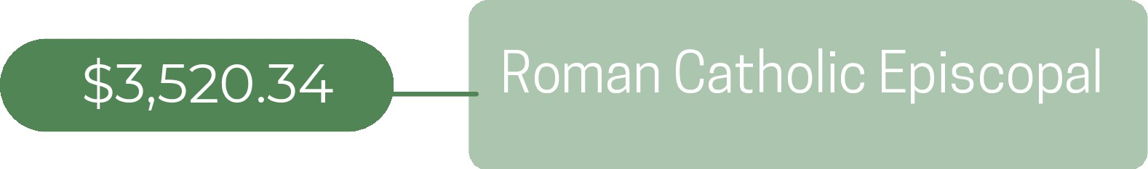




The Statement of Financial Information and the Consolidated Financial Statements can be found in the following pages.

Page 57 of 107
VILLAGE OF BURNS LAKE I ANNUAL REPORT 2025

THE CORPORATION OF THE VILLAGE OF BURNS LAKE - 2024 STATEMENT OF FINANCIAL INFORMATION

The Corporation of the


 I g o

2025 Statement of Financial Information



The Corporation of the Village of Burns Lake
2025 Statement of Financial Information
Table of Contents
Pag

Management Report

General: Section One - se App ndix 1-Audited inancial tements
Statement of Assets & Liabilities: Section Two - e Appendix -Audited Finan ial tatemen Operational Statement: Section Three- App ndix -Audited inancial tat ment Statement of Debts: Section Four- ee Appendix -Audited inancial tatement
Schedule of Guarantee and Indemnity Agreements: Section Five

Schedule of Remuneration and Expenses: Section Six
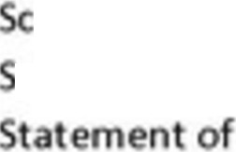
hedule of Council Remuneration and xpen es 3
chedule of mployee Remuneration and xp nses 3
verance reements
Schedule of Suppliers of Goods and Services: Section Seven

list of Suppliers receiving paym nts  tat ment of p yments of gr nts and contrib | tions | 5-6
In ctive Corporation : Section Eight- not applfcabl
Approv I of Fin nclal Information: Section Nine |  | 7
Acee to the Fin ncl I Inform tion: Section Ten |  | 8
APPENDIX l • Audited Fin ndal S temen |  | 9.44
APPENDIX 2-SOFI Checkli t |  | 4 -49

The Corporation of the Village of Burns lake

MANAGEMENT REPORT

T Fi ncial Stat m nts con ai In t is Stat m nt of i ncial Inform tio u d r Flnanciol Information Act have been prepared by management in accordance with generally accepted accounting princip s 0t s a d accoun ing pri cipl s, a d t in grit and obj tivi y of t stat mtn s ar management's responsibility.
nage nt is also responsible for all o her sc edules o inancial in ormation and f0t ensuring that this forma ·o is COl"lsist nt, w r approp iat , with t information contai in th financial sta m nts and for implementing and m in ain·ng as em o in emal con rols to pro ·de reasonable assurance hat
reliable financial information is produced.
and Council a, spoMibl f �Muring ha m nag m nt ful ils its

re�pon.sibili ·es for financial repo ing and in ernal con rol and for ap roving included in he S atemen of ·nancial Information.
finan ·a1 in orma ion

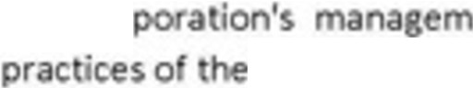
nt s t
T cor
corporafon.
spo ibili y fo ss ssing
man m nt s t ms a

The exter I audi ors, Beswick Hildebrant Lund CPA,conduct an inde nden examination, in accordance Yit g n a ly ccept d auditing standa ds, a d e p ss t i opi 'o on t fin ncial stat m ts as required by the Communi Charter. Theirexamina ion does no rela e totheo her schedules of financial informa ·on required by the Finondol Jnformotion Act.Their examination includes a reYiew and evaluation o corpor tion's syst m of int rnal con ol and prop 'at t t nd p oc dur s to provid reasonable assurance ha the man ·a1 sta ements are presen ed fairly.

On half of e Corpo<ation o Viii g of Bur s La e

(signoru e)


Ti le: Acting Oirec or o Finance Oa e 2026

Pr po, d pu,ruollt to Finorrciol ln/ormot;on R ulotlon, Sch ule l, sec 'or, 9

Schedule of Guarantee and Indemnity Agreements
FIR, S h dul 1, s ction S

Th Villag of Burns Lake h snot giv n ny gu rant s or ind mniti s und th Guaront e and Indemnities Regulation.

.,
Page 61 ot 107 ..,

Elected Officials:
Schedule of Remuneration and Expenses
FIR, S h dul 1,s ct on 6

E cted Off ·•I
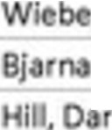
,H y
son, i tv

Rensb• Cha I s
PO$ition
yor C.Ounc:mor Councillor C.Ounc:lllor
R muner tion ($)
35,169.73
14, 1 .60 n,979.60 13,954.60
bP4tnses 4$)
8,187.98
7,733.
1,
6,20S.l

White, evi C.Ounc:lllor
Tot.a I CoWKil Remun nvon •nd Ex.pens-es

----1----
13,719.60
90,238.13
3. 4 .67
26,46-Z.29

Other Employees:

EmployH
bl off, Brad y

th
Position
Truck D ·ve
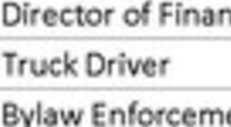
ce

0 fieer
Remuner ion($) bpens s ($)
n.013.59
111,13183 7,812.47 n,611.11
83,467.65 1,696.03

Cur
rms,Chr'
Deputy Corporate Officer Recrea n Fadll F01eman
ork·ng Fore / Utl lty orke vel II
82,1 0.66 6,673.30
89,901.33 239.96
170, 74.28 1,879.72

leber Rlcha d Jones, Le s
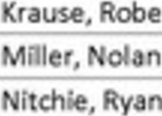
Eq pment Fore Dfrector Rec eatlon
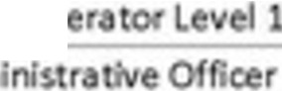
Dfrector P otec e Services Eq ipm t Op
Chief Ad
125,363.07
101.3 3.61
117,250.00
82, 56.
97,Sll.9S
675. 8
4,3 7.65
2,093.25
134.82
1 ,679.91

Per , Eogharn |  |  | Truck Orr |  |  |  |  | 76, 27.26
Ross. Dale |  |  | Dfrector | Pub le |  | orks |  | 11 0.01 |  | 2,797. 6
Wonhfng. Sheryl |  |  | Chle Adm | n stra |  | e Of | cer | 183,782.99 |  | 1,029.00
Remuneretlon over$7S,OOO and expens s |  |  |  |  |  |  |  |  | 1,586,921.98 | 44,059.05
Remunera on under S75,000 and e penses |  |  |  |  |  |  |  |  | 810, 6. 3 | 25,886.35
Tot.al Employ Romunoration and Exponsos |  |  |  |  |  |  |  |  | 2,397,76&.4 | 69,945.40

Tot I Cou an Empl R m
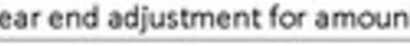
y

ra ion
Goods a rvi r FS ot 12
Amount($� 2, 88,006..S
(224,365.21)

Yea en adj stments to ac:aued ages and bene Employer costs; medlcal, den a, lnsu ance and o Employer's po Ion toCPP, El, and Pension
ts able r bene ts
28, 45.2
159,766.29
317S75.1

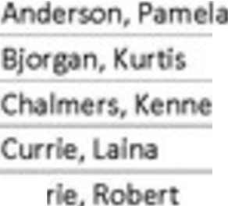
Tot.al W•r s, employ • �n fits nd Council tip nds p r FS ote 12 2,769,128.00

Page 62 of 107

Page 63 of 107
Page 4

Statement of Severance Agreements
IR, hedul , tion 6(7)

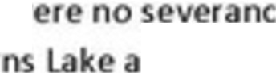
Th w of Bur
gr em nts und r wh ch p ym nt comm n db t nth Villag nd its non-unloniz d mploy dur ng th fis I ye r 2025.

Suppr ,
0800230 BC LTD
1205192 BC LTD BCHVORO
Schedule of Suppliers of Goods and Services
FIR, S h dul 1, s ct on 7

Amount1$t
61,062.13
79,22 02
288, 01.3

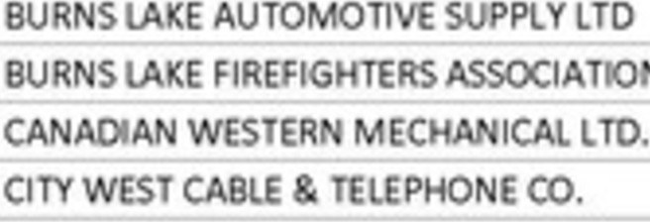
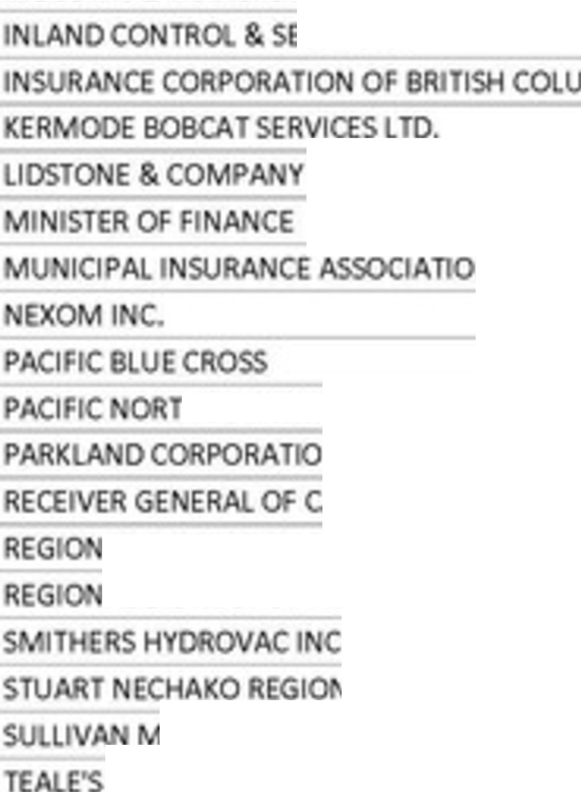
BE I H LOE8RANOT LUNOCPA BREE CONTRACT! G LTD.
8 TISH COLUMBIA PE SION CORPO TI

CIVIC I.EGAL L P
CIVIL ORTH C SULTING LTD. CUTSFORTH TER
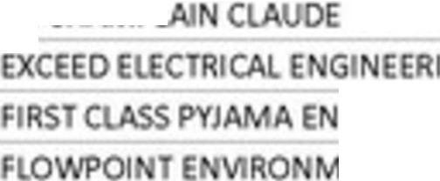
OE L.l>M.IVIP"I
Gl D
T RTAI M TCORP.
E SY$TE P ORSITE CO SU T TS LTD.
FU K DELORES
GDS GOLF DESIGN SER CES
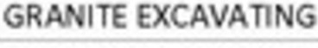
I RIAL TR SFOR ERS INC.
RVIC S

BARRISTERS SOl.lCITO S

HER GAS LTD

ADA
AL DISTRICT OF BULKLEY NE AKO AL DIS RICT OF FRASER F . GE G
HOSPITAL ors RICT
OTOR PRODUCTS LTO. TER um, SER ICES TD.
29 0.00
1.332,724.65
335,885.87
5,790. 2
9,373.50
530 21.30
1,612,796.21
5,651.5
396,17 .12
35,887.36
33,614.29
71 9.2
396 S4.22
57,031.37
38,639.63
3,590.76
28,140.00
910,030.69
91,672.32
07,767.80
'· 23.00
2,027.93
37, 0.51
55,154.38
92,736.00
28,112.00
82 7.21
11 35.65
90,49 .01
722,789.61
568,766.72
32,752 38
69,937.67
3 6,601.63
80, 6.71
3 , 06.89

TECH ORTH SOLU ONS C
TERUS STRUCTION L D. OBA LB PAVI G
3S,020.96
1,015,749.75

THURBER E GI EERI G l
o.
7,119.97

TRUE CO SULTING G OUP UPANUP S U01OS LTO.
W S ER I OUS I CONT AC I GI C. -
WIWAMS ACHI ER
DA OREA
7,333.33
38,797.SO
303,597.02
16,9 4.01
30, 70.2S

WORKERS' C PE TIO
BO D
S2, 1.03

SUPPUER PAYMENTS EXCUDI G $25,000
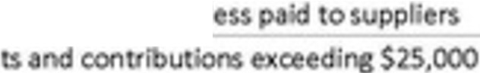
Consoli t d to I of Consoli t d to I of II ti n
of S2S,OOO or I

-------1----
11,352,767.90
1,277,4S3.88

TOTAL GOODS & SERVICE PAYMENTS, GRANTS AND CONTRIBUTIONS

An dlffe enees
12,630,226.71

followlng. Fl st,

is schedule is prepared on a cash basis of accoun ing versus accrual basis used o prepare t e
fin nel s e ts.�so. p vm n s d toot r Ina uthoti ies fo t colleetio o eir t a ion
are included in the list of suppliers although hese amounts are no a Village expense, such as OCAA,
FA, S RHO. ex , t sc dule includes he full GST paid to the supprers, while he inancl n t of GST rebat . in lly, non• p ns ela i ms, sue s som oft investments under aken and principal repa ments on debt also appear on e supplier list.

VILLAGE OF BURNS LAKE
STATEMENT OF FINANCIAL INFORMATION APPROVAL
Th und rsign d, as authoriz <f by th Fin nci I Inform tion R gul tion, h dule 1, subse tion 9(2), approv s II th st t m nt nd schedul s included in this Station of Financial Inform tion, produ ed under the Financial Information Act.
(signotur }
{signotur }
NAM:
O,arles Hamilton
Po ition of Financial Officer/Administrator
NAM: Ma or Henr Wiebe_
Cou ii Memb r on b half of Council
OATE:
DATE:

Approval of Financial Information
FIR, Sch dul 1, s ct on 9

Access to the Financial Information

 Accommod tlon
R son bl accommocJ tlon must b p ovlcJ d to any indlvidu I ho m k s r qu st to x min th SOFI. Corporations must k p opies of the financl I inform tion for thr y ars following th fis I y<! r r pon d on. Corpo tions a also uthoriz d to provid pubr ss to th SOFls by posting th m on n pproprlat int met w bsit or by oth rel troni m ns.
M mb rs of th pubIi re not r quir d to pay th f if th y r willing to vi th<! SOFI on th p mis s of the corpor tion. If th individual r qu sts copies by man, corpo tions should m ii SOFls on p yment of th f .

S v ring lnfonn tron
FIR, Schedule 1, subsec ionl0 3}

Und r th-s se tjon, the corporation m y supply only the p rt of the O I th t the member of the publi desir s, if th t p rson is satisfi d ith this. The ch rg for a part of the SOFI is determin d, in p rt, by th dupli tion f at din h Freedom of Inform tion and Prote tion of Privacy R gvlation (exc rpt intluded b�ow). Th fee canno exc ed $ , hich i th curr nt f e under the IR.
or in tance, a common r qu ti for th remun ration and expense of a parti ular p r on. A photocopied page is le exp n ive for the member of the public. Corporation may be able to anticipat which p rts ill b in demand and duplicat them ahead of tim . xcerpt should be accompani d by th approval pag from he O I

APPENDIX 1

Corporation of the Village of Burns Lake
Audited Financial Statements December 31, 2025

Page 69 of 107 q
I I

THE CORPORATION OF THE VILLAGE OF BURNS LAKE
FINANCIAL STATE ENTS
December 31, 2026

Page 70 of 107
12

INDEX TO THE FINANCIAL STATE ENTS

M n gem nt's Report
Ind p ndent Aud O 'R port
Financial S t ments:
- Statem t o F nci I P on
- Sta em t o Ope t ons
- Sta em
- St ement of C a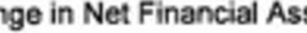
- Sta eme o Cash Flows
- N es to e Fin ciaf Stat m n s
Schedul :
Page
2
3-

6
7
8
9
10
1 -26

- Sched | 1 • Revenues | 27-28
- Sched | 2 - S tement Financial Position - By Fu | 30
- ScMdu | 3 - St teme of Operations - By Fund | 3
- Schedu | 4 - Se nted Oisci e | 32

13
Page 71 of 107



RESPONSIBILITY FOR FINA CIAL REPORTING

Th fin ncl I St t ments o the Corporation of he v,11 ge of Burns lake (th "Viii ,.. have been p ep r d by m nagement In accordanc • h g nerally cc pted accounting standards for local governments estabhsh d by the Public Secto Account ng Board of the Canadian Institute o Charter d Profe sional Accountants.

M nag m nt is responsibl for the pr par tlon and pr nta io of th n ncl I statement , ncluding respon ibility for s· nificant ccountin jud m nts and estJm tes, and the choice of accounting principl sand methods that ar appropriate o th Villag .

The V llagc's m nagement maintains a system of Internal controls designed to provid
e sonabl ssurance th are safegu rd d, transactio are prop rly autho it d and recorded In compllanc th legislative and regulatory r qulrem nts, a d reliable financial informatio s produced.

Mayor nd Council m et Ith m na ment and h e:ict rn I uditors tor vie the financial statements and di cu s ny slgnl c nt r portin or intern I c,0 trol matt rs prior to heir approval of the financl I stat m nts.

The fin ncial a ements h v en audited by Beswick Hildebrandt Lund, Ch rtered
Pro ess onal Accountan , independent aud tors appointed by he Villag . Th accompanying Ind pend nt Audito s Report outlines th Ir responsibili ie , the s of th r amlnat on and their opinion on th Villag 's financ al stat ments.

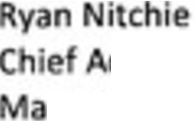
dminis rative Offic r
y 12, 2026


Carve your path.
Page 72 of 107 2
14


beswick hildebrandt lund
AT ED r ON

INDEPENDENT AUDITOR'S REPORT

To th ayor and Co ncil of The Copora n oft Village of Bums La e, Op nlon
We ve audited the ' ts o The Corpora· n of th Vallag of Bums La e ( he "Organiza c tatemen of nancial positton as a O mbef 3 . 2025, d statements of operati gains a d losses, ang n cial assets a d cash
fl for e year the the financi I statemen , i summary of sig• ,cant
accounting porcies (t nt '1-
ln our opinion, e acco nyi fin ncial s t s pres n fairly, in all mat ial r: peels, th financial po o o th Organization as at Oecemb r 31, 2025, a d t e resu of ,ts opera OI\S and ca h
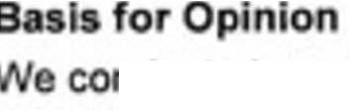
ows for th y th ended·n ccordanoe th t Canadian Public Secto Acco nting S1andard.

nducted • • accord Canad p ed \Jdrti tandard . Our
re s e s and are urther d ua: ors Responsibil,ti for the Audit o al ts secti our report. zation In accordance
wi I r nts that are relevant to in Ca ada, a d
h ur other eth cal r ib'lities in a ir . We ber that
the audit evidence e av ob s suffi• a a for our o• ion.
R pon lbllltJ of Man gement and Thos Charged with Govem nee for the Flnanclal
Statements

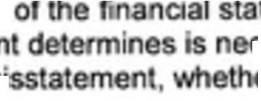
a agemen is respons e for th ation a d fair ion accordance with PSAS, nd for uch mal control eme th preparation of financial st temen at ar fr fr ·aI m error.
teme ts 1n
cessary to enabl du o fraud or

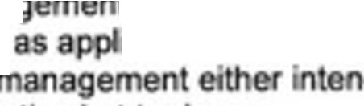
In prepar cial stat me t�. mana
o contin oing con m, disclosing,
goi g oo sis of accounting n ess
t f01 assessing the Organ12at on's abili
i I ed to going concem and u ng the ds to uidate the Or:g aa o or to

cease operations, Of ha no r al tic a emative but to do so.

T ose ch rg process.
go ma ce are responsible or ove see ng h Organization's fina cial e Ing

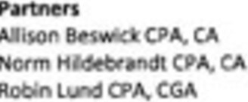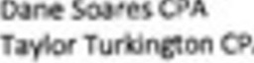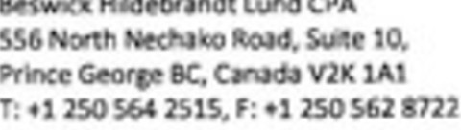

Page 73 of 107 15 3



beswick hildebrandt lund
Auditor's Re ponaiblllt for th Audit of the Financial statemen

0 • • ar
i
a
ma eri I mt
ob in re ssu ce about r the financi s as a whol
I mis ate er du to frau or, and to iss e s epc>rt a Reason high le ranee but is ntee that an
n neralty d audl ays detect a
n• ents can om fr or and are co idered

ma eria•l , i th . could reasonably be e o th economic
decisions of f these na cial statem

As part o n au it in acoorda of ssio al judgme t and m
C

rot
g er ly accept
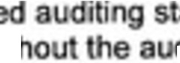
I sk pticism throog
anda ex rclse
di.W .

- Identify and assess e ris te ial mi na • ts, d
fraud or error, perform audit prooedu t;;rvm�Ne t tain au
evid ce th a e to pr r of not d ng a material es ud i h on resulting from error, s 1 ay involve collu , in ions, lion , or th o rrlde of internal control.
- Obtain an unde ng ol r ant a • in ord r to desi n a it prncedur th t ar ap op the oes, but not fo of expressing an opinion o th effective es o gan emal oo I.
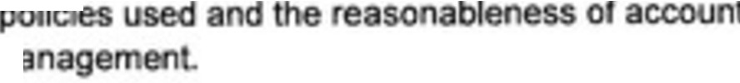
- Evaluate the a t of accoun·ng • • g imat s and related disclosures msde y m

- Conclude
ed on th co ditlon
If we con report to t modify ou audito s r conti u as a
ropriat ess t's use of going conceri of accounting and, ce obta mat rial uncertainty e ·sts to ents or
·gni ca Orga ability to co s a • concem.
rial un we a to dr w at n our ltor's
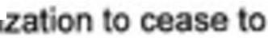
re tat m . such disck> e ina at , to lu based on the aud e n obtai t e o o r tu or cond·ions may cause the Organ·
,

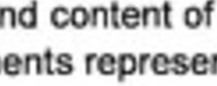
- Ev luat th o • . re
disclosures, a er a t
a man that fair e
e fin ncial $ta m nts, incl ding the
e und tying trans.actions a d 

We comm charged • h ovemance regardi g, among ot
scope nd and ignificant audit m<fngs,·ncludi g any
·ntemal co fy duri g our a di
matters, the planned iflcant deficiencies i

Page 74 of 107
16


beswick hildebrandt lund
C'l ';'DtCD PIIO lSSI ACCOU, n

Chartered Profess onal Acoou ta t

Prince Georg , British Co mb a
May 12, 2026

THE CORPORATION OF THE VILLAGE OF BURNS LAKE
STA T OF FINANCIAL PO mo
r 31, 2025

2025 2024

FINANCIAL ASS

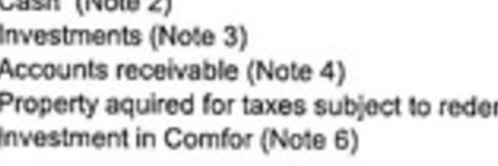
$ 3,785,143 $ ' 8,007
9,510,544 4,995, 6
1,675,635 2,587.990
mp on( 688,449 378 0
13,879:593 ,937, 87

29,519,3 27.457. 0

UASJUTIES

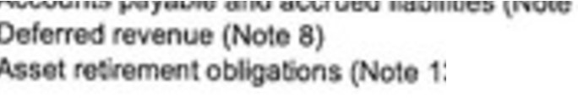
7) 1,810,042 1,675.230
3)
BS.,968 338.293
178,304 1 .
2: 3-,314 2,182.577

ET F'I ANCW. ASSETS 26,876,050 25,274.7 3

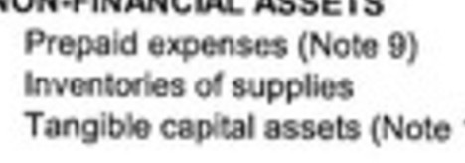
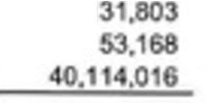
105,722
71,556

10) 43:215:362

43.3921840 ,987

ACCU u TED SURPLUS 70 266 690

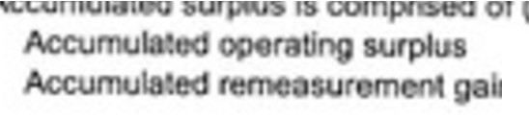
11)·

$ 70,252,277 s 5,536,02A

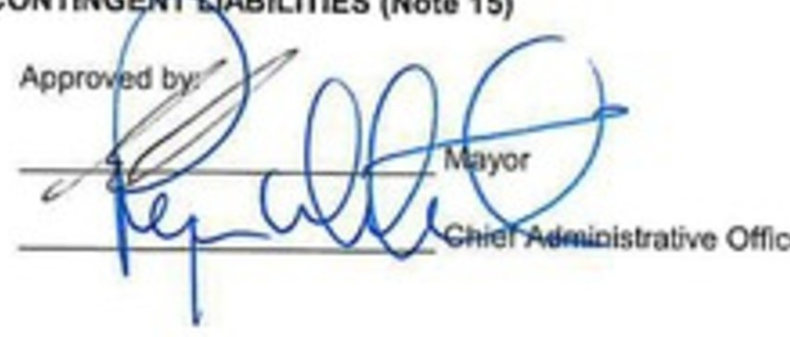
ln11(1os s) 1 413 37,726

$ 70,2881690 $ 65,573,750

cer


T CORPORATIO OF THE STAT
GE OF BURNS UK£

Fer they ded Decem 31, 2025
20Z5 2102"
Min! �
( 18)

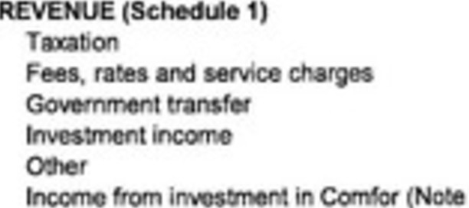
$ 2,591,683 $ 2,673,16.s $ 2,4 ,029
,542,782 1,887.384 1,<467,2&4

14,124,115 887,229 9,213,390
2,&71,398
687.9&5
1
938,7
mo.1se1
2QS,OOO 44 W1 507.�

6)

2 1224197'8
1
,052,1-45
762,028
,25',700
uoo
2,&10.378
92 9$3
1.1162.817
14 375.
.
,505
756.705
.702.508

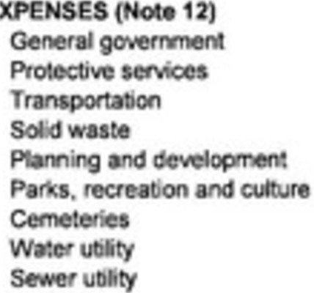
72,388
78,�2
,122,848
95,,898 17,
681,709 2,7 3
1,498,145 1.4 .281

29,537 2 0�3 34,809
841,425 n◄,103 72&.520
455. 4401943 484,825

AN UAL SUR�US

Otherccmptetle


ACCU ACCU UL.AT 0

US • BEGIN G OF YEAR
00 YEAR( at, 11)
6 1806,987 �UOt724
1◄.85, 70
4,575.513
7,◄n.742

40.740 1, 3 ,005
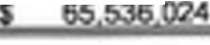
65 536.024 &5,53 ,02A 55₁93g_m

8039 994 70 252 277

THE CORPORATION OF THE VILLAGE OF BURNS UK STATE ENT OF REMEASUREMENT GAi S AHO LOSSES
Oec..nb r 31, 2025

2025 2024

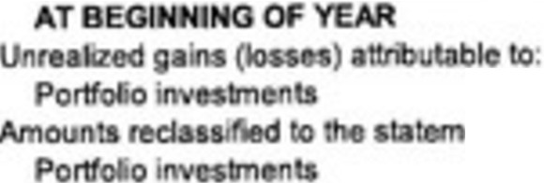
ACCU ULATED R EA.SUR ENT GAINS (LOSSES)

Ofll o

opcratiofl

$ 37,726

3,502

124111!}

$ Sl-4(),1

7 .735

j87.• 13)

.,. 121,3131

ACCU ULATED RE UR GAIHS(LOSS
ATE OF YEAR s 111413

(15.678)

37i726

See to

THE CORPORATION OF THE VILLAGE OF BURNS LAKE STATEMENT OF CHANGES IN NET FINANCIAL ASSETS
For the ye r ended Dec mber 31, 2025

2025 B d
(Note 18)

ANNUAL SURPLUS 14,855.970
Other Compre nsrvc Inc.om om Comfo
s 4,675,513 $ 7,472,742
40,740 ,131,005

14,855,970 |  |  |  | 4,716,253 | 8,603.747
(16,917,131) |  |  |  | (5,180,018) | (8,950,050)
 |  |  |  | 1,440,946 | 1,279,955
 |  |  |  | 24,659 | 1,497
613,065
(16,917,131) |  |  | (3,101,346) |  |  | (7,668.59 )
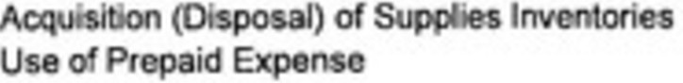 |  |  |  | (18,3&8) 26,081 |  | 38,949  !591120)
 |  |  |  | 71693 |  | C22.17tl
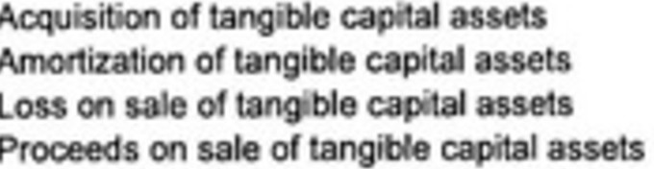  N remea�uremen gain lo |  |  |  | (21,313) |  | (15,678}
CHANGE NET FINANCIAL ASSETS | (2,061,161) |  |  | 1 601.287 |  | 897,300

NET FINANCIAL ASSETS AT BEGINNI G
Of THE YEAR

NET FINANCIAL ASSETS AT END OF THE YEAR

25.274,763

23213 602

25 27 763 24,377,463

26 876 050 25 274 763

TliE CORPORATION OF THE VILLAGE OF BURNS LAKE

$TATEM OF CASH FLOWS
or th , nded D c_emb r 31, 202.5
2Q25 2024

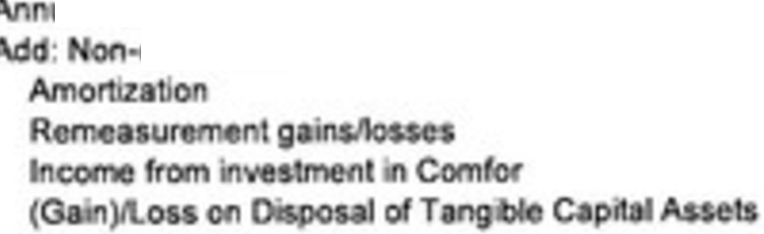
OPERATING ACTIVITIES
u I rplua

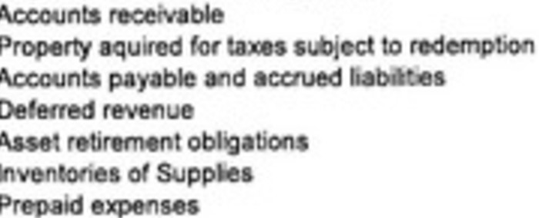
C

CAPITAL ACTMTIES

s 4,675,613 s 7,472.74'
1,440.1,46 U79,
(21.313► (15,878)
1,098,334 230,7
24&!51 1.497

7,211,139 8,969,
192 ss (1 0,120)
(310,00tt 37,807
(SS,1H) 233,005
tiUl,4175 (7 , 76)
9,250 6,502
(11 , .. , 36,9<49
26,-081 jS9.120}

•ctivi ·�68.915 813 913S

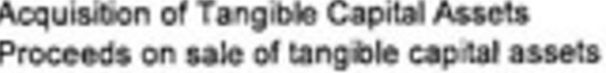
(5,110,016) ( , 50050)
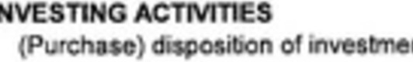
,u1oss

4 U951 (8,950.050)

nts 4 |  |  |  |  | 141%8 | 2 4"3.299
4 |  |  |  |  | 14121 | 2 443.299
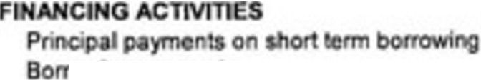 |  |  |  |  |  | («0,314)
ch |  | ga |  |  |  | (440,3141
N TCHAHG | CASH |  |  | (812,164) |  | 372.288
CASH ATB GI |  | THE YEAR |  | 4,571,007 |  | 3.205.721
CASH AT ENO OF TH YEAR |  |  | s | ).785143 |  | s | 41578.007

THE CORPORATION OF THE VILLAGE OF BURNS LAKE
NOTES TO THE FINANCIAL STATE ENTS

For the year nded December 31, 2025

OPERATIONS
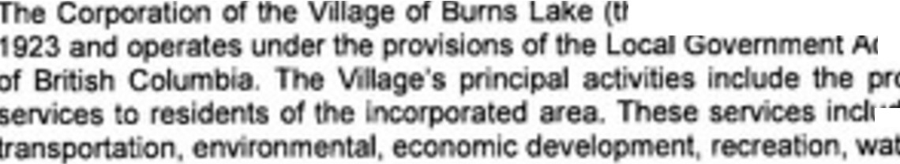
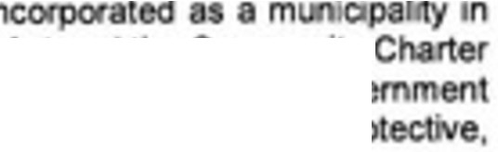
he V.lage) •
ct m ity
ovision of local gov ude a m, , pr
ter and
- SIGNIFICANT ACCOUNTING POLICIES

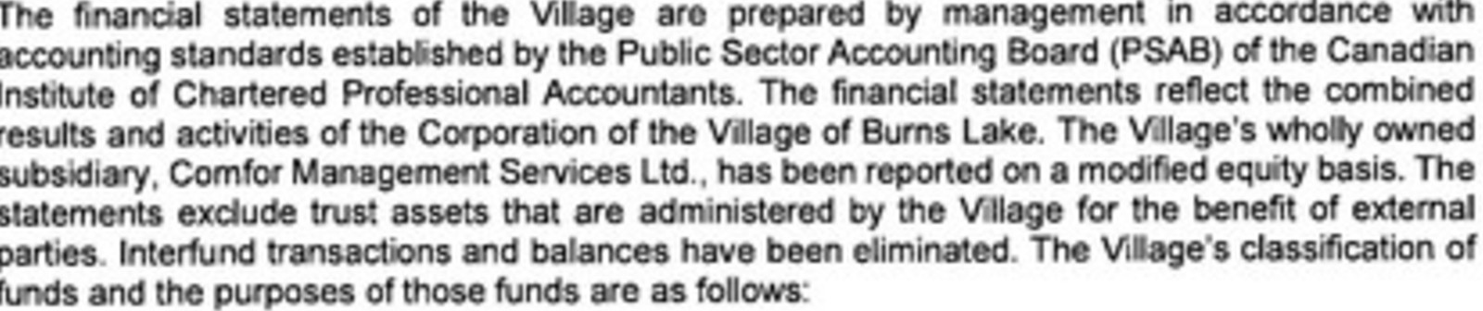

Op«aUng Fund report the , ter a
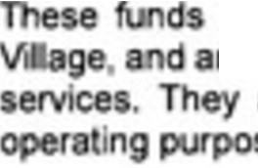
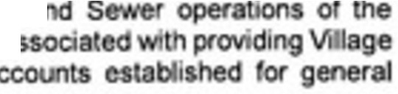
re used to re he a so incl se a es.
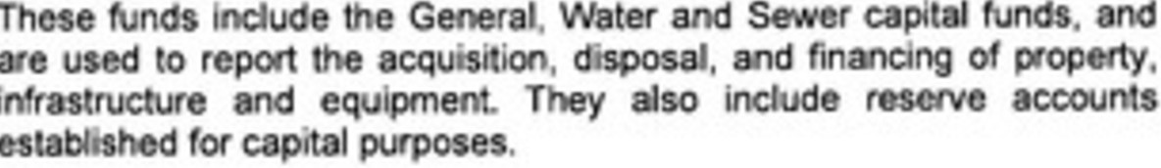
Capital Funds

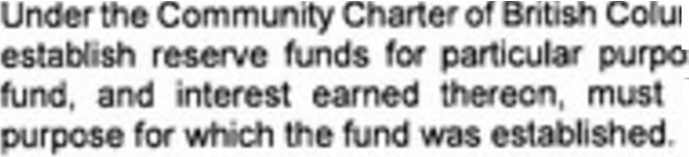
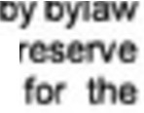
Re$ervefunds m• . Council may,
$8 . oney i the
be expended only

Tru t nd
These funds have be
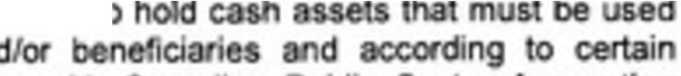
for specffic purpos an
t
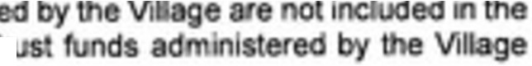
greemen s. In accordan 1h ·ng Standa ds, trust funds ad
r
Tr
Viii e's F social S atem re presented In ote 16.

THE CORPORATION OF THE VILLAGE OF BURNS LAKE NOTES TO THE F1 ANCIAL STATE ENTS
For th yoar ndtd Dec mb r 31 2025

- SIGNIFICANT ACCOUNTING POLICIES, contlnu d
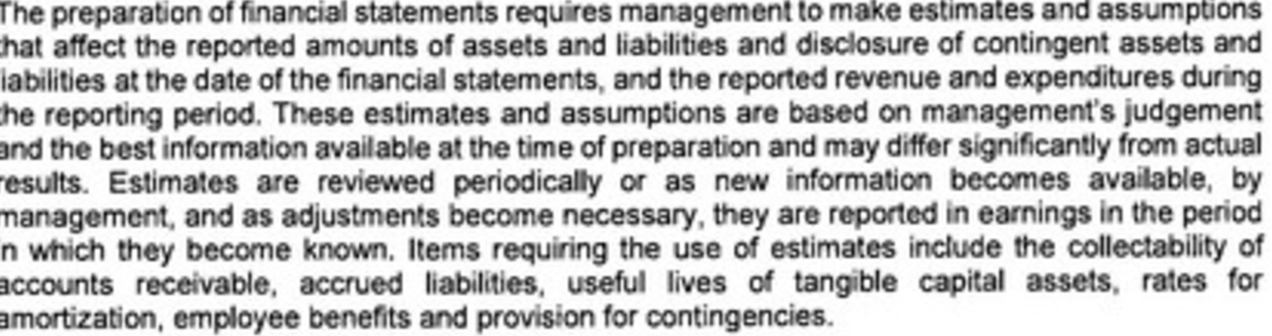
vseofes· aes

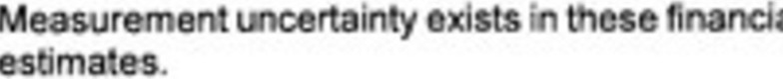
te .A ualre coold d f om

R
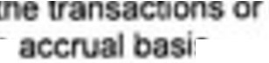
Revenues e recognized in nod ·n wtl eh to ttie reven es. revenues a e recorde on an

en s occurred that g e n
s.
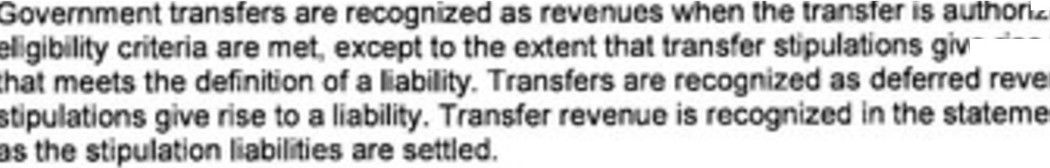
  - edand any
e nse to an obliga•
nue en transfer o opera ions

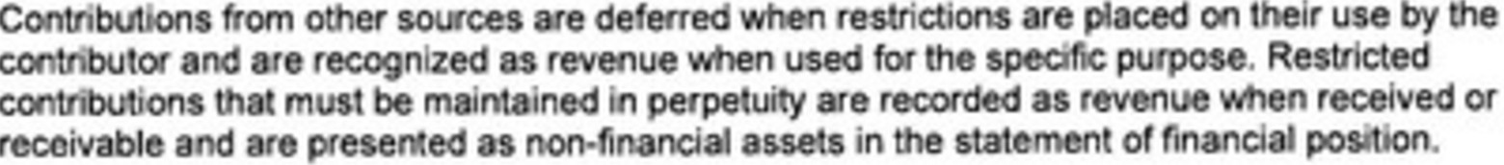

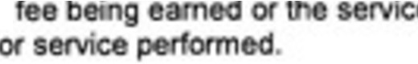
anoe e Is earned
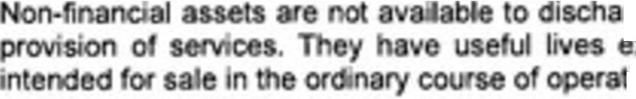
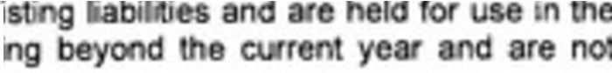
y n ch y re le i .
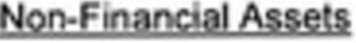
rge ex xtend jons.

THE CORPORATION OF THE VILLAGE OF BURNS LAKE NOTES TO THE FlNANCIAL STATE ENTS
For th y r nded December 31, 2025

1. S.GNIFICANT ACCOUNTING POLICIES, con nued

Financial lnstmments
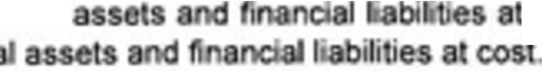
The VI age i• • Hy measures • s n cial subsequently measures all rts fi nci
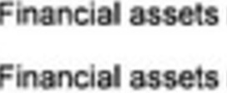
m
m red . ta· m
F ancia 11at11t1rt11as measUI' d t CCSl incilJde ac:coun s p y
em, borr
lmpallm6nl

t f 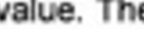e Village

and aocru Ila sand short

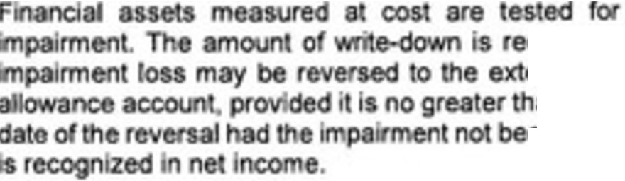

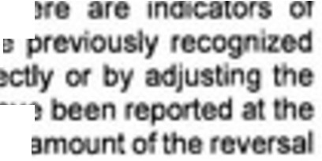
h
n th Th dir
d hav
. The

cognized
ent of the im a amou en recog iz

Tron ction eosls

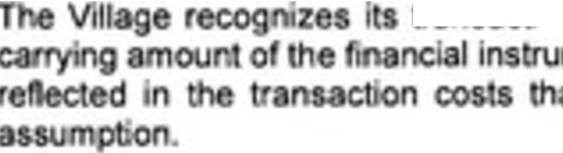
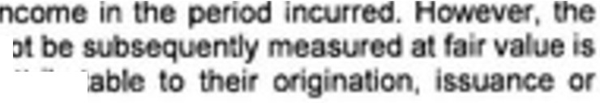
lr<1r,c<>1-ti0fl COSts in ne
me its th II n
re directly a bu


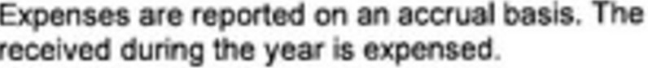
cost 'all goo s consu ed and ervice

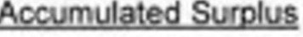

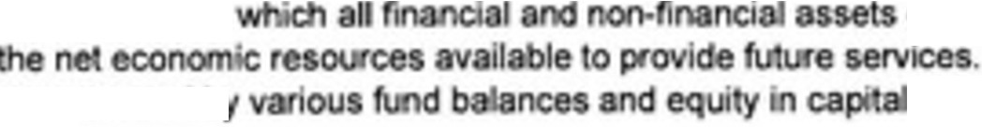
Accumul ed surplus I by abl es and dica es
Accumulated surplus I b
exceed ff

asses.

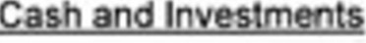


Cash con·sts o cash a aocoun s Fin i I Authority money
Inv ed r t .
Id t Ion lnve tments con °$ o un'clpal d po Interest s oc:rued at the

THE CORPORATION OF THE VILLAGE OF BURNS LAKE NOTES TO THE FINANCIAL STATE ENTS
For lh y r nd d December 31, 202,5

1. SIGNIFICANT ACCOU TING POLICIES, eontfnued
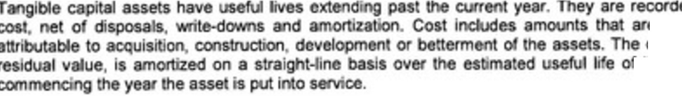
ed
e d1 ec1ly
cos. les f the asse

I.I 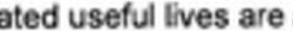 85

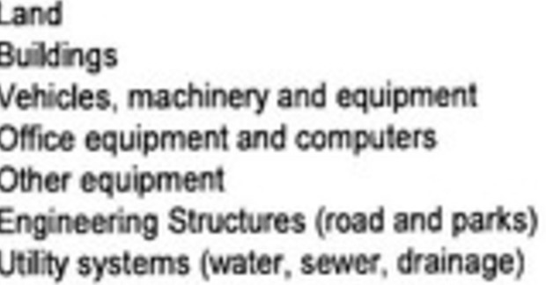
amorta.ed
15-50
5-20
5-10
5-15
10-75
20-100

using
en erpris.e, Comfor a ge en So
Ltd. (ComfOI') ( o e 6},

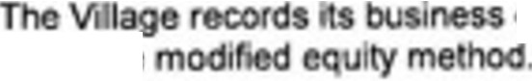
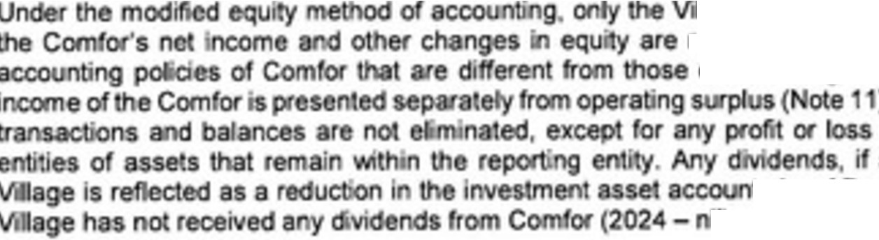
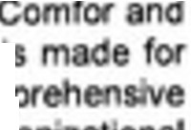
ge's i nt Int recorded. No adjus t i of m
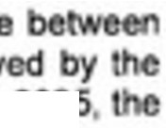
). I -org na.�,1�11UU
on sal
any. r •
t, As of Decemb r 31,202
II).
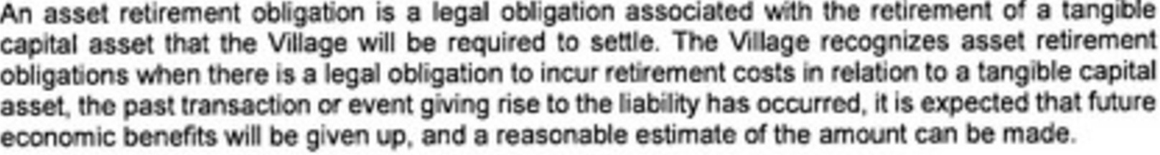

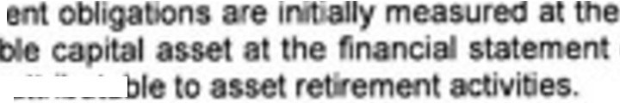
Asset etirem re re a tangi
costs directly ..,,,,.,..,rs

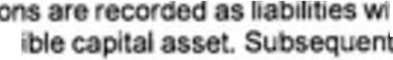
As$et r tirement o a i
mount o the rela ed ang
best e a da e. The es

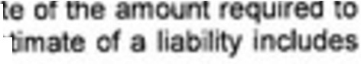
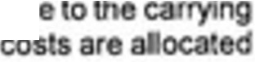
th 8 correspond! 9 increas
ly, e as t retirem

THE CORPORATION OF THE VI LAGE OF BURNS LAKE NOTES TO THE FINANCIAL STATEMENTS
Fort.ht y r ended O c m r 31, 2025

- SIG IFICANT ACCOUNTING POLICIES, con lnu d

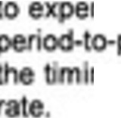
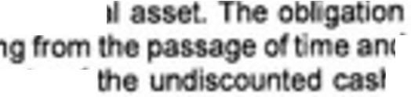
nses o er useful
pit

f
d h
period changes in • ng or the moon of

Is adj sted to ri for revi• s to flows or the di

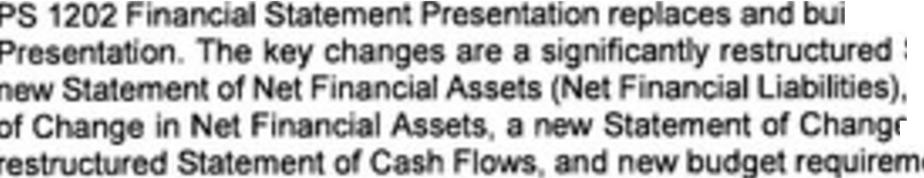
- CASH
1lds u
Sta
, re es i
en

ts.
I ment n, e en
).

2025 2024
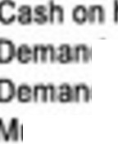
nd $ 652 $ 652
he
dd
dd
u icipal
. 1,204,958 2,016,865
.
OlY' s 43,413 '3021
'ty Pooled High In et 2,518,120 2,S 7,469
$ 3 765143 4,578,007

- INVEST ENTS

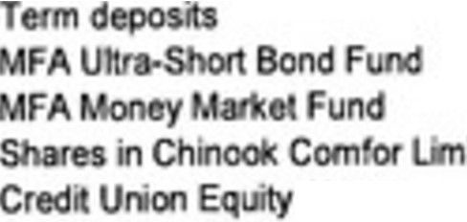
ited
Sh

2025 2024

$ 3,53,4,224 | ,503,588
1,049,698 | 894 247
4,925,963 | 2,597,126
656 | 658
103 99

$ 9,51054,4 $ 4 995,716

ACCOUNTS RECEIVABLE
2025 2024

Property s | $ 548,374 | $ 455,47.t
u i • s | (13,524) | 7,862
0 G emments | 598,182 | 813,318
T nd 0 | 544,623 | ,29 ,338
 | $ 1,675,635 | $ 2.567990

THE CORPORATION OF THE VI LAGE OF BURNS LAKE NOTES TO THE FINANCIAL STATEMENTS
For th year end d O.e mb r 31, 202.S

- PROPERTY ACQUIRED FOR TAXES SUBJECT TO REDEMPTION

0 ning Tran fera
b ance Additions and
R demptions 2025 2024

Tax properti 378,440 736,389 (426,380) $ 688,449 S 378.440

THE CORPORATION OF THE VILLAGE OF BURNS LAKE NOTES TO THE FINANCIAL STATEMENTS
For the year nded December 31, 2025

- INVESTMENT IN CO FOR
Comfor . or) is a ry • to
ope ate nd C ty F m Provmce
of BC. Oet 5 e s Acto British Col r d for i 16, Bums Lake, BC.

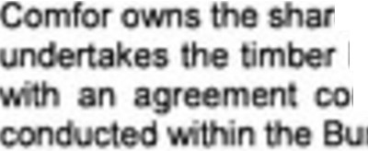
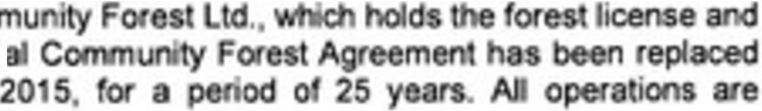
om
es of harve mm msl
in
2,
a.
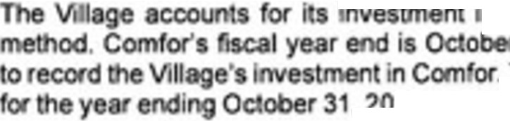
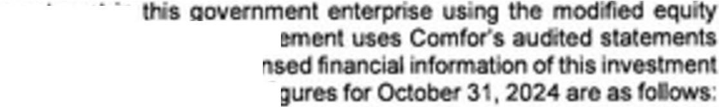
•
n
nag
. Theconde
. 25, • h com e fi
2025 2024

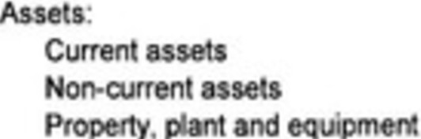
$ 7,669,n9 $ 8,481,278
9,513,103 9 225.32.8
1,769,557 2,002,999

18.852,439 19 709,605

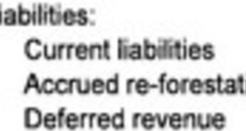
L

ion cos s

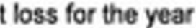

0 er compreh ive incom

Total n t ncome d comp,ehen • e·ncom fo ho yoar

1,933 769 2,781.«8
2,400,383 ,306,657
638 694 684,3 3

4,97218"6
◄.n2.◄a
$ 13,879.693 $ ◄ 937 187
S (1,098,334) s (230.788)

40,740 1,131.005

$ {1,057,6941 $ 900.217

Du g 2025, VI 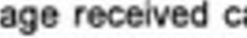
(2024 - $781,6 7).
ion$ from Comfor ·n amoun o S ,061.9S3

The nvH en in Co ot sed by$ , (202 - ncreased by �00.217) let, is al to Comfot' n nco con,pr he nc:ome for e ye ended October 31, 202S.

THE CORPORATION OF THE VILLAGE OF BURNS LAKE NOTES TO THE FINANCIAL STATEMENTS
For lhe year ended December 31, 2025

1. ACCOUNTS PAYABLE AND ACCRUED LIABILITIES

2025 �
Trade &CXX>Unts pay and accru s $ 626,479 s 896 295
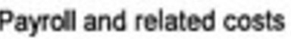
Tax 688,,449 396,454
295,114 382,481
$ 1161011W2 s 675.230

- DEFERRED REVENUE
2025 2024
Gowan $ 490,768 s
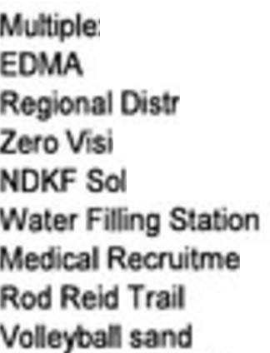
LG Hou ' 133155 135,374
)(
ic1F nd ng
on Cros
ar project

nt
65,148 49,703
3�963 35,000
3�373 47,122
26,261
25,000
20,618 7,167
13,927 13.927
8,329 25,000
7 500
Regional District. Faces ndP 2,500
T 'il KohG n recreation 426
SCBAE pme t 25.000
$ 854 968 s 338 293

- PREPAID EXPENSES

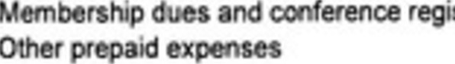

202.6 2024
ioni. s •• �2 29,893
101,260 0 ,910

$ 1051722 $ 131,803

THE CORPORATIO OF THE VILLAGE OF BURNS LAKE NOTES TO THE FINANCIAL STATE ENTS
For the yeu ended December 31 2025

- TANGIBLE CAPITAL ASSETS

Cott | 2024 |  | Addi ona | Diapouls | Adjuatm ma | ms
Land | 1,199,681 |  | $ 2◄8,522 | s | 219,625 | $ 1,667,828
one in Progress |  | 4,863,648 | 4,482, 33 | (5,495,496) |  | 3,850,28$
Building |  | 8, 38,199 | 123,478 | (541,653) |  | 17,720,024
l'lef)' |  | ;.,n .210 | 273262 |  | 41,000 | 5 085,472
red Structur, |  | 9,437,807 | 31,542 | (642.310) | 5,299,43 | 24126,470
 |  | O,TT2,143 |  | (5.820) | 477,093 | 11,243,416
 |  | 113,031 | 21,079 |  |  | 134,110

156.300 156,300
$ 59,◄52.019 $ 5,180,016 . S 63,983,905
Aceumutated 2024 Addi on Ol1p ,. Adju tments 2025
Amortization
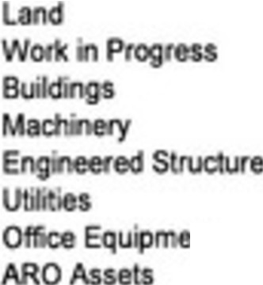
$ . s . s . $ . s
nl

4,785,544 | 398,134 |  | (902) | 5,182,776
3,244,399 | 22◄,218 |  | 68 | 3,"68,685
6,152 847 | 574,84o | (7 88) | (247) | 6,720,168
5,050.806 | 200,699 | (3,118) | 1,08 | 5,2-49.468
75.008 | 9,924 |  |  | S.932
29.399 33,125 62,524
$ 19.3381003 ,◄40,946 s 104 $ . $ 20,768.643

Boo V lu 2024 2025
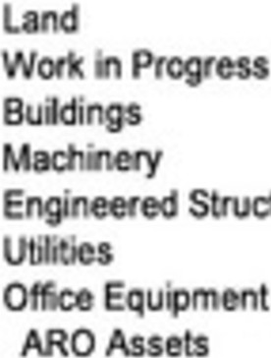
 | $ ,199,681 | $ 1,667,828
 | 4,86.l.848 | 3,850,285
 | 3,35 655 | 12,537,248
 | ,526,811 | 1,616-,787
re | 13,2$4,960 | 17,-406,312
 | 5,721,337 | 5,"3941!1
 | 38,023 | 49,178
 | 126,901 | !3),776

$ ,114.016 $ 43121 362

THE CORPORATION OF THE VILLAGE OF BURNS LAKE NOTES TO THE FINANCIAL STATE, ENTS
For th y ar nded December 31 202.5

- ACCUMULATED SURPLUS
2025

Unapprop • d Surplus
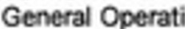ng Fund Water Operating Fmd
Sewer Ope t ng Fund

Ro rve Accounts

$ 940148 $ 868,333
355,258 364,517
379-357 924, 66

1,674.763 2,157,016

G | I | ngFnd | 2,7..0 053 |  | 3,379,922
General Capital Fund |  |  |  | 686,925 | 508,880
W er Ca· al Fund |  |  |  | 783.59-3 | 608,342
s �pl at und |  |  |  | 1,631,490 | 952,302
 |  |  |  | 5,842,061 | 5,449,446
Statutory� N• Fund |  |  |  | 5,818,802 | 3,085,139
Equity In Comfor Management Servfcea Ltd. |  |  |  | 13,879,593 | 14,937,187
Equity In Tanglbl• cap tal
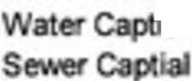  G captl Fu |  |  |  | 30,194,253 | 28,165,SS..
·a1Fund |  |  |  | 8,962,215 | 8,82 862
 |  |  |  | 3,880,590 | 2,953.536
 |  |  |  | 43,037,058 | 39,944,962
Total Accumu |  | d Surpl | s | 10,252,277 | 65,573.750

Accumula d Surplus fo oth r e-ompreh n ve income
Accumulated Surplus from other comprehen v income from Comfor
Total Accumulated Surplus
s 68,874,5:W &4,238,747

1,377,7-'3 ,l37.003

$ 70125�277 $ 651573,750

Page 90 of 107 20
32

THE CORPORATION OF THE VILLAGE OF BURNS LAKE NOTES TO THE FINANCIAL STATEMENTS
Fo they r dcd Dec mber 31, 2025
- EXPENDITURES BY OBJECT
2025 202•

w | - ctn |  | be | I , Council | pends | s Z,769,128 | $ 2,738,309
Util, | (hydro, |  | s. | I phon , ,nt | ) | 377,512 | 359,588
Insurance |  |  | 133,182 |  |  |  | 144,003
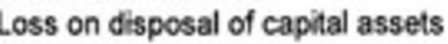  Good |  |  | 3.8S2.2SO  24,659 |  |  |  | 2.374,370
A,:;a  Arn | . | 9,250  1,4'0,9'6 |  |  |  |  | 6,502  1.279,954
s 8 606987 $ 6.902.n4

- ASSET RETIREMENT OBLIGATION
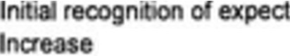
2025 2024

 | ed discounted ea | s 158,000 | s 158,000
du |  | 20,304 | OS4
 |  | s 178,30. | 169,054

provides specific giad h for deeom II
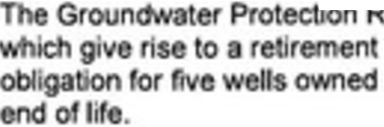
obi on. Th has r cogn ed an as t ,..;.., �w.
'
by 1llage ired to be decomm t



and, es
renov
asbes os and, a r;
the hsz dous
0tscount1ng andInna ion

upon disturoanee s a sign· ,ea
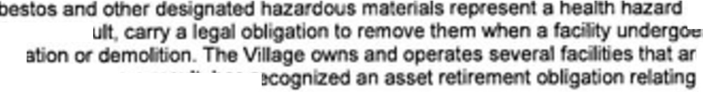
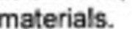
e kn to ha e to he removal o

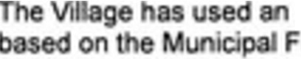
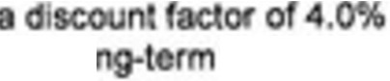
8$ ed rate of 4. infl lion based
inance onty of COlum 's (" FASC-) lo Ctn
r

THE CORPORATION OF THE VI LAGE OF BURNS LAKE NOTES TO THE FINANClAL STATEMENTS
For they r ndtd D c mb r 31, 2025

- PENSION LIABILITY
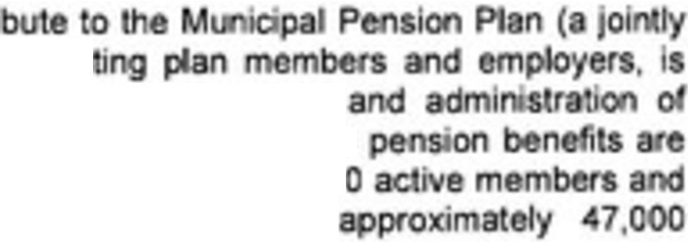
The Village of Bu s La e d ,ts employeu co
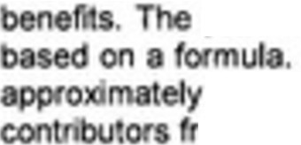
teed pension plan). The stees, repress
Porl• or ini inch.Kf invest ssets
pl e e 1ned efi pe . Basic
As 1, 2024, pl 73,00
133,000 retired members. A members include
om Ioctl g s.

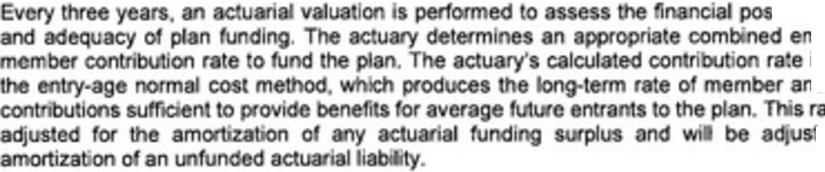
i n
d
d employer le maybe ed for the

at ber 3 , 2024,
go emb is.
The Village e pa d 69,909 (2024 - 1◄9,869) for employ con ,bu
e oyee:s 7, 3◄(202◄- S138,60 ) to e pla n ,seal 2025.
The next val ·1 be as at Decem r 31, 2027.
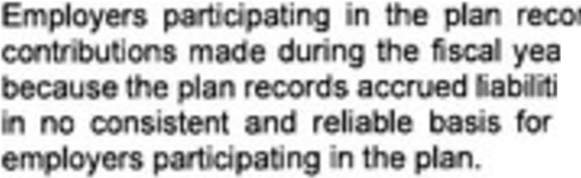
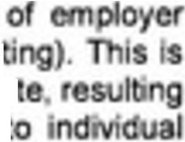
d their pension exp se as the amoun
r (d ed con nsion plan accoun es and accrued or the pla in aggrega loca the obligation, ai.sets and co!>t

15, CONTINGENT LIABILITIES

VII respo le. of any opera 'ng d cit of
e

o. for• s portio


ed by local emments percent ge of• fell
p
t

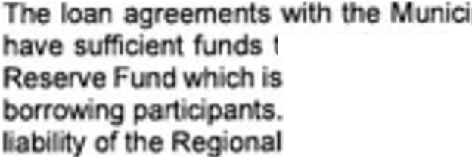
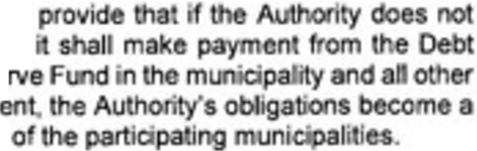
Finance Authooty
o m ents on ob igations,
esta y a similar Deb Rese If e Debt Reserve Fund· deflcl District d may become a liabi y

THE CORPORATION OF THE VILLAGE OF BURNS LAKE
NOTES TO THE Fl ANCIAL STATEMENTS
For the year ended December 31, 2025

18. CE ETERY CARE TRUST FUND

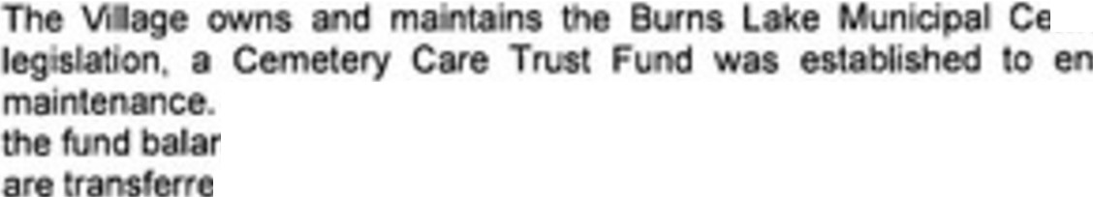
metery. t to pro incial
!i>tJre cemetery

A creel ed fund. 
stment UM ar
di
2025 202•

Assebl
B Accoun1 $ 5,921 s 5,8 8
s rm tme s 4&1•2• 47,237
Fund $ 55 3-45 s 53.055
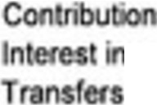
Opera ·ons
s | 1,962 |  | s | 867
come | 103 |  |  | 2,265
tog n oper | ttlg | 225 |  | (328)

Chang In und !>,lane $ 2;290 s 2,806
The Ceme ery C e Trus F nd is not included·n 1he nancial sta e
- SEGME TEO INFORMATIO
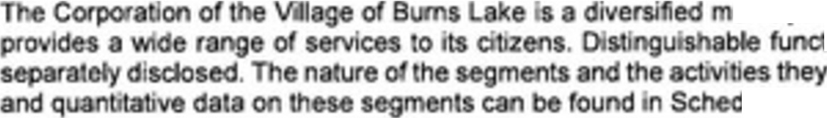
go e ment in • n that Iona segme b encompass are as follows,
uni
ule 4.

Pro protection.

men ciud s ev

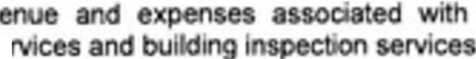
ani al con1rol, victim ae
Services: The
as ed with leg slat' e,
ervice .

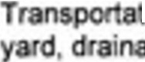
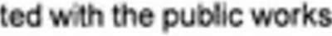
ion: This segment includes the revenue and expenses � 9e stree s and sldewal s.

Solid te; Th gment incl e the1ev ue nd expenses as&Ocia ed
•

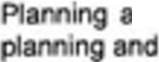
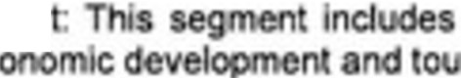
nd O elopmen
1onl g. ec
n
8nd
the reven e and expenses aa.sociated 'th rism s.

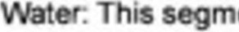
s segment includ revenue a e
expenses associated c.uttural fa ities.
socia ed h• �erme ts and pr ng ater services.

Page 93 of 107 23
35

THE CORPORATION OF THE VILLAGE OF BURNS LAKE NOTES TO THE Fl ANCIAL STATEMENTS
For th ye r nded Dee mber 31, 2025

- CO PLIANCE WITH LEGISLATIVE FINANCIAL PLAN REQUIRE ENTS

.
was prepared h
C a anPub g
reconciles th a
moun s report .,,.,,,.,., -,4 to
•
1
.
the g ants
<:iWretely reff
2025

Budge d 11.1rplu1 per Sta mont of Op rations S 1-4,855,970

L
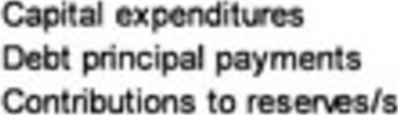
(16,917,131}

,-40-4,1-49)

Add:

rans surplus an_d , _...,.
Borrowing proc

s,n0,690
694,620

B need nei:al $

- COMPARATIVE FIGURES
Ce in prior year gures, p1esented for co a e pu to the current ye s inancl ta ement presen a ion.

to con 0ml

- COVIO RESTART GRANT
tor c da. COVID RMt ru mg �

2025 2024
0 ng $ 28,042 s 63,700

AM r
281042 35,658

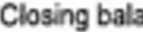m:e s 28,042

THE CORPORATION OF THE VILLAGE OF BURNS LAKE NOTES TO THE FINANCIAL STATE ENTS
For the year end d December 31 2026

- NORTHERN CAPrTAL PUNNING GRANT

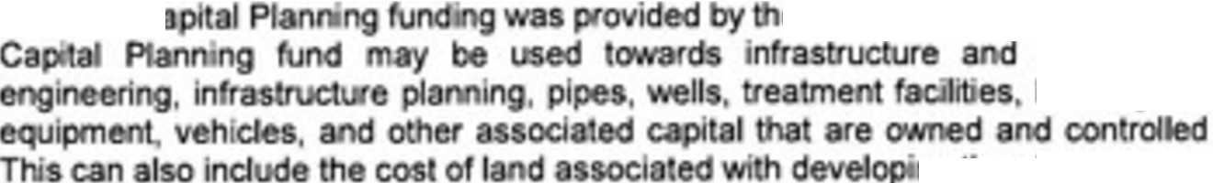
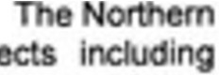
onhc<nC e Pr nee of Brib Columbla.
eltgibfe proj
bu roads, machinery.
by me Ila�.
n bo I investm
2025

Open' g b oe

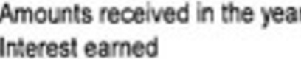
Add'

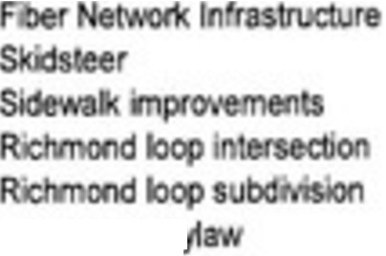

SubdiVISIOfl b
$ 930,511

16,763

16?63

720,069
n,344

149,861
,◄15,382

52,815

52,6 5

3,156
2 ,399
229,857
-4,074

�7,488

Clo ng nee 930.511
- C UNrTY WORKS RESERVE

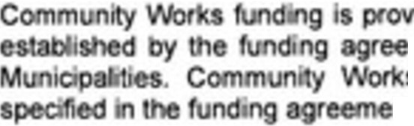
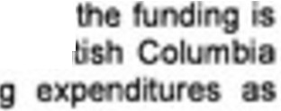
ed by the Go e of Canada. The use of
•
me
nt.
n be en la and the U• on of at·
ndi may be used towards qu i


Add nts"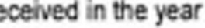
Inter t eJmed
2025
s 179,647
150,836
7,212

202A
s 265. 2
150,&36
0.211
16 . 7

e  109,797
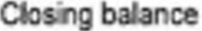
s 227 9S

2 .482
179647

25

THE CORPORATION OF TliE VILLAGE OF BURNS LAKE NOTES TO THE Fl ANCIAL STATEMENTS
For th ye r nded Deeemb r 31, 2026

- LOCAL GOVERN ENT HOUSING INmATIVES GRANT

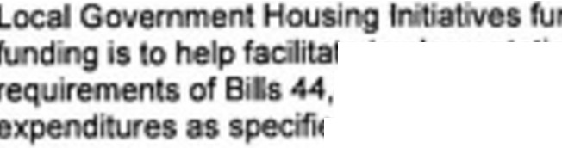
i$ prov1d d of BC. The use of the
nd
t ,.mfllnt1111on
,4 .
ed Inga
s to w legislative
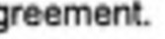
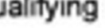
g lruti.�ts rds q


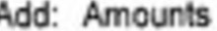 reoeiV'ed I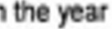
pen the r
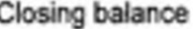
2026 202A
S 1l5 74 $
58,332
2,,219
$ 13 155 $ 35374

Sch dul

THE CORPORATION OF THE VILLAGE OF BUR S LAKE REVE UES
For th 'I ar nded D c mber 31, 20.25
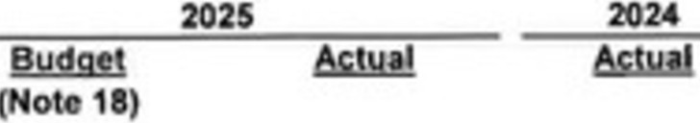

TAXAT  R |  | $ 2,004.273 | s | 2.00.,273 | s | 1,854,7"5
F |  | 237,102 |  | 236,93$ |  | 237,102
 |  | 55,000 |  | 134,856 |  | 6-4,338
 |  | 25325 |  | 253,,252 |  | 2n,142


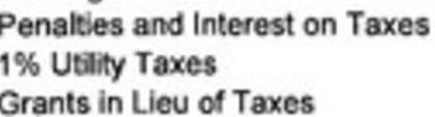
T "
 |  | 42t0S7 | 43,754 | ◄ ,232
rO'V'Cf'lu |  | 2,591,683 | 2,673,074 | 2,470,159
 | ing | 1,530,447 | 1,622,907 | 1,500,4◄0
 |  | 4,122. 30 | ◄12951981 | 3:97015



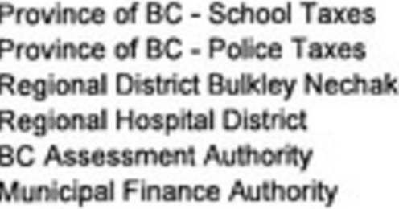
663,739
102,739
0 413,236
339. 56
1, ...10
57
714,687
106,'31
442,467
346,602
12468
61
662,466
102,737
403,806
33 ,282
11,223
56

1,5304"7 |  |  |  |  |  | 1,622,816 | 1,511,570
2 591.683 |  |  |  |  |  | $ 2,673,1'5 | s | 2,459 029
FEES, RATES AND SERVICES CHARGES  Solid W te - Refuse Colectlon nd |  |  |  | 127,623 |  | $ 130,781 | s | 147,18,4
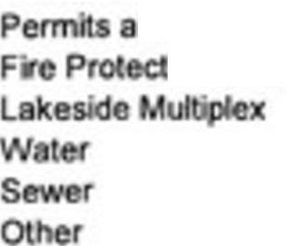  C |  | - Bu. | Pio S I | �500 |  | 21,693 | 21,303
 | nd |  |  | 106,33 |  | 96,901 | 47,063
Ion S |  |  |  |  | 23,000 | 23,000 | 23,000
 |  |  |  |  | 261.087 | 314,496 | 241,SO
 |  |  |  |  | 500,744 | 502,791 | 495,080
 |  |  |  |  | "75,072 | 501,490 | 474,8 5
 |  |  |  |  | 26.425 | 96�232 | 371318
s |  |  |  |  | 11S◄211e2 | $ 1687 !84 | 1487 264

OAATI �THE

ued)

Of
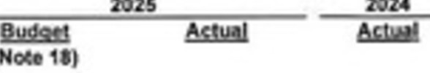

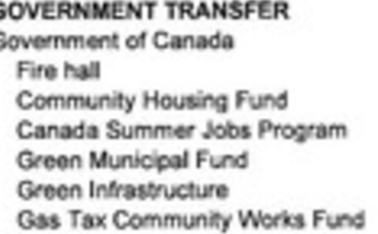
s s ', 56.l,405
1 S17C
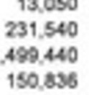
,001 •.
'45,761
,so,, '

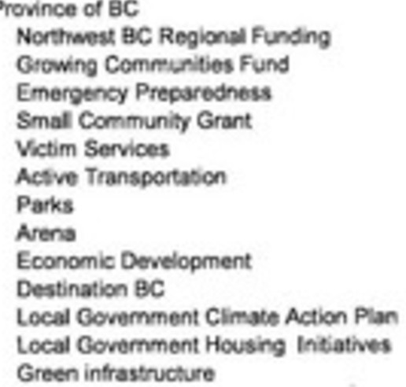
.SOO
s 5. 2 ' | 5,7'4,382  41,ffl | S 193U  5000
504.000 | 601,000 | 1.200
5 1 | 65,111 | 72,261
500.000 | 500,000 | 500.000

1.2
..
1,217 2 2

5.000 15,
111.
13 ,().12 2'.
1,249,4011 2 111 7 20

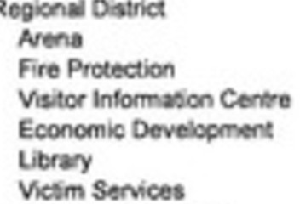
4,2' 73
355,000
••.• 5

5,1123 • .OOC
115. 427 S?3
00,000
l ,000 20,000
Glllba,goa:ileCllon 5,000
75 7 12.

Uniot1 of8C

und "4.431 zt,171
"°
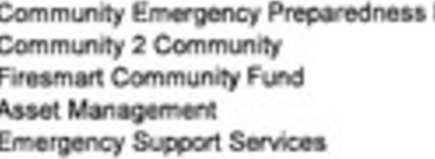
&7l •.111

4950
000 .,. s .000
1 . USO

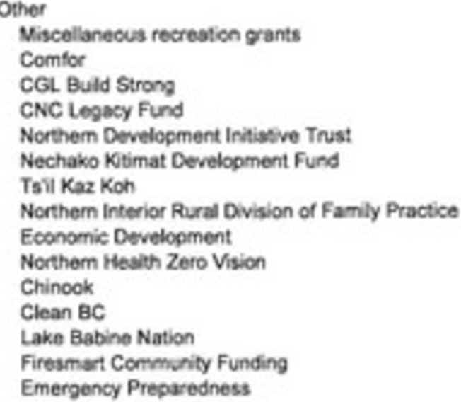
mooo •.m
000 49,17
21,000
1000

000 n,ooo 151.575
000 23.000
5000 34,574
10000 0,000
41750
,. 733 2',4?2
2,
00000
'
. 7 15,275 91,344
,870
•
s &a72'2t s e12 3,390

IO floe

THE CORPORATION OF THE VILI.AGE OF BURNS LAKE

REVENUES (continued}

For the year ended D cember 31, 2025

2025 2024

Budget ActuaJ
(Note 18)
Actu I

INVESTMENT INCOME
nt re t 295,000 s 445 091 $ 507,802

OTHER  C | INCOME  bution1 om Com 01 |  | $ 534,983 s | 634,983 | $ 788,573
R | .I Income |  | 120,624 | 120,038 | 119,516
Other |  |  | 5,29 | 32,944 | 30,680
Sale ot |  | se s | 2,010,500
 |  |  | $ 2,671,398 s 687 965 $ 933,769

COMFOR INCOME
ncomefrom n t on Comfor (Note 6) $ s 1 098,334 s 230,788

See esto

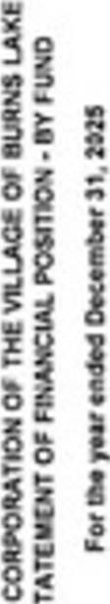
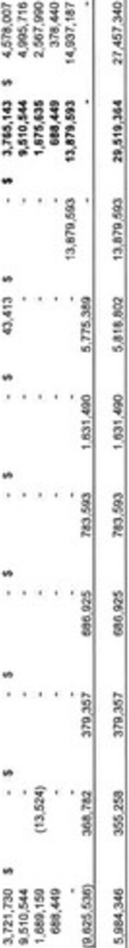
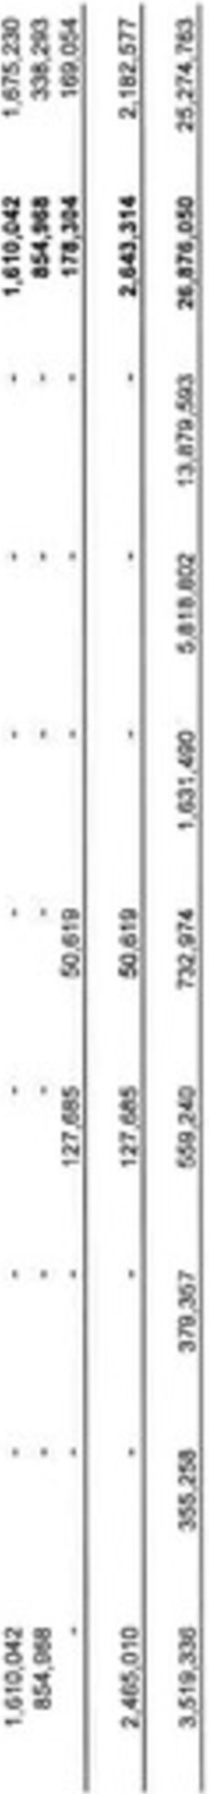
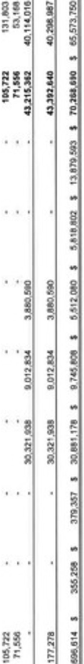
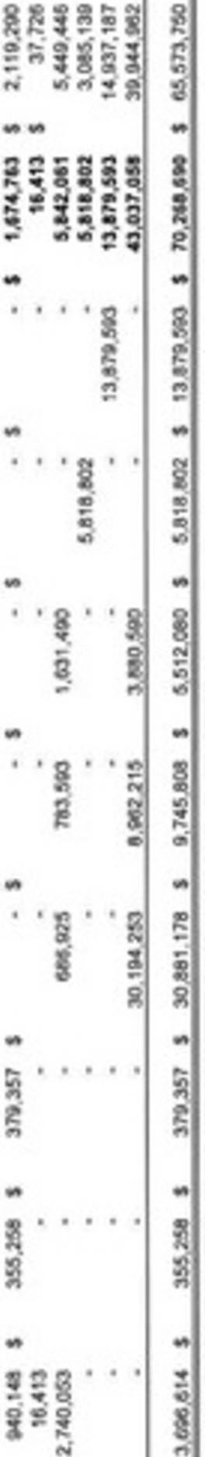
z

.X.
..
..
...
..
SI

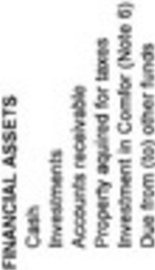

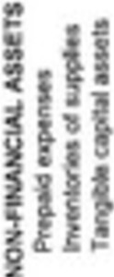
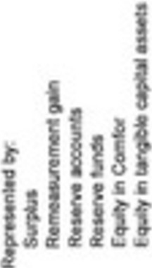

..


^{i} .. 

.,!. ...
..
.. .:


i 1

j ..
. . . ..
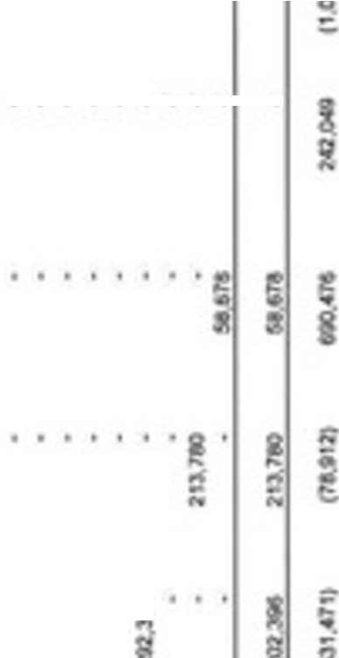
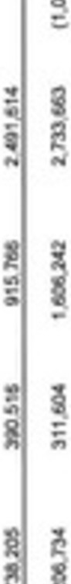
�
. .
..
.
!....:



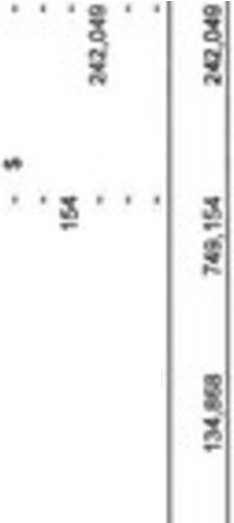
a·
..
I
R
.. .a .

. . . •z

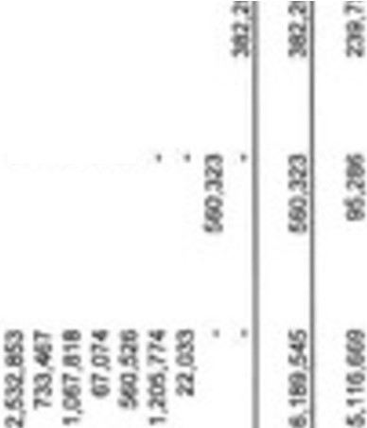

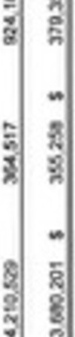
l .. i"' -
. . .

..
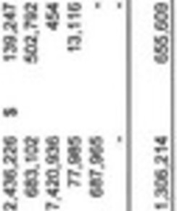

A ..

..

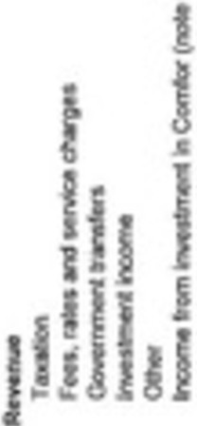
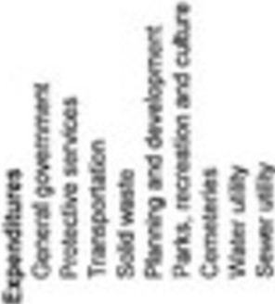

l

I

N M


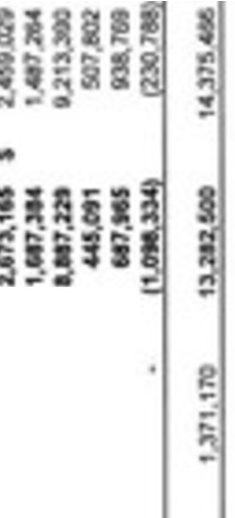
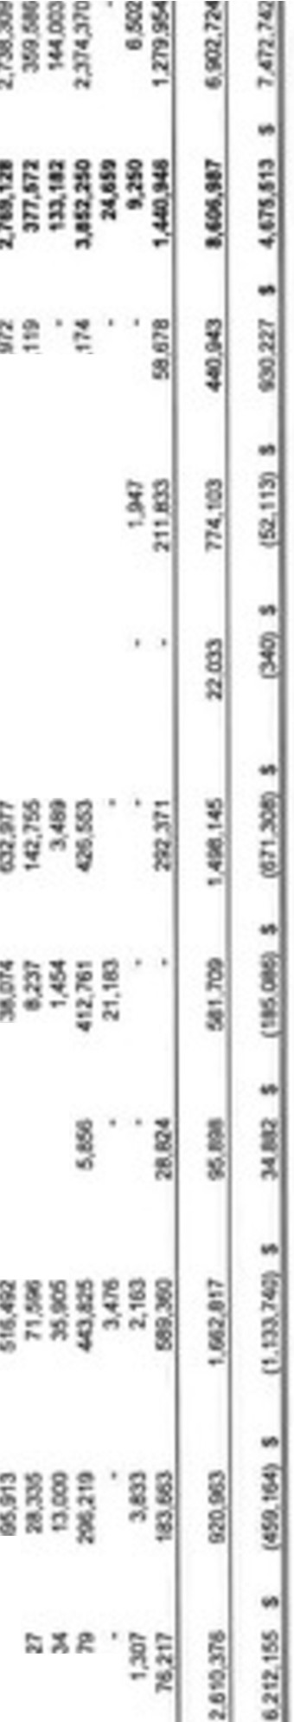
•
.�. g·g·
...
-
�· .
;
:!
.:

^{I} ..
...,-.i •
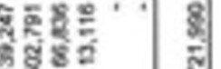
..

..
I
;;
.. .•

..:.



.. I
'
�

-�- •.1.•
�
.. .
'!.
�


..

.

.. ...

Ii

ij '
s:

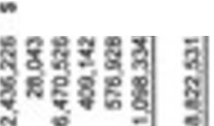
..
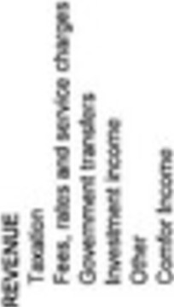
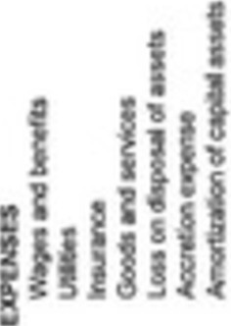

Financial Information Regulation, Schedule 1 Checklist - Statement of Financial Information (SOFI)
For the Corporation:

Corporate Name: VII� of Burn L Fiscal Year End:Deoember 31• 2025 Date Submitted:
Contac Name: Char Ham 00 Phone Number: 2:S0-692-7587 E-mail: nee@


For the Ministry:
e.ca
Minis ry Name: Date Received: Date Reviewed: App oved (SFO):

Revie,er: Deficiencies:
Deficiencies Addressed: Further Aotion Taken:
Yes  Yes | □ | No  No | □
Yes  Yes | □ | No  No | □

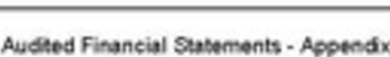
Dis ribu1ion: Legislative Library □ Ministry Retention □
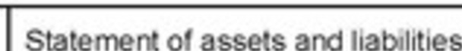
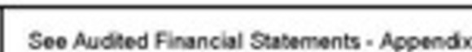

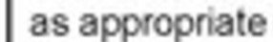
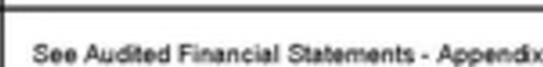
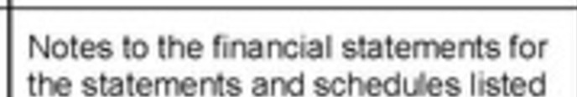
General
1 (1)(a)
Operational sta ement
Sched
El □
El □
El □
□
□
□
□
□
□
□
Sff
Schedu 1ndemrn
anct
El
□
S.. SOFI , P, git 2
El □
El □
El □
S..SOFI-P
:l
Schedu
service
p ers o goods and
S..SOFI•
git&,8
Sta e
cor.sol
redo a
s1 o ror eae fl.M'ld,
S..Audbd
a
e
□ □
1 (4)
1 (5)
1 (3)
(1) (f)
1 (1)(e)
1 (1)(d)
1 (1)(c)
1 (1)(b)
Corrments
NIA
No
Yes
Item
FJR
SChedule 1
Section

FIR  Schedule 1  Section | Item |  | Yes | No | NIA | Conments
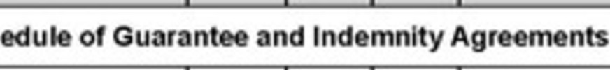
Sch
5 (1) | a a reeme  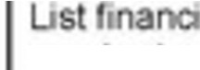  r n I prior  to G sand  I la 10n 1n FIA  G ge) |  | □ |   □ |  | OIi•· WFI P Z
5 (2) | 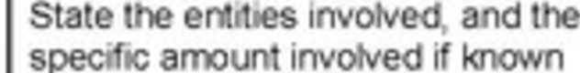
5 (3)  5 (4) | - The SC ed le ma O ed aiddressed uooer sect n 2 or and rt pro no addrt1onal info ma on  - The o ion roo a1ned 1n a note o the sched e |  |   □ |   □
( |  | Schedule of Remuneration and Expenses  ted forrna )
(2) (a) | List se , bo/ name and  otal ion and  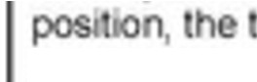  t nse lected  o ber of dlrecto �oyee appo by Ca |  |  | □ | D | 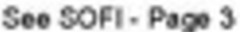
6 (2) (b) | List a be1 lly eac rll)loy whose total rerTVJnera ion exceeds 75,000 and to ale nse rot each [e clud1� t persons h ed uooer 6 (2) (a)) |  | )CJ | □ | □ | S..SOFI-
6 (2) (c) | lnctude c olida ed otal or employees whose rerooneraho  $75,000 or I [ duding the  per h ed r6 (2) (a)] |  | )CJ | □ | □
6 (2) (d) | Reconcile ore plain any erence between t al ren'k!nerat1on n t sched le and rela d I orma on the o rational ta eme |  | )CJ | □ | □ | S..SOFI• P l
6 (3) | clucf perso 11 ormatton ot r than name, posrt10 function or ren'k!ne ation and ex nses of employee |  |  | □ | □ | S.♦SOFI- ;,t)

Page 104 of 107
47

FIR
Schedule 1
Section
Item Yes No NIA Conments

Sch (See

6 (6)
Repo t emplo er po on of El and CPP as a supplier pa me to the Recel'\/ Gen ral or Canada ra er n as employee re""Jnerat,on

SffSOFI• P S
D D

6 (7) (a)
6 (7) (b)
looude a sta eme of sev ance a eeme prov1d1ng

- t erance

a rw ,ch
,n he
f1 reported on for
D
no loy es, and

com
(see Guidance Package for suggested ormat)
hs'

6 (8)
Provide t reason for om I g a sta ment of se ranee a me in a no e to e schedu of
t,on and expe

□ □ JC)

Schedule of Suppllers of Goods or Services (5ee G ted forrna )

7 ( )(a)

7 (1)(b)
Ust m alphabetical II
goods and o 1v d aggregate payme 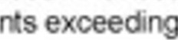
$25,000

lncfude a consohda of all
payme s o supplier ece1vecl
$25,000 or I s
'1J □

□
□ 

D S..SOFl•Pi S


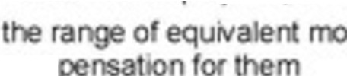

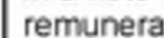
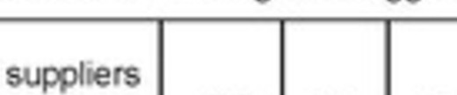
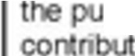
7 (1)(c)

7 (2) (b)
Reconcile or explain a"'I erence be n the oonsohdated otal and rela ed fi res in e opera 10 I sta ement

lncfude a sta eme of paymen s for rposes of gran or
io
□ □ :;..SOFI· gt$

□ □ 

FIR
Schedule 1
Section
Item
Yes No NIA
Conments

8 (1)
Them,
corpor cor not
operati extent red o
pr I

□ D )CJ

8 (2) (a)
□ □ )CJ

- (2) (b) The m1n1s s c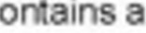
sta eme of atu o the corporat,o G 
Pa ge rega hat to include)
□ D )CJ

- (1)

Corpora ons o her an
Approv

rn.in1c1paht1es - the SOFI I ned a approv d t board or
□ □
directo or he govern ng body (see G dance Pac ge or e am )

9 (2)
urnc1pal1ties - the SOFI IS appcov "'>' cour-.:d and t>,, t o 1cer assigned respo , 1 for
financial ad tra n (see
Guicsance P ge for e a )
□ D S..SOFI• 1

9 (3)
□ □ S..SOFI•�

9(4) The ma i:i.tv1,n.c:ll'\lt the rol and
board o e
auchtoom nd
t auditors

)CJ □

D S..SOFI•

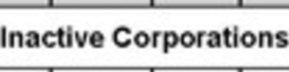
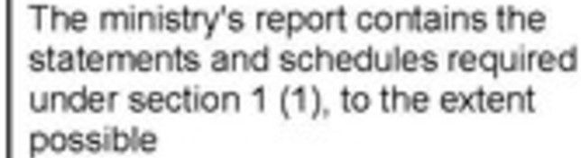
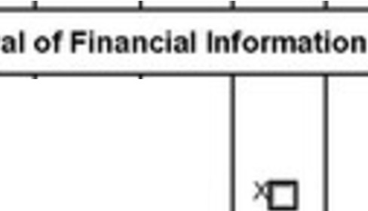
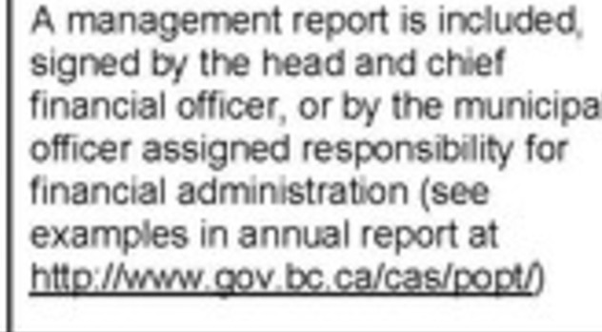
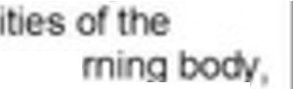
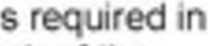
9 (5) s,gnatu ea al
s 9 are e
s n a of r1nanc1a1 Info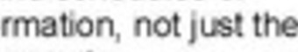 financial sta s
)CJ □

□ S.. SOFI • Per,e 7



Carve your pa h

