To: Village of Burns Lake Mayor and Council
From: Amy Wainwright, Deputy Director of Planning and Development
Regional District of Bulkley-Nechako
Date: January 13, 2026
Subject: Zoning Amendment Application VBL-RZ-2025-03
Bylaw for 1st, 2nd and 3rd Reading
Zoning Amendment Bylaw No. 1102, 2025

RECOMMENDATION:
- THAT Village of Burns Lake Zoning Amendment Bylaw No. 1102, 2025 be given first, second, and third readings.

EXECUTIVE SUMMARY
Staff is presenting for Council’s consideration Zoning Amendment Bylaw No. 1102, 2025 (Application VBL-RZ-2025-03) to rezone the property located at 405 8th Avenue to modify the existing Residential High Density (R6) Zone to increase the permitted density and reduce the minimum floor area requirements. The proposed zoning amendments are required to permit the construction of a seniors’ housing apartment building and would only apply to the subject property. The proposed seniors’ housing building is designed to meet BC Housing design standards and has been submitted to the BC Housing Community Housing Fund for grant funding.

APPLICATION SUMMARY
Name of Agent / Owner: Roman Yamchshikov, Tengri Architecture Ltd. (agent)
Lakes District Senior Citizens Housing Association (owner)
Subject Property: 405 8th Avenue, legally described as Lot 35 District Lot 5347 Range 5 Coast District Plan PRP13907 (PID 018-633-901)
Property Size: 0.5 ha (1.235 acres)
OCP Designation: Residential High Density (RH) pursuant to “Village of Burns Lake Official Community Plan, Bylaw No. 970, 2017” (the OCP)
Zoning: Residential High Density (R6) Zone pursuant to “Village of Burns Lake Zoning Bylaw No. 880, 2008” (the Zoning Bylaw)
Existing Land Uses: Vacant, cleared
Location Map:
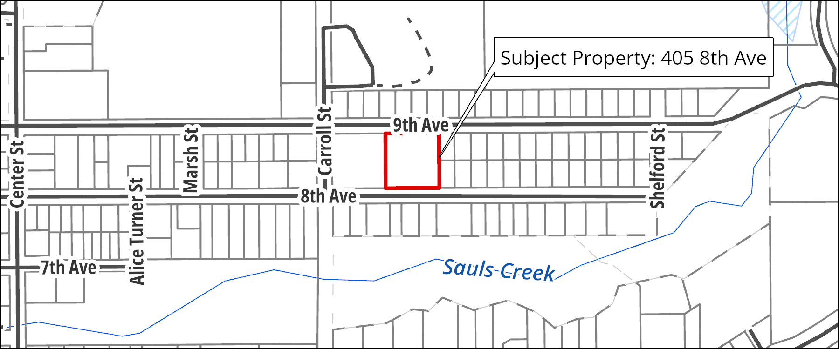

Proposal:
The applicant is requesting two text amendments to the R6 Zone in order to accommodate a proposed seniors’ housing apartment building.
- The first proposed amendment requests an increase in density for the subject site to 74 units/ha. Currently, the R6 Zone permits a maximum density of 60 units/ha. The subject property is 0.5 ha in size, and the proposed apartment building has a unit count of 37. This results in a density of 74 units/ha, which exceeds the base 60 units/ha.
- The second proposed amendment requests a reduction in the minimum floor area requirements prescribed by the R6 Zone for apartments to 55 m² for one-bedroom units and 70 m² for two-bedroom units. Currently, the R6 Zone requires a minimum floor area of 65 m² for one-bedroom units and 72 m² for two-bedroom units.
The proposed increase in density exceeds the maximum density permitted in the Residential High-Density designation in the OCP. However, the Village of Burns Lake has initiated an amendment to the OCP that will permit the requested density increase.
DISCUSSION:
The Lakes District Senior Citizen Housing Association (LDSCHA) applied to BC Housing’s Community Housing Fund (CHF) Program for a 37-unit apartment building. Created in 2018, the CHF develops rental housing for individuals, families, seniors, and people with disabilities. The CHF investment includes rental housing for low- and moderate-income households, but it does not include support services or residential care components.
BC Housing is expected to announce which projects will receive funding later this year. Projects that do not receive funding during this round can revise and strengthen their application for the next round. Additional funding rounds will continue until CHF funding is depleted.
BC Housing has indicated that projects under application should be as “shovel-ready” as possible. This includes having required development approvals in place or providing a schedule for development approvals endorsed by the local “area having jurisdiction”. This rezoning application has been submitted by the LDSCHA in accordance with their submitted development approvals schedule.
The proposed density increase and unit size decrease are a direct result of BC Housing's preferred design criteria. These requirements improve the financial viability of a building, allowing BC Housing to fund more units per project. The proposed LDSCHA building meets all the other zoning requirements for setbacks, site coverage, building height, and amenity area. A variance will be required for parking as part of the development permit application process.
Official Community Plan (OCP)
The property is designated Residential High Density (RH) pursuant to the OCP. The RH designation generally includes apartments, townhouses, and those complementary secondary uses such as daycares, preschools, amenity and park areas, which are integral parts of a high-density area. The maximum density in this designation is 65 units per gross developable hectare. The Village of Burns Lake is currently updating the OCP to remove or amend the maximum density restriction in this designation. The zoning amendment proposed in this application can be taken to third reading, but cannot receive adoption until the OCP amendment is adopted.
Zoning
The purpose of the R6 Zone is to provide high-density multiple dwelling housing, including apartments, congregate housing, rowhouses, and special needs housing. The proposed seniors’ housing apartment building is a permitted use within this zone. The currently proposed building design complies with the setback, maximum height, and maximum lot coverage regulations within the R6 Zone.
The proposed zoning amendment would increase the permitted density by approximately 23% and reduce the unit size by approximately 15% for one-bedroom units and 3% for two-bedroom units. These amendments are required to accommodate the BC Housing preferred design guidelines and construction standards, which were developed to maximize economies of scale while preserving liveability.
Servicing Considerations
The proposed increase in density may impact the Village's water and sanitary systems. See the Village Public Works department comments below.
STAFF COMMENTS
Staff have no preliminary concerns regarding the proposed increase in density and decrease in unit size.
REFERRALS
A referral report was provided to the Village’s Public Works Department, Fire Department, Administration Department, and Building Inspector. It was provided to the Ministry of Transportation and Transit, as the property is within 800 metres of an intersection with a controlled-access highway.
Administration: From an administrative perspective, we have no concerns; however, I will defer to comments from the Directors of Public Works and Protective Services regarding fire protection and servicing issues.
Public Works: Currently, the requests are unrelated to infrastructure, so I have no concerns at this time. At a later stage, however, the developer will need to prove to the Village that whatever they propose for water/sewer and storm is going to work and not negatively impact the existing system. An on-site stormwater detention will be required.
Fire Department: The Protective Services department has no concerns with the increase in density. All fire and life safety requirements as per the BC Fire Code will be maintained.
Building Inspection: Building Inspection has no concerns.
Ministry of Transportation: I have reviewed your application File #2025-04977 for a Zoning Bylaw Text Amendment at 405 8 Avenue, Burns Lake, B.C. The Ministry sees little-to-no impact and has no objections to the proposed text amendment.
Pursuant to section 52(3)(a) of the Transportation Act, the Ministry is prepared to endorse the bylaw after its third reading and OCP approval. Please submit the bylaw and include MoTT File No. 2025-04977 in your correspondence.

ATTACHMENTS
- Zoning Amendment Bylaw No. 1102, 2025
- Applicant submission
- R6 Zone

