

THE CORPORATION OF THE VILLAGE OF BURNS LAKE

OFFICIAL COMMUNITY PLAN AMENDMENT BYLAW NO. 1087, 2025

A Bylaw to Amend Village of Burns Lake Official Community Plan Bylaw No. 970, 2017

The Council of the Village of Burns Lake, in an open meeting assembled, hereby enacts as follows:
This Bylaw may be cited for all purposes as the “Corporation of the Village of Burns Lake Official Community Plan Amendment Bylaw No. 1087, 2025”.
That the "Corporation of the Village of Burns Lake Official Community Plan Bylaw No. 970, 2017” be amended as follows:
- That Section 12.2 of Schedule A of "Village of Burns Lake Official Community Plan Bylaw No. 970, 2017" be amended by removing:
“Concept Development Plan Area
Land designated as Concept Development Plan area shall not be rezoned for use until this plan is amended to apply the appropriate land use designation to the land.”
And replacing it with:
“Village Heights Development Area
The Village Heights Development Area designation includes a range of residential uses including single family dwellings, duplexes, triplexes, fourplexes, townhouses, apartments, and complementary secondary uses such as daycares, preschools, amenity and park areas. This designation also includes local service commercial, small-scale retail and personal service uses in combination with or independent from residential use. Commercial uses should compliment residential uses and not detract from the commercial village areas.”

- That Schedule B, Map 7 "Village of Burns Lake Official Community Plan Bylaw No. 970, 2017" be amended such that the following lands are redesignated from the “Concept Development Plan Area (CDP)” Designation to the “Village Heights Development Area (VHD)” Designation:

District Lot 5345, Range 5, Coast Range 5 Land District, Except Plan 4623, Ex the Most Southerly 15 Chains; and Lot 1, Plan PRP4381, District Lot 5345, Range 5, Coast Range 5 Land District, shown on Schedule A, which is incorporated in and forms part of this bylaw.

- That Schedule B, Map 3 of "Village of Burns Lake Official Community Plan Bylaw No. 970, 2017" be amended such that the following land is included within the “Multi-Family DPA” area.

Unsurveyed portions of District Lot 5345, Range 5, Coast Range 5 Land District, Except Plan 4623, Ex the Most Southerly 15 Chains; and Lot 1, Plan PRP4381, District Lot 5345, Range 5, Coast Range 5 Land District, shown on Schedule B, which is incorporated in and forms part of this bylaw.
Full Force and Effect:
This Bylaw has full force and effect from the date of adoption until amended, repealed, or replaced.
READ A FIRST TIME THIS 25TH DAY OF FEBRUARY 2025
READ A SECOND TIME THIS 25TH DAY OF FEBRUARY 2025
PUBLIC HEARING HELD THIS ___ DAY OF _______, _______
READ A THIRD TIME THIS__ DAY OF_______, ______
ADOPTED THIS __ DAY OF_______, ______

______________________________________ ______________________________________
MAYOR CORPORATE OFFICER

Certified to be a true copy of “The Corporation of the Village of Burns Lake Official Community Plan Amendment Bylaw No. 1087, 2025”.

SCHEDULE “A” BYLAW NO. 1087
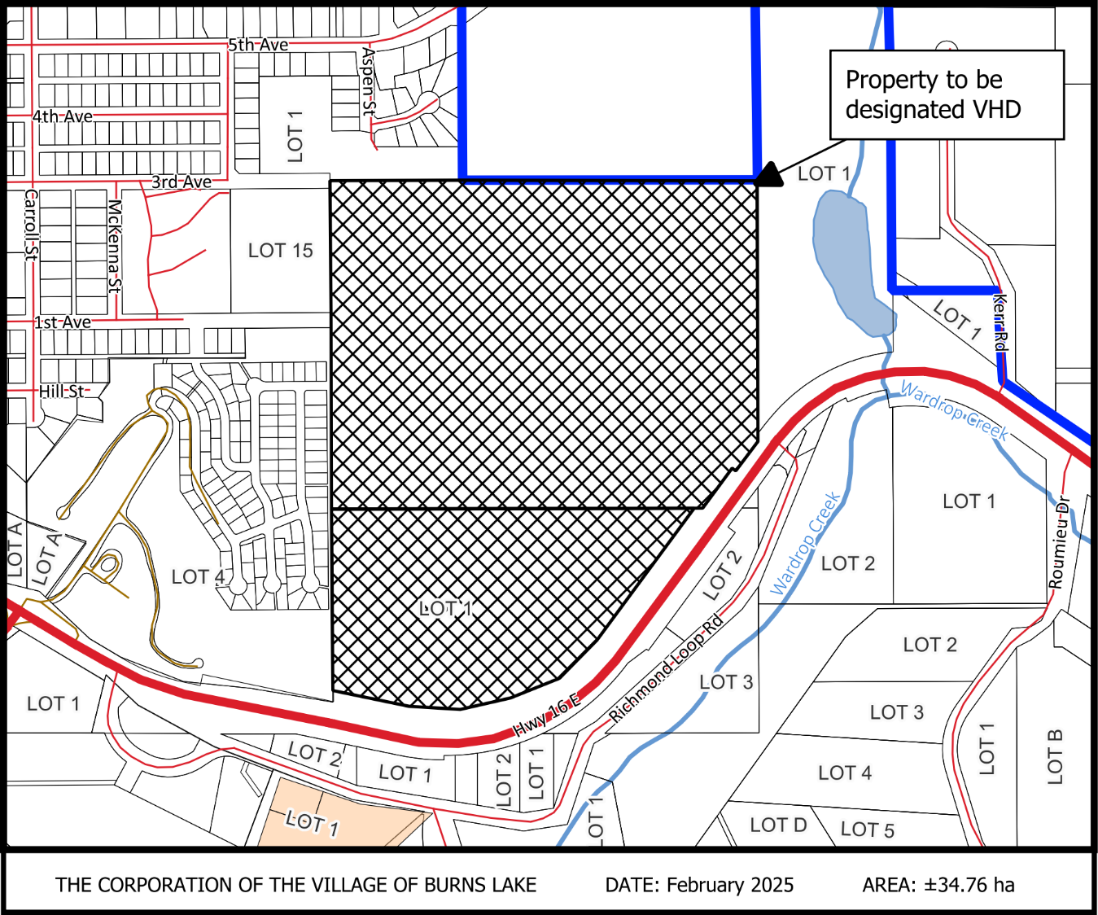
District Lot 5345, Range 5, Coast Range 5 Land District, Except Plan 4623, Ex the Most Southerly 15 Chains comprising approximately 34.76 ha (85.9 acres), being redesignated from the “Concept Development Plan Area (CDP)” Designation to the “Village Heights Development Area (VHD)” Designation, as shown.

SCHEDULE “B” BYLAW NO. 1087
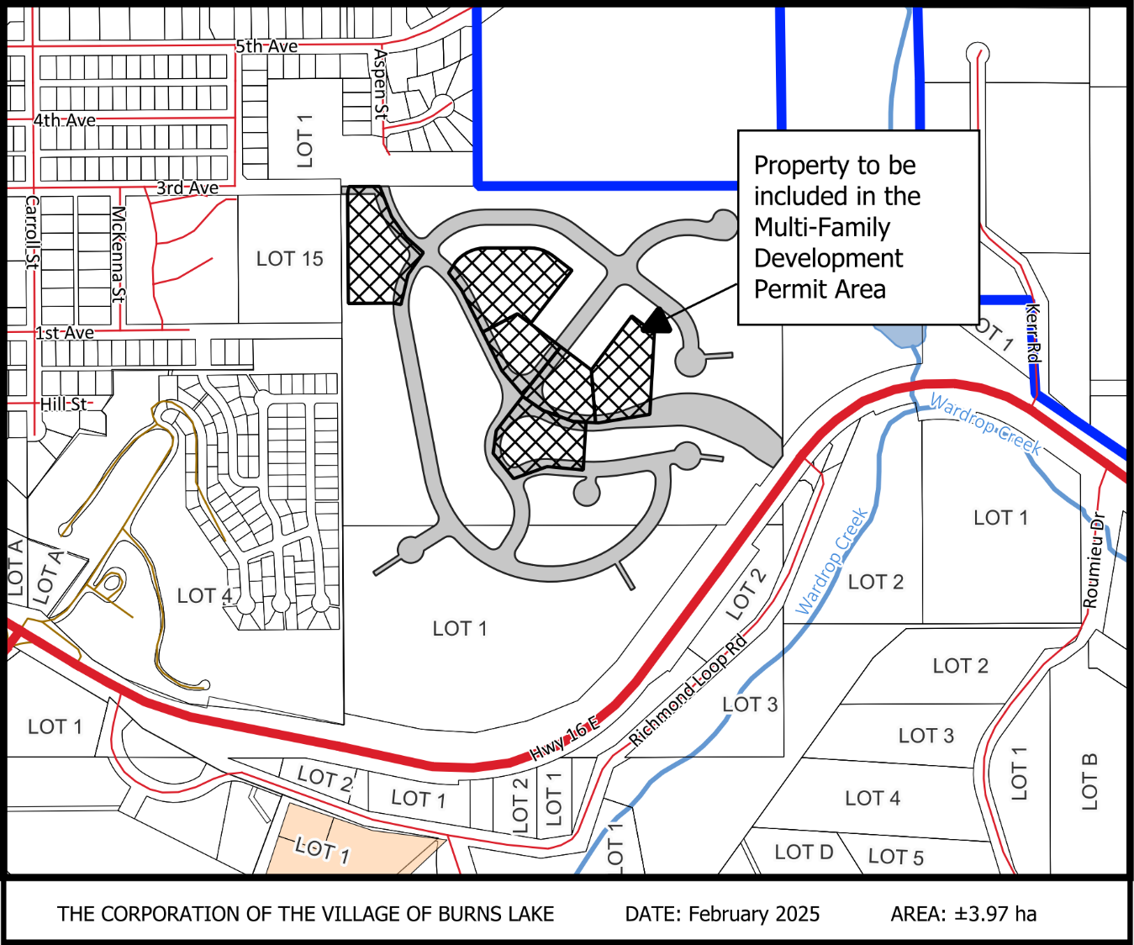
District Lot 5345, Range 5, Coast Range 5 Land District, Except Plan 4623, Ex the Most Southerly 15 Chains comprising approximately 3.97 ha, being included in the Multi-Family Development Permit Area, as shown.

