
Village of Burns Lake
Council Report

Date: 19/02/2025
To: Mayor and Council
From: Amy Wainwright, Manager of Planning and Development
Subject: OCP and Zoning Amendment Bylaws 1087 and 1088 Village Heights

RECOMMENDATION

Option 1

THAT The Village of Burns Lake OCP Amendment Bylaw No. 1087, 2025 and Zoning Amendment Bylaw No. 1088, 2025, be given First and Second Readings;
AND THAT a public hearing be set for Tuesday, March 11, 2025.

Option 2

THAT Village of Burns Lake OCP Amendment Bylaw No. 1087, 2025 and Zoning Amendment Bylaw No. 1088, 2025 not be considered at this time.

EXECUTIVE SUMMARY

These bylaws propose to amend the OCP and Zoning Bylaw in order to implement the land uses recommended by the Village Heights Master Plan.

CAO COMMENTS

Reviewed and approved by CAO Worthing.

PROPOSAL SUMMARY

Subject Property: District Lot 5345, Range 5, Coast Range 5 Land District, Except Plan 4623, Ex The Most Southerly 15 Chains; and Lot 1, Plan PRP4381, District Lot 5345, Range 5, Coast Range 5 Land District comprising approximately 34.76 ha (85.9 acres).

Location: 615 Highway 16 and 515 Highway 16

LOCATION MAP
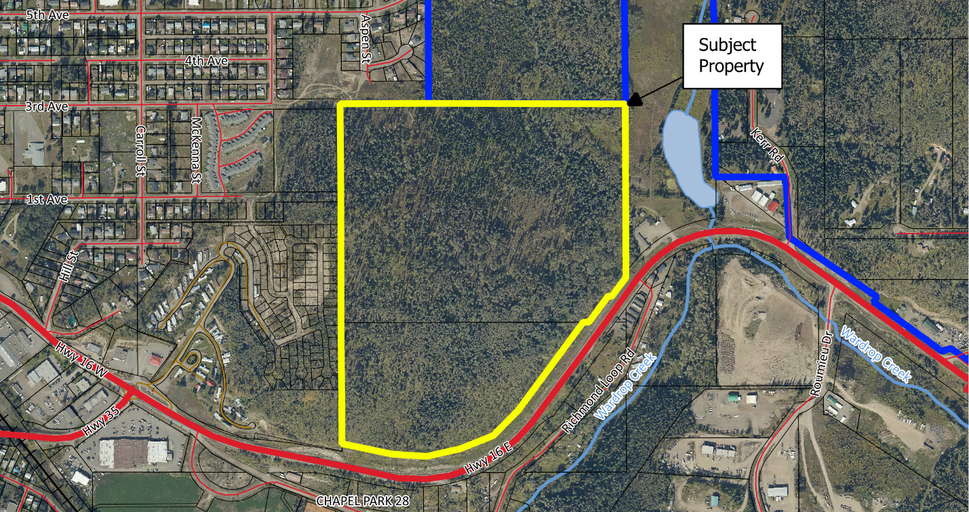

O.C.P. Designation: Concept Development Plan Area (CDP)

Zoning: Urban Reserve (UR)

Existing Land Use: Vacant

Proposal: These Bylaws propose to amend the OCP and Zoning Bylaw to allow the subject properties to be developed for varying densities of residential, mixed residential-commercial, park, and institutional uses. The proposed land uses are in accordance with the Village Heights Master Plan.

OFFICIAL COMMUNITY PLAN AND ZONING:

Official Community Plan

The subject properties are currently designated “Concept Development Plan Area (CDP)” in the Village of Burns Lake OCP. This designation states that:

Land designated as Concept Development Plan area shall not be rezoned for use until this plan is amended to apply the appropriate land use designation to the land.

Village of Burns Lake Official Community Plan Amendment Bylaw No. 1087, 2025 proposes to remove the CDP designation and replace it with the following:

Village Heights Development Area

The Village Heights Development Area designation includes a range of residential uses including single-family dwellings, duplexes, triplexes, fourplexes, townhouses, apartments, and complementary secondary uses such as daycares, preschools, amenity and park areas. This designation also includes local service commercial, small-scale retail and personal service uses in combination with or independent from residential use. Commercial uses should complement residential uses and not detract from the commercial village areas

The subject properties will be redesignated “Village Heights Development Area (VHD)”, and areas proposed to be zoned for medium and high-density residential uses and mixed residential/commercial use will be included in the Multi-Family Development Permit Area.

Zoning

The subject properties are currently zoned Urban Reserve (UR). The purpose of this zone is to reserve those areas of the municipality which are rural in character for future urban development until such time as Council approves a specific urban zone. The Village Height Master Plan has provided guidance for the future land use and servicing for these properties, and the proposed zoning bylaw amendment is in line with the Master Plan.

Village of Burns Lake Zoning Amendment Bylaw No. 1088, 2025 proposes to:
- Rezone the subject properties from the “Urban Reserve (UR)” Zone to the “Residential Low-Density (R1)” Zone, the “Residential Duplex (R2)” Zone, “Residential Medium-Density (R5)” Zone, “Residential High-Density (R6)” Zone, “Park and Open Space (P2)” Zone, “Institutional (I)” Zone, and “Residential Mixed-Use (R7)” Zone (as shown on the proposed zoning map);
- Delete the Urban Reserve (UR) Zone, as there will no longer be any land that this zone applies to;
- Add a definition for “secondary use”; and
- Add a new zone called Residential Mixed-Use Zone (R7), which would permit high-density multiple dwelling housing combined with local service commercial.
Proposed Zoning Map:
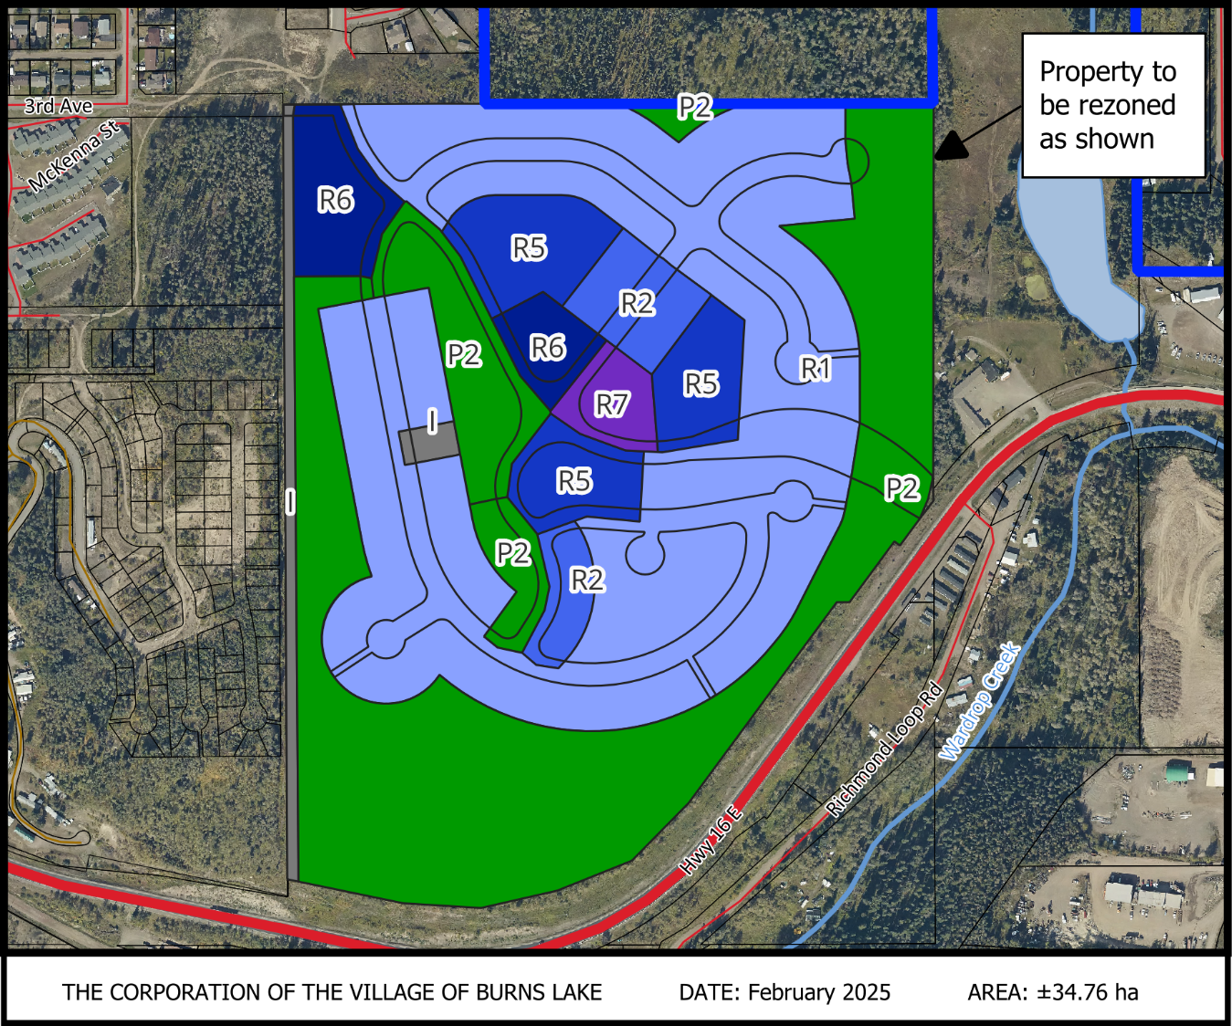

LAND USE / SERVICING CONSIDERATIONS

The area around the subject property is low-density residential and medium-density residential, and is bounded by Highway 16. The nearby low-density residential areas are mostly single-detached dwellings. The nearby medium residential properties consist of a vacant parcel and one that contains an affordable housing row housing development of approximately 40 units. The adjacent land within the Regional District of Bulkley-Nechako is undeveloped and zoned for low-density residential one-acre parcels.

REFERRALS

A referral report was provided to the Village’s Public Works Department, Fire Department, Administration Department, and Building Inspector. It was provided to the Ministry of Transportation and Transit as the property is within 800 metres of an intersection with a controlled access highway. It was also provided to the Regional District of Bulkley-Nechako as the property is adjacent to the Village boundary.

Referral responses will be sent out on Thursday, February 20, 2025, and are not expected before Council consideration of 1st and 2nd Reading. As such, the referral responses will be presented to Council before the Public Hearing is conducted.

Administration and Public Works: Comments pending

Fire Department: Comments pending

Building Inspector: Comments pending

RDBN: Comments pending

Ministry of Transportation: Comments pending

A consultation checklist is attached to this report to address the consultation requirements of an OCP Amendment.

