

THE CORPORATION OF THE VILLAGE OF BURNS LAKE

ZONING AMENDMENT BYLAW NO. 1088, 2025

A Bylaw to amend the Village of Burns Lake Zoning Bylaw No. 880, 2008.

The Council of the Village of Burns Lake in an open meeting assembled, hereby enacts as follows:
This Bylaw may be cited for all purposes as the “Corporation of the Village of Burns Lake Zoning Amendment Bylaw No. 1088, 2025”.
That the "Corporation of the Village of Burns Lake Zoning Bylaw No. 880, 2008" be amended as follows:
- That Schedule 3 of "Village of Burns Lake Zoning Bylaw No. 880, 2008" be amended such that the following land is rezoned from the “Urban Reserve (UR)” Zone to the “Residential Low Density (R1)” Zone, the “Residential Duplex (R2)” Zone, “Residential Medium Density (R5)” Zone, “Residential High Density (R6)” Zone, “Park and Open Space (P2)” Zone, “Institutional (I)” Zone, and “Residential Mixed-Use (R7)” Zone as shown on Schedule A, which is incorporated in and forms part of this bylaw:
District Lot 5345, Range 5, Coast Range 5 Land District, Except Plan 4623, Ex The Most Southerly 15 Chains; and Lot 1, Plan PRP4381, District Lot 5345, Range 5, Coast Range 5 Land District comprising approximately 34.76 ha (85.9 acres).
- That Section 5.1 Zoning Districts of Schedule 1 of "Village of Burns Lake Zoning Bylaw No. 880, 2008" be amended by deleting the following:
“Urban Reserve UR”
- That Section 6.2 Urban Reserve Zone (UR) of Schedule 1 of "Village of Burns Lake Zoning Bylaw No. 880, 2008" be deleted.
- That Schedule 1 of "Village of Burns Lake Zoning Bylaw No. 880, 2008" be amended by adding the following definition to Section 2.3:
“secondary use” means uses that are only permitted on property that is legally occupied and used for one or more of the permitted principal uses.
- That Schedule 1 of "Village of Burns Lake Zoning Bylaw No. 880, 2008" be amended by adding the following new zone “Residential Mixed-Use (R7)” Zone to Section 8.0 Multiple Dwelling Residential Zones:
8.3 Residential Mixed-Use Zone (R7)
.1 Purpose:
The purpose of this zone is to provide high density multiple dwelling housing combined with local service commercial.
.2 Principal Permitted Uses:
- apartment;
- congregate housing;
- rowhouse; and
- special needs housing;
.3 Secondary Permitted Uses, subject to Section 8.3.14:
- eating and drinking establishment;
- health services;
- office;
- personal service establishments;
- retail store, convenience; and
- secondhand store.
.4 Accessory Permitted Uses:
- accessory buildings and structures.
Regulations
.5 Minimum Lot Area: 1,600 m².
.6 Minimum Lot Width: 30 m.
.7 Minimum Setbacks to Lot Lines:
- principal buildings:
  - front yard – 7.5 m;
  - interior side yard for buildings less than 2 storeys – 4.5 m;
  - interior side yard for buildings over 2 storeys – 7.5 m;
  - exterior side yard – 7.5 m; and
  - rear yard – 7.5 m.
- accessory buildings and structures:
  - front yard – 7.5 m
  - interior side yard – 1.5 m;
  - exterior side yard – 7.5 m; and
  - rear yard – 1.5 m
.8 Maximum Height:
- principal buildings – 14 m; and
- accessory buildings and structures – 5 m.
.9 Maximum Density:
- 60 dwelling units per hectare; and
- despite 8.1.8(a) where provision for special needs housing is provided, as defined in Section 2.3 and regulated in Section 3.17 of this Bylaw, this density may be increased to 65 dwelling units per hectare.
.10 Minimum Floor Area:
- apartments:
- bachelor units – 50 m²;
- one bedroom unit – 65 m²;
- two-bedroom unit – 72 m²; and
- three-bedroom unit or greater – 85 m².
- rowhouse:
- one bedroom unit – 70 m²;
- two-bedroom unit – 85 m²; and
- three-bedroom unit or greater – 95 m².
.11 Maximum Lot Coverage:
- all buildings – 40%; and
- all buildings, driveways, and parking areas – 60%.
.12 Recreation Vehicle Storage:
- must not be located within the front yard setback.
- must be screened and landscaped according to section 3.14 of this bylaw.
.13 Off-street Parking and Loading: in accordance with Schedule 2 of this Bylaw.
.14 Commercial Use in R7:
- any local service commercial use combined with residential must:
    - have a floor area of not more than 40% of the residential use;
    - be located on the ground floor, or within a separate building;
    - provide access to the ground level from a separate access from the residential or other permitted use;
.15 General Regulations:
- in accordance with Section 3.0 of this Bylaw; and
- despite the general regulations, other than the required yard setbacks, for rowhouse and apartments, a minimum of 7 m² per bachelor unit; 12 m² per one-bedroom unit; and 18 m² per each two or more-bedroom unit of amenity area is required.
.16 Specific Use Regulations: in accordance with Section 4.0 of this Bylaw.

Full Force and Effect:
This Bylaw has full force and effect from the date of adoption until amended, repealed, or replaced.
READ A FIRST TIME THIS 2TH DAY OF FEBRUARY 2025
READ A SECOND TIME THIS 25TH DAY OF FEBRUARY 2025
PUBLIC HEARING HELD THIS ___ DAY OF _______, _______
READ A THIRD TIME THIS__ DAY OF_______, _______
Approved pursuant to section 52(3)(a) of the Transportation Act
this day of , 2025

_______________________________________________
for Minister of Transportation & Infrastructure

for Minister of Transportation & Infrastructure

ADOPTED THIS __ DAY OF_______, _______

______________________________________ ______________________________________
MAYOR CORPORATE OFFICER

Certified to be a true copy of “The Corporation of the Village of Burns Lake Zoning Amendment Bylaw No. 1088, 2025”.
SCHEDULE “A” BYLAW NO. 1088
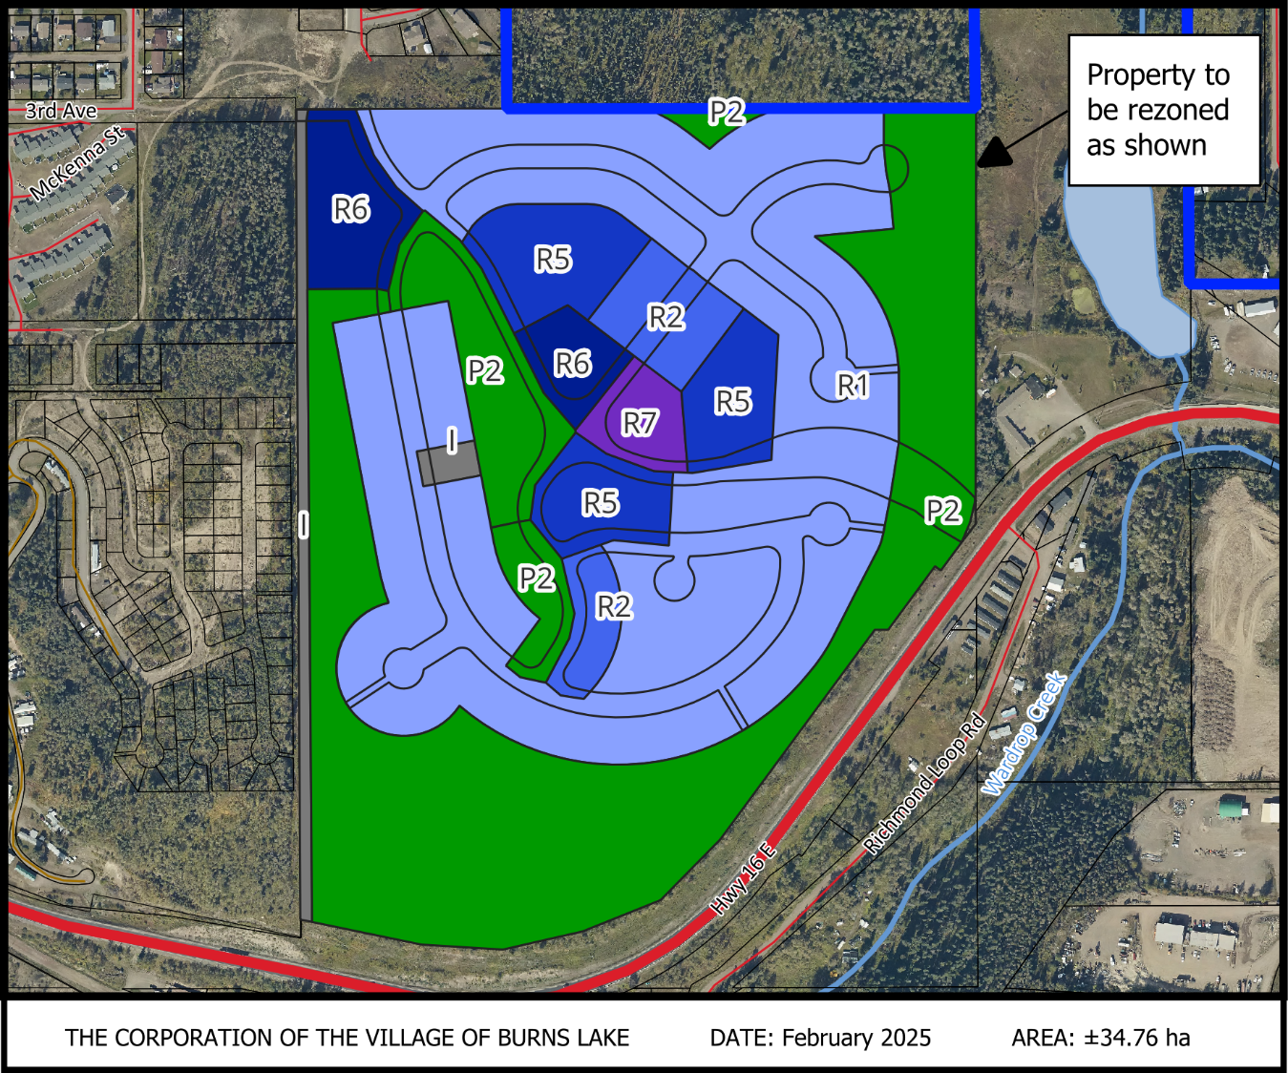
District Lot 5345, Range 5, Coast Range 5 Land District, Except Plan 4623, Ex The Most Southerly 15 Chains; and Lot 1, Plan PRP4381, District Lot 5345, Range 5, Coast Range 5 Land District comprising approximately 34.76 ha (85.9 acres), being rezoned from the from the “Urban Reserve (UR)” Zone to the “Residential Low Density (R1)” Zone, the “Residential Duplex (R2)” Zone, “Residential Medium Density (R5)” Zone, “Residential High Density (R6)” Zone, “Park and Open Space (P2)” Zone, “Institutional (I)” Zone, and “Residential Mixed-Use (R7)” Zone, as shown.

